**Assignment1:**

1. Basic Calculator

BasicCalculator.html

<html>

<head>

<title>

Basic Calculator

</title>

<link rel="stylesheet" href="BasicCalculator.css">

<script src="BasicCalculator.js" type="text/javascript"></script>

</head>

<body>

<div align="center">

<form>

<input type="text" id="result"><br><br></form>

<button class="button" value="C" onclick="getExpression('C')">C</button>

<button class="button" value="%" onclick="getExpression('%')">%</button>

<button class="button" value="+" onclick="getExpression('+')">+</button>

<button class="button" value="/" onclick="getExpression('/')">/</button><br><br>

<button class="button" value="7" onclick="getExpression('7')">7</button>

<button class="button" value="8" onclick="getExpression('8')">8</button>

<button class="button" value="9" onclick="getExpression('9')">9</button>

<button class="button" value="*" onclick="getExpression('*')">*</button><br><br>

<button class="button" value="4" onclick="getExpression('4')">4</button>

<button class="button" value="5" onclick="getExpression('5')">5</button>

<button class="button" value="6" onclick="getExpression('6')">6</button>

<button class="button" value="-" onclick="getExpression('-')">-</button><br><br>

<button class="button" value="1" onclick="getExpression('1')">1</button>

<button class="button" value="2" onclick="getExpression('2')">2</button>

<button class="button" value="3" onclick="getExpression('3')">3</button>

<button class="button" value="." onclick="getExpression('.')">.</button><br><br>

<button class="button" value="0" onclick="getExpression('0')">0</button>

<button class="button" value="=" onclick="getExpression('=')">=</button>

</form>

</div>

</body>

</html>

BasicCalculator.js

function getExpression(e)

{

var expression=sessionStorage.getItem("expression");

var flag=sessionStorage.getItem("flag");

var dot=sessionStorage.getItem("dot");

if( expression == null){

expression="";

sessionStorage.setItem("expression",expression);

sessionStorage.setItem("flag",0);

sessionStorage.setItem("dot",0);

}

if(e=="+" || e=="-" || e=="%" || e=="/" || e=="*"){

var count=sessionStorage.getItem("count");

if(flag==0){

alert("Wrong input!");

}

else{

expression=expression.concat(e);

sessionStorage.setItem("flag",0);

sessionStorage.setItem("dot",0);

sessionStorage.setItem("expression",expression);

document.getElementById("result").value=expression;

}

}

else if(e=="."){

if(dot==1){

alert("Wrong input!");

}

else{

expression=expression.concat(e);

sessionStorage.setItem("expression",expression);

sessionStorage.setItem("dot",1);

document.getElementById("result").value=expression;

}

}

else if( /\d/.test(e)){

expression=expression.concat(e);

sessionStorage.setItem("flag",1);

sessionStorage.setItem("expression",expression);

document.getElementById("result").value=expression;

}

else if(e=="=" && flag==0){

alert("Wrong input!");

}

else if(e=="=" ){

var result=eval(expression);

document.getElementById("result").value=result;

console.log(result);

sessionStorage.setItem("expression","");

sessionStorage.setItem("dot",0);

sessionStorage.setItem("flag",0);

}

else if(e=="C"){

sessionStorage.setItem("expression","");

sessionStorage.setItem("flag",0);

document.getElementById("result").value=null;

}

}

BasicCalculator.css

.button {

display: inline-block;

padding: 15px 25px;

font-size: 24px;

cursor: pointer;

text-align: center;

text-decoration: none;

outline: none;

color: #fff;

background-color: #4CAF50;

border: none;

border-radius: 15px;

box-shadow: 0 9px #999;

}

.button:hover {background-color: #3e8e41}

.button:active {

background-color: #3e8e41;

box-shadow: 0 5px #666;

transform: translateY(4px);

}

input[type=text] {

border: 2px solid #4CAF50;

border-radius: 4px;

width:250px;

height:50px;

}

“Output:”

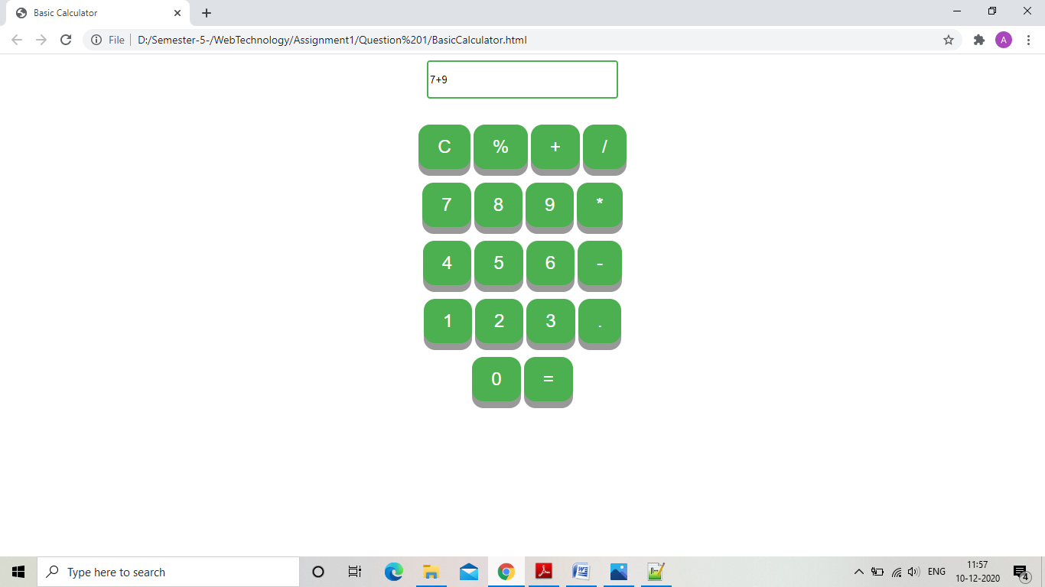

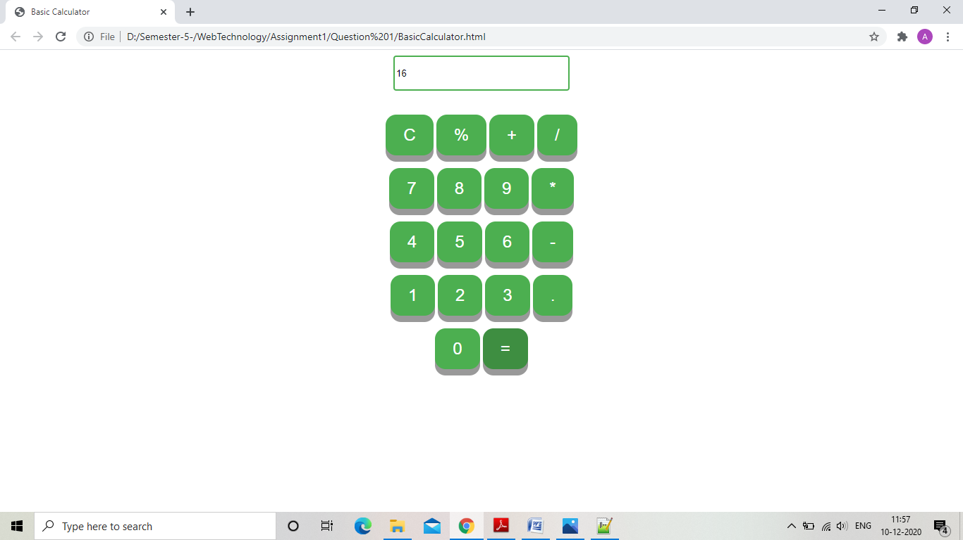

1. Form Field validation

“FormValidation.html”

<html>

<head>

<title>

Form Validation

</title>

<link rel="stylesheet" href="Form.css">

<script type="text/javascript" src="FormValidate.js"></script>

</head>

<body>

<h3 align="center">Registration Form

<table align="center">

<form method="post" name="MyForm" onsubmit="return(validateForm());">

<tr>

<td>

<label for="name">Name:</label>

</td>

<td>

<input type="text" name="Name" >

</td>

</tr>

<tr>

<td>

<label for="contact_number">Contact number:</label>

</td>

<td>

<input type="text" name="Contact_number" maxlength="10">

</td>

</tr>

<tr>

<td>

<label for="email">E-mail:</label>

</td>

<td>

<input type="text" name="Email" id="Email">

</td>

</tr>

<tr>

<td>

<label for="password">Password:</label>

</td>

<td>

<input type="password" name="Password" id="password">

</td>

</tr>

<tr>

<td>

<input type="submit" value="submit">

</td>

<td>

<input type="reset" value="reset">

</td>

</tr>

</form>

</table>

</body>

</html>

“FormValidate.js”

function validateForm()

{

if(document.MyForm.Name.value == "" || /\d/.test(document.MyForm.Name.value))

{

alert("Enter your name correctly!");

document.MyForm.Name.focus();

return false;

}

if(document.MyForm.Contact_number.value=="" || /\D/.test(document.MyForm.Contact_number.value) || (document.MyForm.Password.value).length<8){

alert("Please provide your contact number!");

document.MyForm.Contact_number.focus();

return false;

}

if(document.MyForm.Email.value=="" || (document.MyForm.Email.value).indexOf("@")<1 || ((document.MyForm.Email.value).indexOf("."))-((document.MyForm.Email.value).indexOf("@"))<2){

alert("Please provide your email!");

document.MyForm.Email.focus();

return false;

}

if(document.MyForm.Password.value=="" || (document.MyForm.Password.value).length<8 || /\s/.test(document.MyForm.Password.value) || /\W/.test(document.MyForm.Password.value)){

alert("Please provide password!");

document.MyForm.Password.focus();

return false;

}

return true;

}

“Form.css”

body{

background-color:papayawhip;

font-family:Century;

text-align:center;

text-decoration:bold;

text-indent:left;

font-size:25px;

}

input{

border-radius:4px;

box-sizing:border-box;

}

input[type=button], input[type=submit], input[type=reset] {

background-color: #4CAF50;

border: none;

color: white;

padding: 16px 32px;

text-decoration: none;

margin: 4px 2px;

cursor: pointer;

}

“Output”

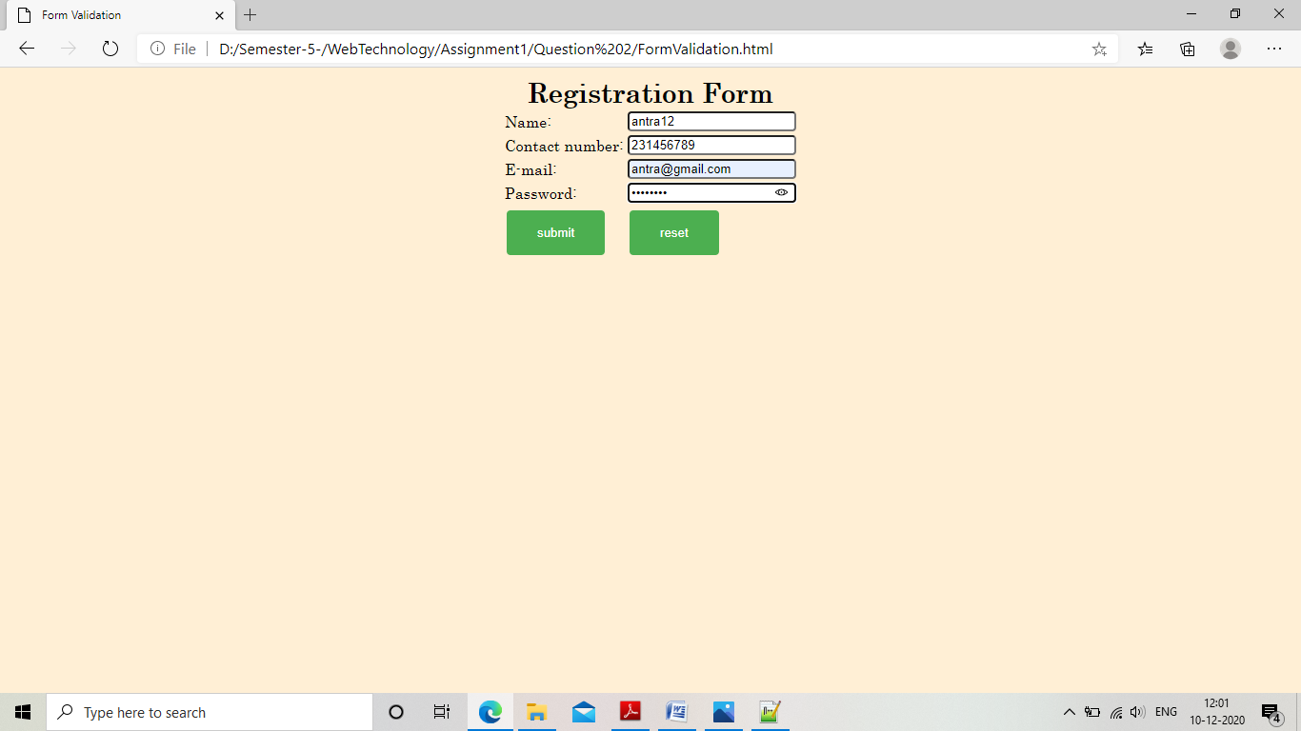

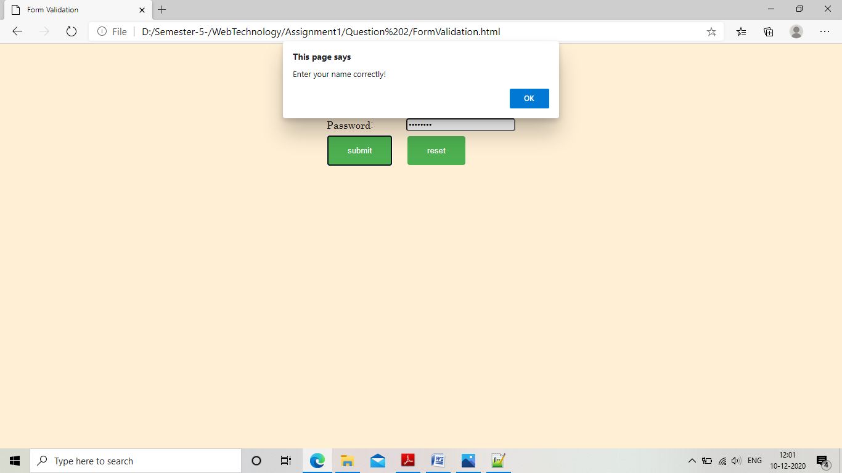

1. Image change on mouse over event

“ImageChange.html”

<html>

<head>

<title>

Image change

</title>

<script language="jacvascript" type="text/javascript">

var flag=0;

function changeImage()

{

var imageSrc=["scenery1.jpg","scenery2.jpg"];

if(flag==0)

{

document.getElementById("image").src=imageSrc[0];

flag=1;

}

else

{

document.getElementById("image").src=imageSrc[1];

flag=0;

}

}

</script>

</head>

<body>

<p align="center">

<img src="scenery1.jpg" width="500px" height="500px" onmouseover="changeImage()" id="image">

</p>

</body>

</html>

“Output”

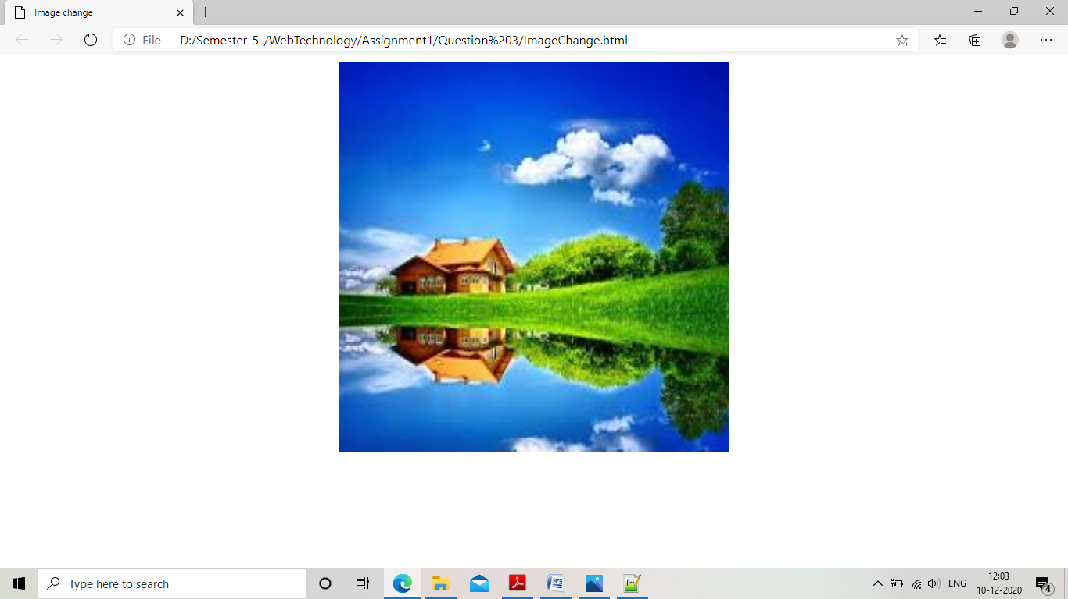

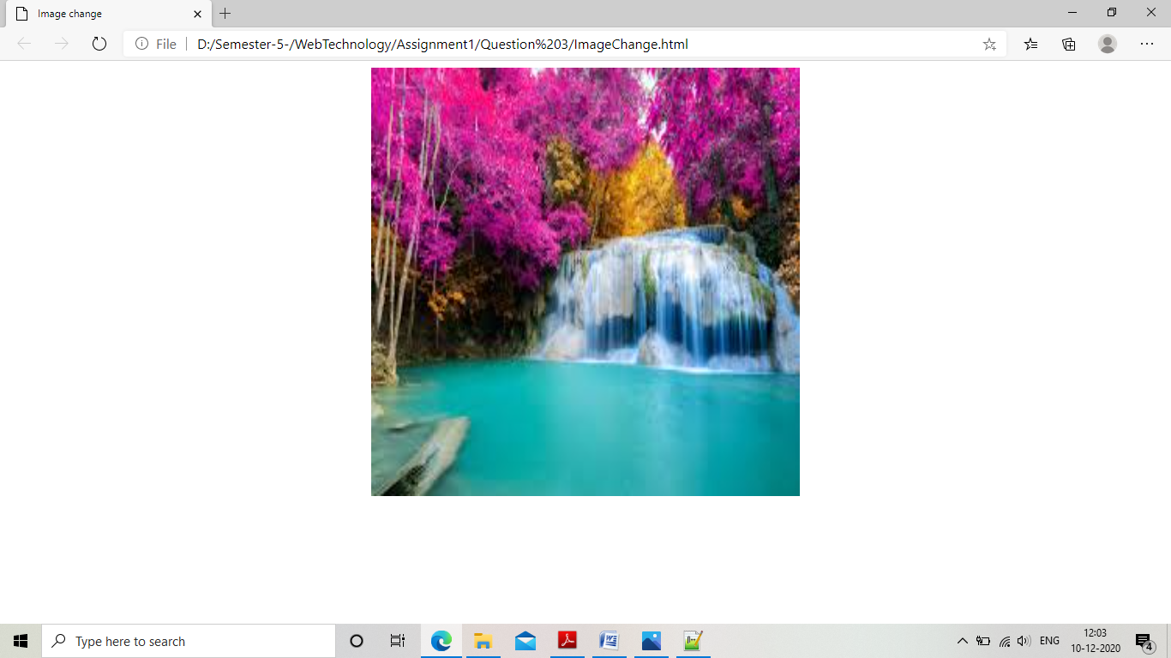

4.Random image change on mouse over event.

“ImageChange.html”

<html>

<head>

<title>

Image change

</title>

<script language="jacvascript" type="text/javascript">

function changeImage()

{

var number=Math.floor(Math.random() * 2);

var imageSrc=["scenery1.jpg","scenery2.jpg","scenery3.jpg"];

document.getElementById("image").src=imageSrc[number];

}

</script>

</head>

<body>

<p align="center">

<img src="scenery1.jpg" width="500px" height="500px" onmouseover="changeImage()" id="image">

</p>

</body>

</html>

“Output”

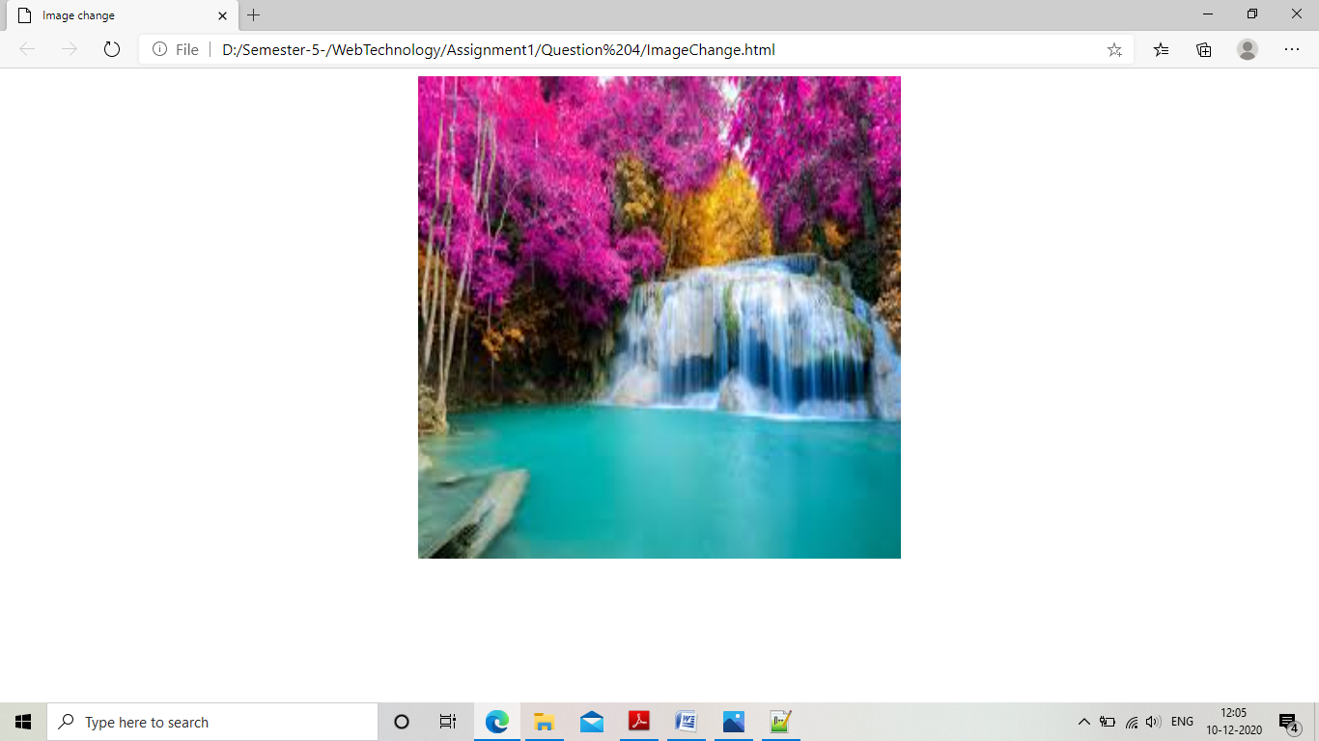

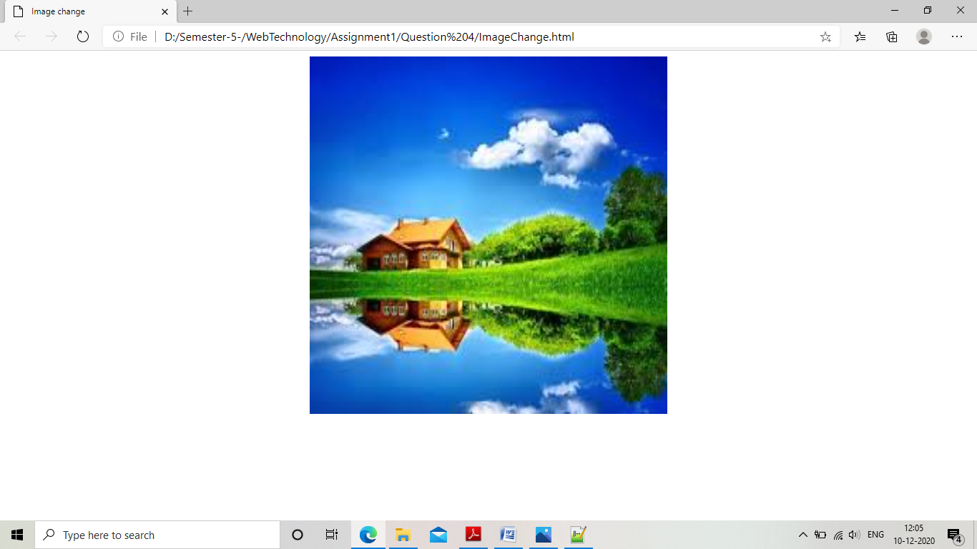

5.Display your browser properties.

“BrowserProperties.html”

<html>

<head>

<title>

Browser Properties

</title>

<link rel="stylesheet" href="Table.css">

</head>

<body>

<h2 align="center">Browser Properties</h2>

<table align="center" >

<tr>

<td>

Is cookie enabled?

</td>

<td id="cookie_enabled"></td>

<script type="text/javascript" language="javascript">

document.getElementById("cookie_enabled").innerHTML= navigator.cookieEnabled;

</script>

</tr>

<tr>

<td>

Application name

</td>

<td id="App_name"></td>

<script type="text/javascript" language="javascript">

document.getElementById("App_name").innerHTML= navigator.appName;

</script>

</tr>

<tr>

<td>

Application code name

</td>

<td id="App_codename"></td>

<script type="text/javascript" language="javascript">

document.getElementById("App_codename").innerHTML= navigator.appCodeName;

</script>

</tr>

<tr>

<td>

Browser Engine name

</td>

<td id="browser_name"></td>

<script type="text/javascript" language="javascript">

document.getElementById("browser_name").innerHTML= navigator.product;

</script>

</tr>

<tr>

<td>

App version

</td>

<td id="App version"></td>

<script type="text/javascript" language="javascript">

document.getElementById("App version").innerHTML= navigator.appVersion;

</script>

</tr>

<tr>

<td>

Browser Agent

</td>

<td id="browser_agent"></td>

<script type="text/javascript" language="javascript">

document.getElementById("browser_agent").innerHTML= navigator.userAgent;

</script>

</tr>

<tr>

<td>

Browser Platform

</td>

<td id="browser_platform"></td>

<script type="text/javascript" language="javascript">

document.getElementById("browser_platform").innerHTML= navigator.platform;

</script>

</tr>

<tr>

<td>

Language

</td>

<td id="browser_language"></td>

<script type="text/javascript" language="javascript">

document.getElementById("browser_language").innerHTML= navigator.language;

</script>

</tr>

<tr>

<td>

Is browser online?

</td>

<td id="browser_online"></td>

<script type="text/javascript" language="javascript">

document.getElementById("browser_online").innerHTML= navigator.onLine;

</script>

</tr>

<tr>

<td>

Is browser java enabled?

</td>

<td id="java_enabled"></td>

<script type="text/javascript" language="javascript">

document.getElementById("java_enabled").innerHTML= navigator.javaEnabled();

</script>

</tr>

</table>

</body>

</html>

“Table.css”

th, td {

border-bottom: 1px solid #ddd;

padding: 15px;

text-align: left;

height: 50px;

vertical-align: bottom;

}

table {

border: 1px solid black;

}

“Output”

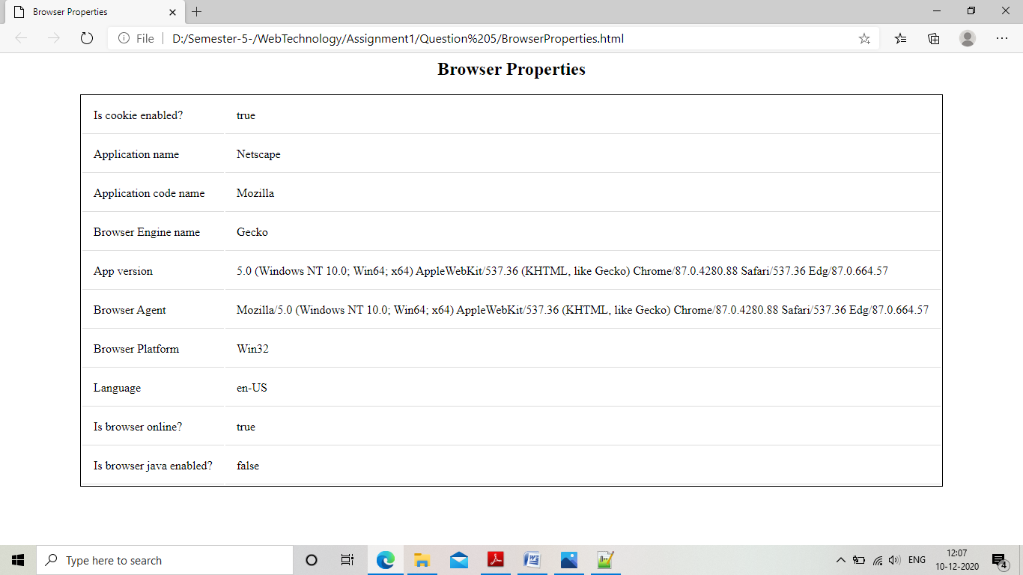

6.Open a new window on button click event

“NewWindow.html”

<html>

<head>

<title>

New window

</title>

<link rel="stylesheet" href="Button.css">

<script type="text/javascript" language="javascript">

function newWindow()

{

window.open();

}

</script>

</head>

<body>

<h3 align="center">Click the button to open a new window

<table align="center">

<form method="post">

<tr>

<td>

<button class="button" onclick="newWindow()">Click me!</button>

</td>

</tr>

</form>

</table>

</body>

</html>

“Button.css”

.button {

display: inline-block;

padding: 15px 25px;

font-size: 24px;

cursor: pointer;

text-align: center;

text-decoration: none;

outline: none;

color: #fff;

background-color: #4CAF50;

border: none;

border-radius: 15px;

box-shadow: 0 9px #999;

}

.button:hover {background-color: #3e8e41}

.button:active {

background-color: #3e8e41;

box-shadow: 0 5px #666;

transform: translateY(4px);

}

“Output”

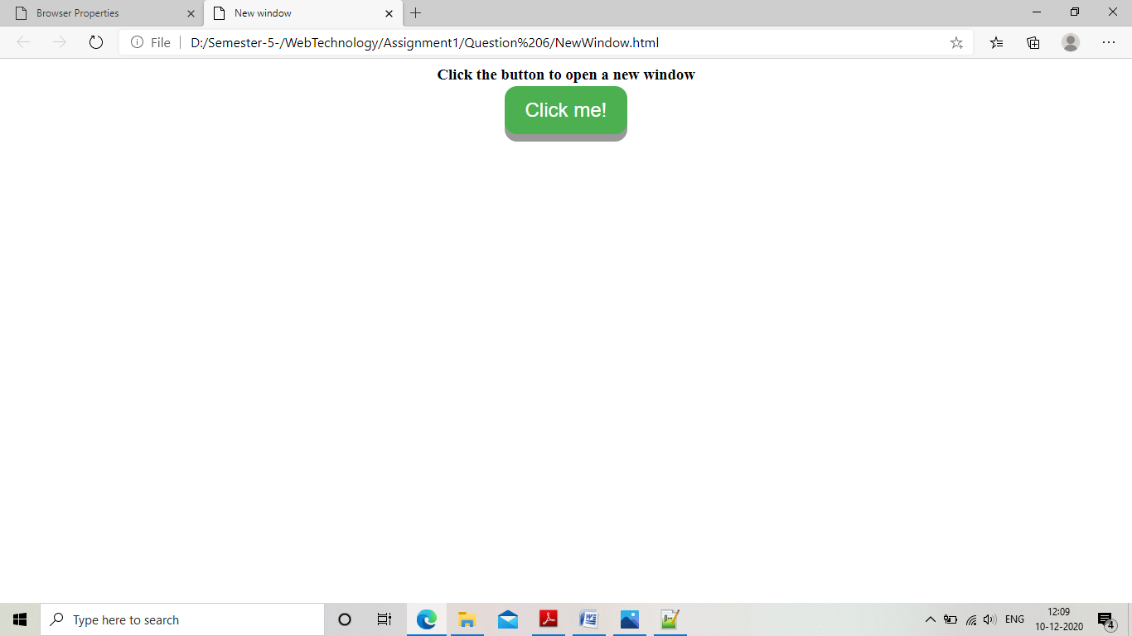

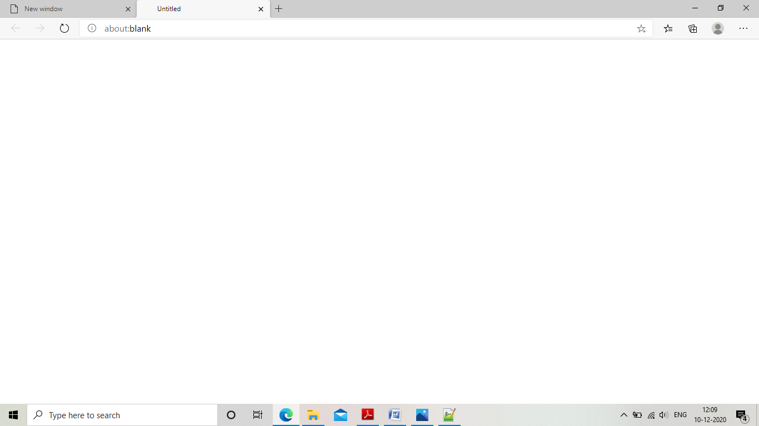

7. Move values from one list box to another

“listbox.html”

<html>

<head>

<title>

Moving items to list box!

</title>

<link rel="stylesheet" href="ListBox.css">

<script>

function moveToSelected()

{

var x = document.getElementById("Fast_Food");

var i=x.selectedIndex;

var y=x.options[i].text;

var option = document.createElement("option");

option.text =y;

document.getElementById("selected_items").add(option);

x.options.remove(i);

}

function moveToUnselected()

{

var x = document.getElementById("selected_items");

var i=x.selectedIndex;

var y=x.options[i].text;

var option = document.createElement("option");

option.text =y;

document.getElementById("Fast_Food").add(option);

x.options.remove(i);

}

</script>

</head>

<body>

<h2 align="center" >

<form>

<select id="Fast_Food" class="myselect">

<option>Apple</option>

<option>Pear</option>

<option>Banana</option>

<option>Orange</option>

</select>

</form>

<button class="button" id="button1" onclick="moveToSelected()">Move to selected</button>

<button class="button" id="button1" onclick="moveToUnselected()">Move to unselected</button>

<form>

<select id="selected_items" class="myselect">

<option></option>

</select>

</form>

</h2>

</body>

</html>

“ListBox.css”

body{

background-color:papayawhip;

font-family:Century;

text-align:center;

text-decoration:bold;

text-indent:left;

font-size:25px;

}

.myselect {

display: block;

font-size: 16px;

font-family: sans-serif;

font-weight: 700;

color: #444;

line-height: 1.3;

padding: .6em 1.4em .5em .8em;

width: 30%;

max-width: 100%; /* useful when width is set to anything other than 100% */

box-sizing: border-box;

margin: 0;

border: 1px solid #aaa;

box-shadow: 0 1px 0 1px rgba(0,0,0,.04);

border-radius: .5em;

-moz-appearance: none;

-webkit-appearance: none;

appearance: none;

background-color: #fff;

}

.myselect::-ms-expand {

display: none;

}

.myselect:hover {

border-color: #888;

}

/* Focus style */

.button {

display: inline-block;

padding: 15px 25px;

font-size: 24px;

cursor: pointer;

text-align: center;

text-decoration: none;

outline: none;

color: #fff;

background-color: #4CAF50;

border: none;

border-radius: 15px;

box-shadow: 0 9px #999;

}

.button:hover {background-color: #3e8e41}

.button:active {

background-color: #3e8e41;

box-shadow: 0 5px #666;

transform: translateY(4px);

}

.select {

display: block;

font-size: 16px;

font-family: sans-serif;

font-weight: 700;

color: #444;

line-height: 1.3;

padding: .6em 1.4em .5em .8em;

width: 100%;

max-width: 100%;

box-sizing: border-box;

margin: 0;

border: 1px solid #aaa;

box-shadow: 0 1px 0 1px rgba(0,0,0,.04);

border-radius: .5em;

appearance: none;

background-color: #fff;

}

“Output”

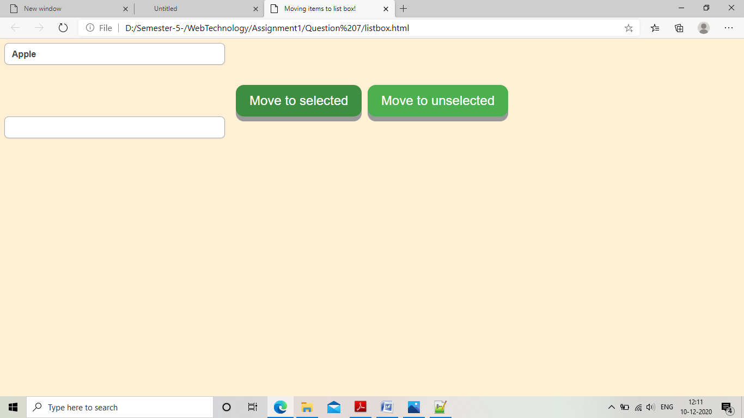

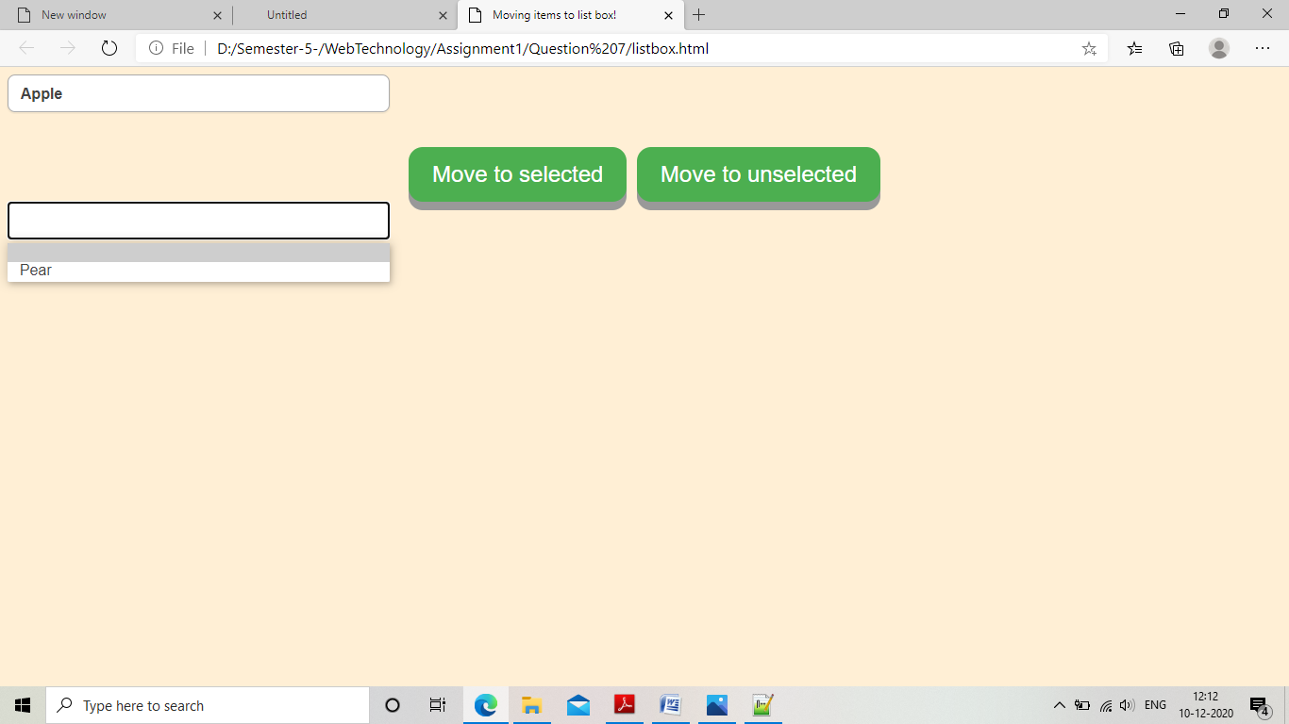

8. Make country , state and city combo box and fill these boxes according to user choice

“ShowLocation.html”

<html>

<head>

<title>

Bill

</title>

<script src="Country.js" type="text/javascript"></script>

<link rel="stylesheet" href="Country.css">

</head>

<body onload="printLocation()">

Location

<p id="location"></p>

</body>

</html>

“Country.html”

<html>

<head>

<title>

Countries

</title>

<link rel="stylesheet" href="Country.css">

<script type="text/javascript" src="Country.js"></script>

</head>

<body>

<form>

<label>Select country:</label>

<select class="myselect" id="country" size="2" onchange="getStates()">

<option value="India">India</option>

<option value="Australia">Australia</option>

</select>

</form>

<form>

<label>Select state:</label>

<select class="myselect" id="state" size="4" onchange="getCities()">

</select>

</form>

<form action="ShowLocation.html">

<label>Select city:</label>

<select class="myselect" id="city" size="4" onchange="getLocation()">

</select>

<input type="submit" value="submit">

<input type="reset" value="reset">

</form>

</body>

</html>

“Country.js”

function getStates()

{

var India=["Gujarat","Delhi"];

var Australia=["Tasmania","Victoria"];

var states=new Map();

states.set("India",India);

states.set("Australia",Australia);

var x=document.getElementById("country");

var i = x.selectedIndex;

var y = x.options[i].text;

var states_display = states.get(y);

for(var i=0;i<states_display.length;i++)

{

var option=document.createElement("option");

option.text=states_display[i];

document.getElementById("state").add(option);

}

sessionStorage.setItem("location","Country:"+y+"<br>State:");

}

function getCities()

{

var Gujarat=["Ahmedabad","Surat"];

var Delhi=["Faridabad","Agra"];

var Tasmania=["Hobert","Burnie"];

var Victoria=["Ararat","Colac"];

var cities=new Map();

cities.set("Gujarat",Gujarat);

cities.set("Delhi",Delhi);

cities.set("Victoria",Victoria);

cities.set("Tasmania",Tasmania);

var x=document.getElementById("state");

var i = x.selectedIndex;

var y = x.options[i].text;

var cities_display = cities.get(y);

for(var i=0;i<cities_display.length;i++)

{

var option=document.createElement("option");

option.text=cities_display[i];

document.getElementById("city").add(option);

}

var location=sessionStorage.getItem("location");

location=location+y;

sessionStorage.setItem("location",location+"<br>City");

}

function getLocation()

{

var x=document.getElementById("city");

var i = x.selectedIndex;

var y = x.options[i].text;

var location=sessionStorage.getItem("location");

location=location+y;

sessionStorage.setItem("location",location);

}

function printLocation(){

document.getElementById("location").innerHTML=sessionStorage.getItem("location");

}

“country.css”

body{

background-color:papayawhip;

font-family:Century;

text-decoration:bold;

text-indent:left;

font-size:20px;

}

.myselect {

display: block;

font-size: 16px;

font-family: sans-serif;

font-weight: 700;

color: #444;

line-height: 1.3;

padding: .6em 1.4em .5em .8em;

width: 30%;

max-width: 100%; /* useful when width is set to anything other than 100% */

box-sizing: border-box;

margin: 0;

border: 1px solid #aaa;

box-shadow: 0 1px 0 1px rgba(0,0,0,.04);

border-radius: .5em;

-moz-appearance: none;

-webkit-appearance: none;

appearance: none;

background-color: #fff;

}

.myselect::-ms-expand {

display: none;

}

.myselect:hover {

border-color: #888;

}

/* Focus style */

.button {

display: inline-block;

padding: 15px 25px;

font-size: 15px;

cursor: pointer;

text-align: center;

text-decoration: none;

outline: none;

color: #fff;

background-color: #4CAF50;

border: none;

border-radius: 10px;

box-shadow: 0 9px #999;

width:100px;

height:50px;

}

.button:hover {background-color: #3e8e41}

.button:active {

background-color: #3e8e41;

box-shadow: 0 5px #666;

transform: translateY(4px);

}

input[type=text]{

border-radius:4px;

box-sizing:border-box;

height:30px;

}

.select{

display: block;

font-size: 16px;

font-family: sans-serif;

font-weight: 700;

color: #444;

line-height: 1.3;

padding: .6em 1.4em .5em .8em;

width: 100%;

max-width: 100%;

box-sizing: border-box;

margin: 0;

border: 1px solid #aaa;

box-shadow: 0 1px 0 1px rgba(0,0,0,.04);

border-radius: .5em;

appearance: none;

background-color: #fff;

}

“Output”

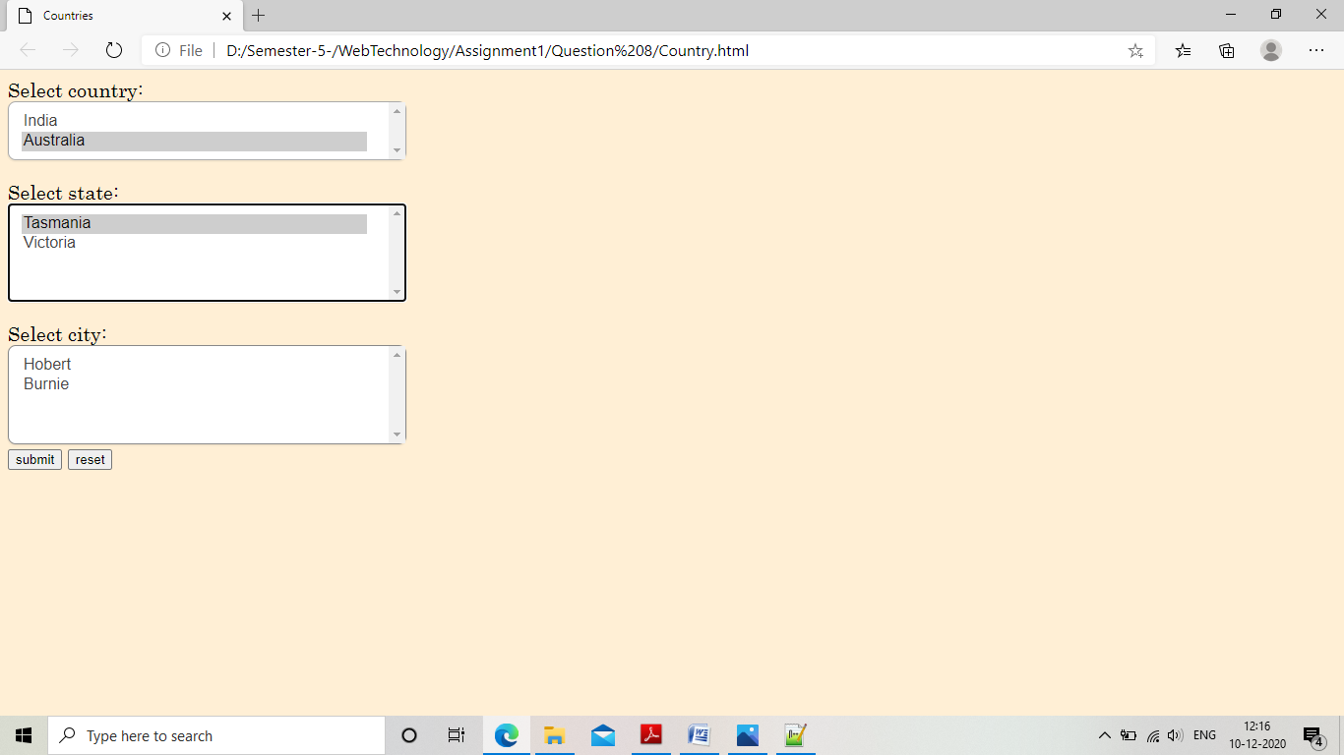

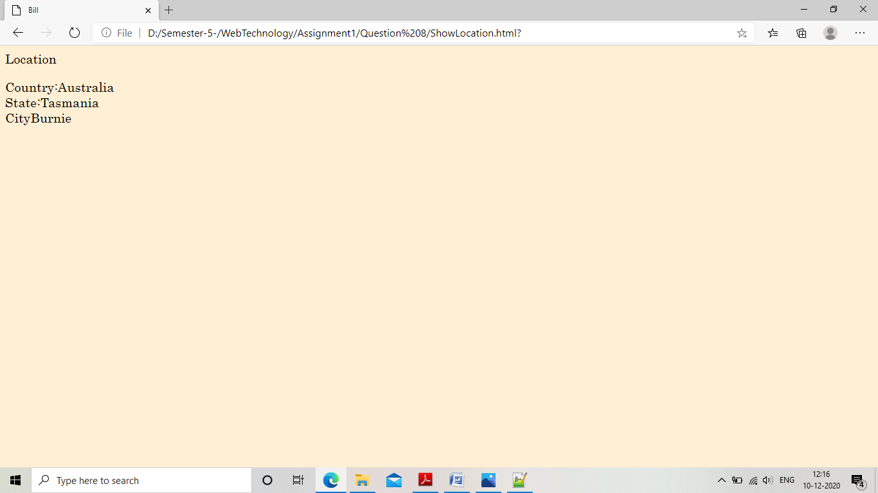

9. Display the list of food items and cold drinks and ask users to select the items and generate the bill.

“FoodItems.html”

<html>

<head>

<title>

Food Items

</title>

<link rel="stylesheet" href="FoodItems.css">

<script type="text/javascript" src="FoodItems.js"></script>

</head>

<body>

<form >

<label>Select coldrinks:</label>

<select class="myselect" id="colddrinks">

<option value="Pepsi-Rs 50">Pepsi-Rs 50</option>

<option value="Coke-Rs 50">Coke-Rs 50</option>

<option value="Chaas-Rs 30">Chaas-Rs 30</option>

<option value="Sprite-Rs 60">Sprite-Rs 60</option>

</select>

<label>Select food:</label>

<select class="myselect" id="fooditems">

<option value="Pizza-Rs 100">Pizza-Rs 100</option>

<option value="Pasta-Rs 50">Pasta-Rs 50</option>

<option value="Brownie-Rs 80">Brownie-Rs 80</option>

<option value="Pav baji-Rs 150">Pav baji-Rs 150</option>

</select>

</form>

<button class="button" onclick="moveSelectedColdDrink()" >Add Coldrink</button>

<button class="button" onclick="moveSelectedFoodItems()" >Add Fooditem</button>

<form action="Bill.html">

<label>Selected coldrinks:</label>

<select class="myselect" id="selected_colddrinks" size="4">

</select>

<label>Selected foodItems:</label>

<select class="myselect" id="selected_fooditems" size="4">

</select>

<input type="submit" value="submit" class="button" onclick="getBill()">

</form>

<button class="button" onclick="removeSelectedColdDrink()">Remove Coldrink</button>

<button class="button" onclick="removeSelectedFoodItems()">Remove Fooditem</button>

</body>

</html>

“FoodItems.js”

function moveSelectedColdDrink()

{

var x=document.getElementById("colddrinks");

var selected_index=x.selectedIndex;

var option=document.createElement("option");

option.text=x.options[selected_index].text;

console.log(option.text);

document.getElementById("selected_colddrinks").add(option);

}

function moveSelectedFoodItems()

{

var x=document.getElementById("fooditems");

var selected_index=x.selectedIndex;

var option=document.createElement("option");

option.text=x.options[selected_index].text;

console.log(option.text);

document.getElementById("selected_fooditems").add(option);

}

function removeSelectedColdDrink()

{

var x = document.getElementById("selected_colddrinks");

var i=x.selectedIndex;

x.options.remove(i);

}

function removeSelectedFoodItems()

{

var x = document.getElementById("selected_fooditems");

var i=x.selectedIndex;

x.options.remove(i);

}

function getBill()

{

var total=0;

var bill="";

var colddrinks=document.getElementById("selected_colddrinks");

var fooditems=document.getElementById("selected_fooditems");

for(var i=0;i<colddrinks.length;i++){

var item=colddrinks.options[i].text;

bill=bill.concat(item);

bill=bill+"<br>";

total = total + parseInt(item.slice((item.indexOf("Rs"))+3,item.length));

}

bill=bill+"<br>";

for(var i=0;i<fooditems.length;i++){

var item=fooditems.options[i].text;

bill=bill.concat(item);

bill=bill+"<br>";

total = total + parseInt(item.slice((item.indexOf("Rs"))+3,item.length));

}

bill=bill+"<br>";

bill=bill+"Total:";

bill=bill+total;

sessionStorage.setItem("bill",bill);

}

function printBill()

{

document.getElementById("Bill").innerHTML=sessionStorage.getItem("bill");

}

“Bill.html”

<html>

<head>

<title>

Bill

</title>

<script src="FoodItems.js" type="text/javascript"></script>

<link rel="stylesheet" href="FoodItems.css">

</head>

<body onload="printBill()">

Bill:

<p id="Bill"></p>

</body>

</html>

“FoodItems.css”

body{

background-color:papayawhip;

font-family:Century;

text-decoration:bold;

text-indent:left;

font-size:20px;

}

.myselect {

display: block;

font-size: 16px;

font-family: sans-serif;

font-weight: 700;

color: #444;

line-height: 1.3;

padding: .6em 1.4em .5em .8em;

width: 30%;

max-width: 100%; /* useful when width is set to anything other than 100% */

box-sizing: border-box;

margin: 0;

border: 1px solid #aaa;

box-shadow: 0 1px 0 1px rgba(0,0,0,.04);

border-radius: .5em;

-moz-appearance: none;

-webkit-appearance: none;

appearance: none;

background-color: #fff;

}

.myselect::-ms-expand {

display: none;

}

.myselect:hover {

border-color: #888;

}

/* Focus style */

.button {

display: inline-block;

padding: 15px 25px;

font-size: 15px;

cursor: pointer;

text-align: center;

text-decoration: none;

outline: none;

color: #fff;

background-color: #4CAF50;

border: none;

border-radius: 10px;

box-shadow: 0 9px #999;

width:100px;

height:50px;

}

.button:hover {background-color: #3e8e41}

.button:active {

background-color: #3e8e41;

box-shadow: 0 5px #666;

transform: translateY(4px);

}

input[type=text]{

border-radius:4px;

box-sizing:border-box;

height:30px;

}

.select {

display: block;

font-size: 16px;

font-family: sans-serif;

font-weight: 700;

color: #444;

line-height: 1.3;

padding: .6em 1.4em .5em .8em;

width: 100%;

max-width: 100%;

box-sizing: border-box;

margin: 0;

border: 1px solid #aaa;

box-shadow: 0 1px 0 1px rgba(0,0,0,.04);

border-radius: .5em;

appearance: none;

background-color: #fff;

}

“Output”

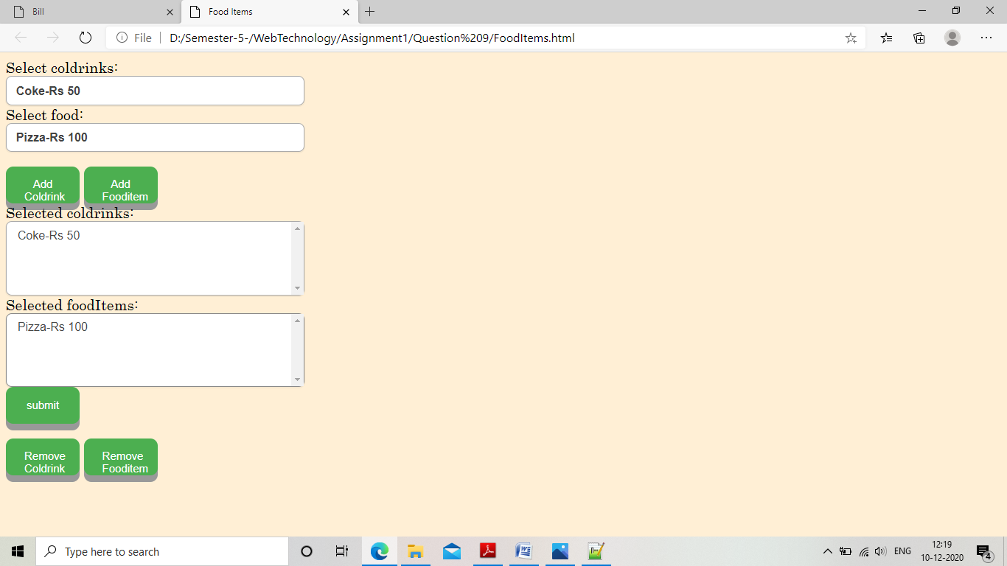

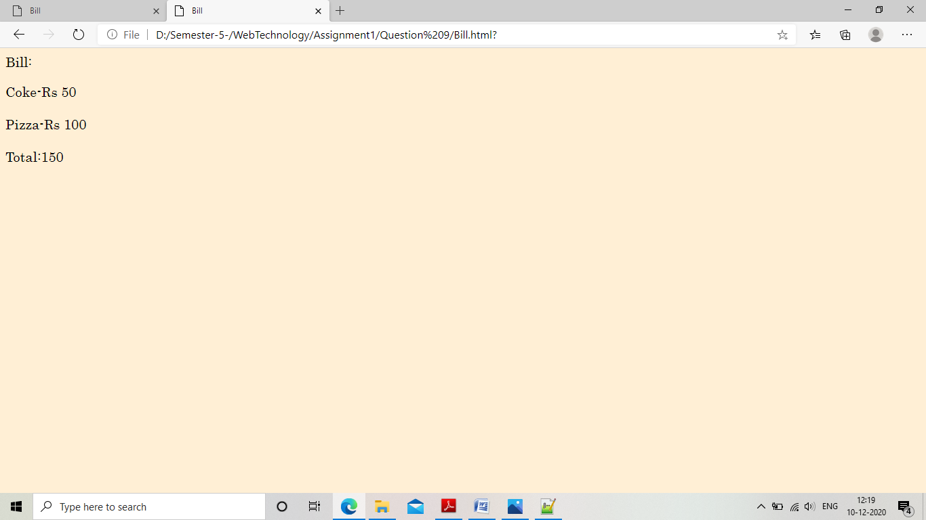

10. Display the current time and update it after every 1 sec.

“CurrentTime.html”

<html>

<head>

<title>

Displaying current time

</title>

</head>

<body>

1<h2><p align="center" id="time" style="font-family:Segoe Script;"></h2>

</p>

<script>

window.onload=function() {

getTime();

}

function getTime()

{

var today=new Date();

var hrs=today.getHours();

var min=today.getMinutes();

var sec=today.getSeconds();

min=formatDigits(min);

sec=formatDigits(sec);

document.getElementById("time").innerHTML=hrs+":"+min+":"+sec;

setInterval("getTime()",1000);

}

function formatDigits(digit)

{

if(digit<10){

digit="0"+digit;

}

return digit;

}

</script>

</body>

</html>

“Output”

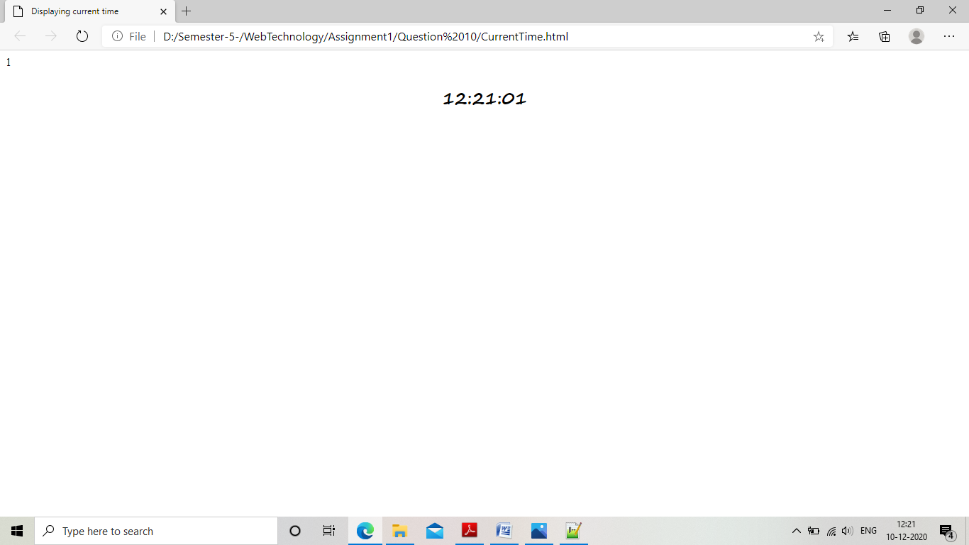

11.Display random quotes on button click.

“randomQuotes.html”

<html>

<head>

<title>

Image change

</title>

<link rel="stylesheet" href="Button.css">

<script language="jacvascript" type="text/javascript">

function changeQuote()

{

var number=Math.floor(Math.random() * 4);

var quoteSrc=["Anyone who has ever made anything of importance was disciplined.” — Andrew Hendrixson",

"“Don’t spend time beating on a wall, hoping to transform it into a door.” — Coco Chanel",

"“Creativity is intelligence having fun.” — Albert Einstein",

"“Optimism is the one quality more associated with success and happiness than any other.” — Brian Tracy",

" “Always keep your eyes open. Keep watching. Because whatever you see can inspire you.” — Grace Coddington"

];

document.getElementById("quotes").innerHTML=quoteSrc[number];

}

</script>

</head>

<body>

<p align="center" style="padding-top=100px;">

<div id="quotes">

“What you get by achieving your goals is not as important as what you become by achieving your goals.” — Henry David Thoreau

</div>

<button onclick="changeQuote()" class="button">Click to change Quote</button>

</p>

</body>

</html>

“Button.css”

body{

background-color:papayawhip;

font-family:Century;

text-align:center;

text-decoration:bold;

text-indent:left;

font-size:25px;

}

.button {

display: inline-block;

padding: 15px 25px;

font-size: 24px;

cursor: pointer;

text-align: center;

text-decoration: none;

outline: none;

color: #fff;

background-color: #4CAF50;

border: none;

border-radius: 15px;

box-shadow: 0 9px #999;

}

.button:hover {background-color: #3e8e41}

.button:active {

background-color: #3e8e41;

box-shadow: 0 5px #666;

transform: translateY(4px);

}

“Output”

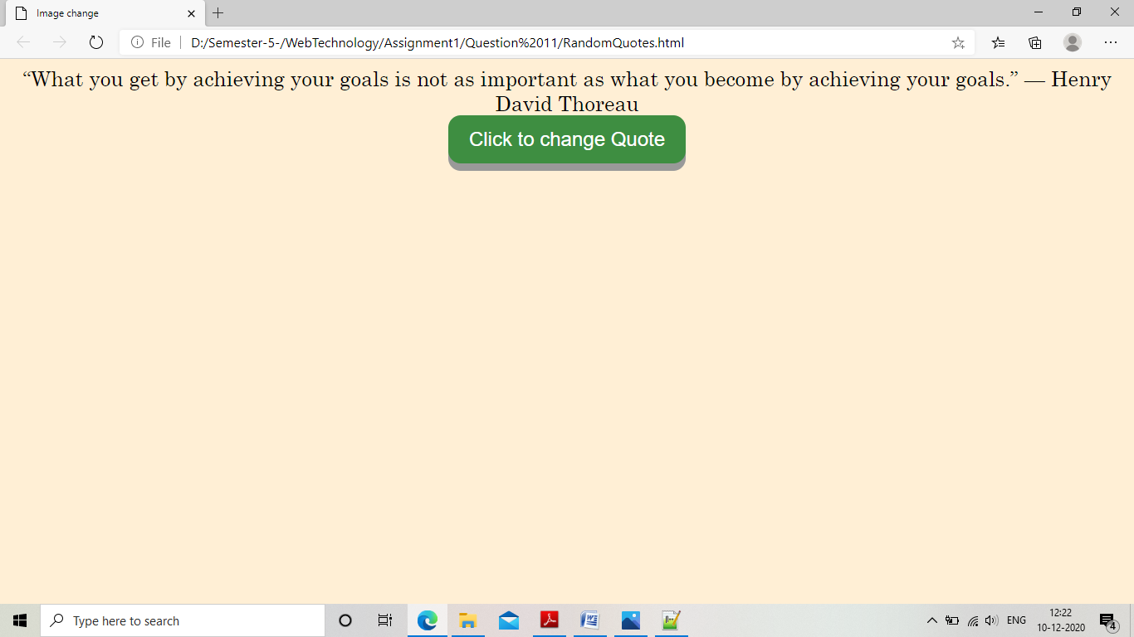

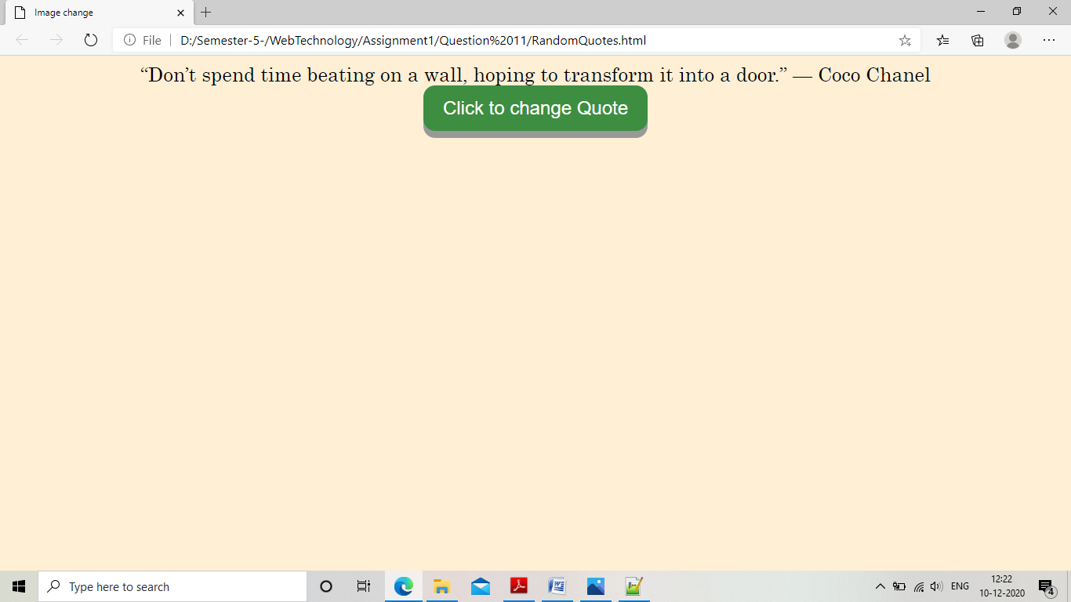

12. Add a new entry in combo box dynamically.

“Combox.html”

<html>

<head>

<title>

Moving items to list box!

</title>

<link rel="stylesheet" href="comboBox.css">

<script>

function moveToSelected()

{

var flag=0;

var items=document.getElementById("Fruits");

var element = document.getElementById("newElement").value;

for(var i=0;i<items.length;i++)

{

if(!element.toLowerCase().localeCompare((items.options[i].text).toLowerCase())){

flag=1;

break;

}

}

if(flag==0)

{

var option = document.createElement("option");

option.text =element;

document.getElementById("Fruits").add(option);

}

}

</script>

</head>

<body>

<div align="center">

<form>

<label>Enter fruit which you want to add:</label><input type="text" id="newElement">

</form>

<button class="button" id="button1" onclick="moveToSelected()">Add</button><br><br>

<form>

<select id="Fruits" class="myselect">

<option>Apple</option>

<option>Pear</option>

<option>Banana</option>

<option>Orange</option>

</select>

</form>

</div>

</body>

</html>

“combobox.css”

body{

background-color:papayawhip;

font-family:Century;

text-align:center;

text-decoration:bold;

text-indent:left;

font-size:25px;

}

.myselect {

display: block;

font-size: 16px;

font-family: sans-serif;

font-weight: 700;

color: #444;

line-height: 1.3;

padding: .6em 1.4em .5em .8em;

width: 30%;

max-width: 100%; /* useful when width is set to anything other than 100% */

box-sizing: border-box;

margin: 0;

border: 1px solid #aaa;

box-shadow: 0 1px 0 1px rgba(0,0,0,.04);

border-radius: .5em;

-moz-appearance: none;

-webkit-appearance: none;

appearance: none;

background-color: #fff;

}

.myselect::-ms-expand {

display: none;

}

.myselect:hover {

border-color: #888;

}

/* Focus style */

.button {

display: inline-block;

padding: 15px 25px;

font-size: 24px;

cursor: pointer;

text-align: center;

text-decoration: none;

outline: none;

color: #fff;

background-color: #4CAF50;

border: none;

border-radius: 15px;

box-shadow: 0 9px #999;

}

.button:hover {background-color: #3e8e41}

.button:active {

background-color: #3e8e41;

box-shadow: 0 5px #666;

transform: translateY(4px);

}

input[type=text]{

border-radius:4px;

box-sizing:border-box;

height:30px;

}

.select {

display: block;

font-size: 16px;

font-family: sans-serif;

font-weight: 700;

color: #444;

line-height: 1.3;

padding: .6em 1.4em .5em .8em;

width: 100%;

max-width: 100%;

box-sizing: border-box;

margin: 0;

border: 1px solid #aaa;

box-shadow: 0 1px 0 1px rgba(0,0,0,.04);

border-radius: .5em;

appearance: none;

background-color: #fff;

}

“Output”

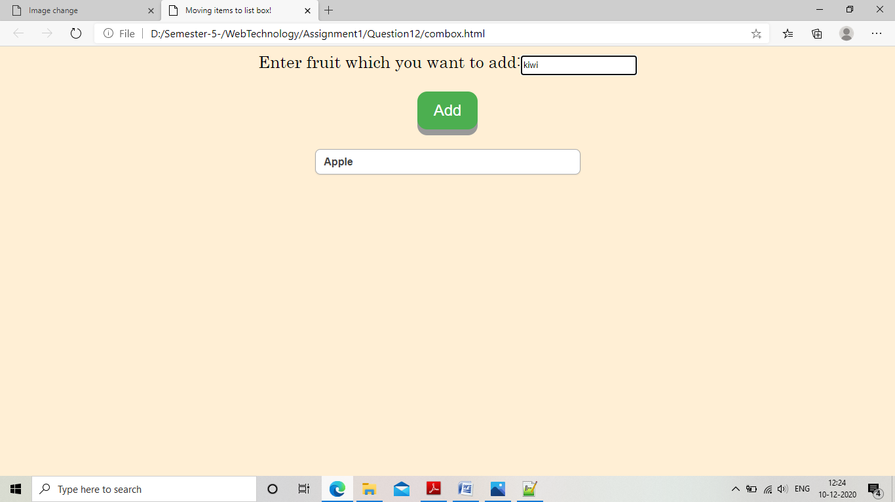

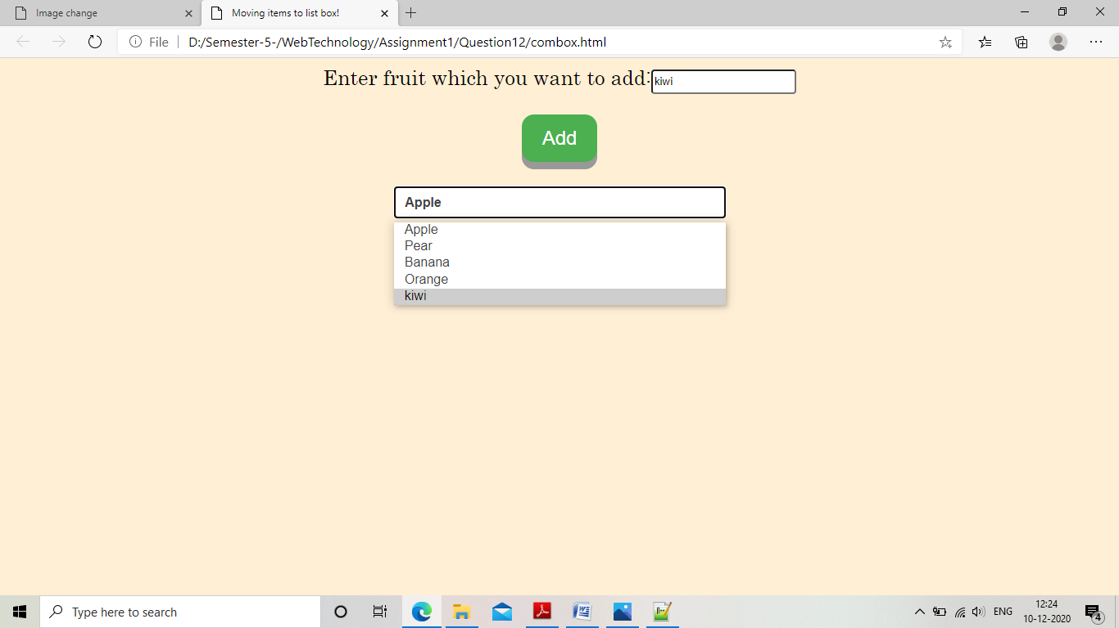

**Assignment-2**

1. Create a JSP file which will display current date and time

“Question1.jsp”

<%@page import="java.util.Date" %>

<html>

<head>

<title>

Current date and Time

</title>

</head>

<body>

<h2><p align="center">Current date and time:<br />

<%

Date today = new Date();

out.println(today.toString());

%>

</body>

<html>

“Output”

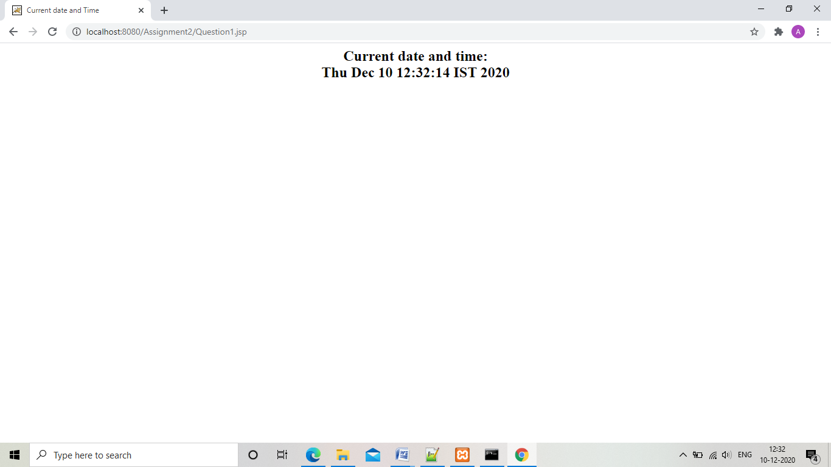

1. Create a JSP page for taking at least three parameters from user and display the details in same page

“Question2Form.html”

<html>

<head>

<title>

User Input

</title>

</head>

<body>

<h2><p align="center">

<form action="Question2.jsp" method="post">

<label>Enter parameter1:</label>

<input type="text" name="Parameter1" required><br /><br />

<label>Enter parameter2:</label>

<input type="text" name="Parameter2" required><br /><br />

<label>Enter parameter2:</label>

<input type="text" name="Parameter3" required><br /><br />

<input type="submit" value="submit">

<input type="reset" value="reset">

</form>

</body>

<html>

“Question2.jsp”

<html>

<head>

<title>

User paramters

</title>

</head>

<body>

<h2><p align="center">User parameters<br />

<%

out.println("Parameter1:"+request.getParameter("Parameter1"));

%><br />

<%

out.println("Parameter2:"+request.getParameter("Parameter2"));

%><br />

<%

out.println("Paramater3:"+request.getParameter("Parameter3"));

%><br />

</p>

</body>

<html>

“Output”

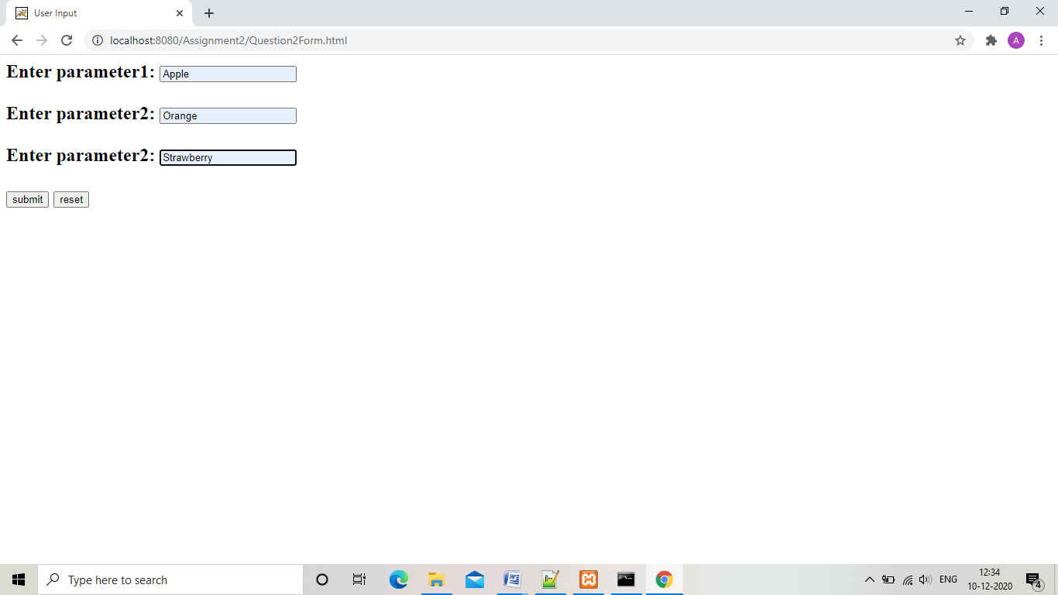

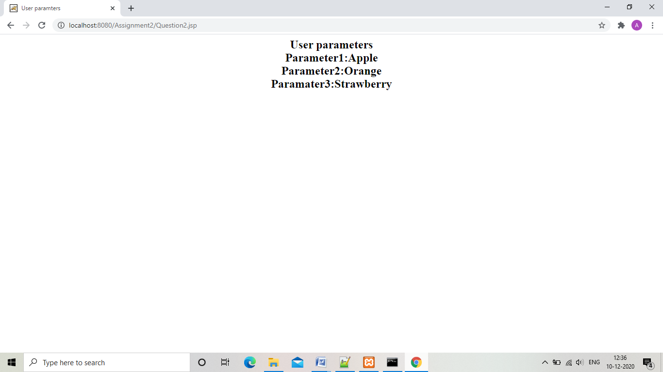

3.Create a jsp page that will take from user . If no parameter is supplied then print “hello world!”

“Question3Form.htmt”

<html>

<head>

<title>

User Input

</title>

</head>

<body>

<h2><p align="center">

<form action="Question3.jsp" method="post">

<label>Enter name:</label>

<input type="text" name="name" ><br /><br />

<input type="submit" value="submit">

<input type="reset" value="reset">

</form>

</body>

<html>

“Question3.jsp”

<html>

<head>

<title>

Welcome User

</title>

</head>

<body>

<h2><p align="center">Welcome User<br />

<%

String name = request.getParameter("name");

if(name.equals(""))

out.println("Hello world!");

else

out.println("Hello "+name);

%>

</p>

</body>

<html>

“Output”

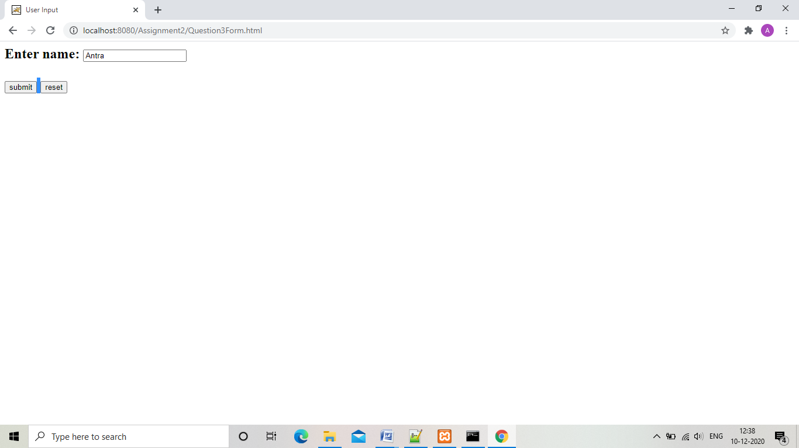

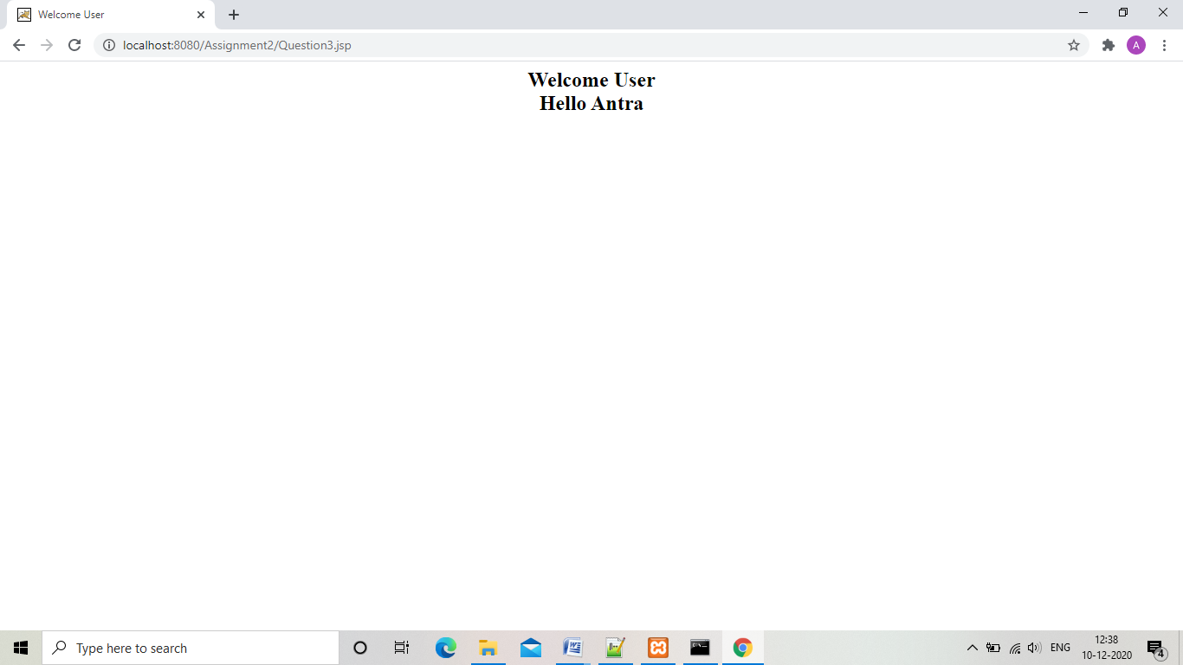

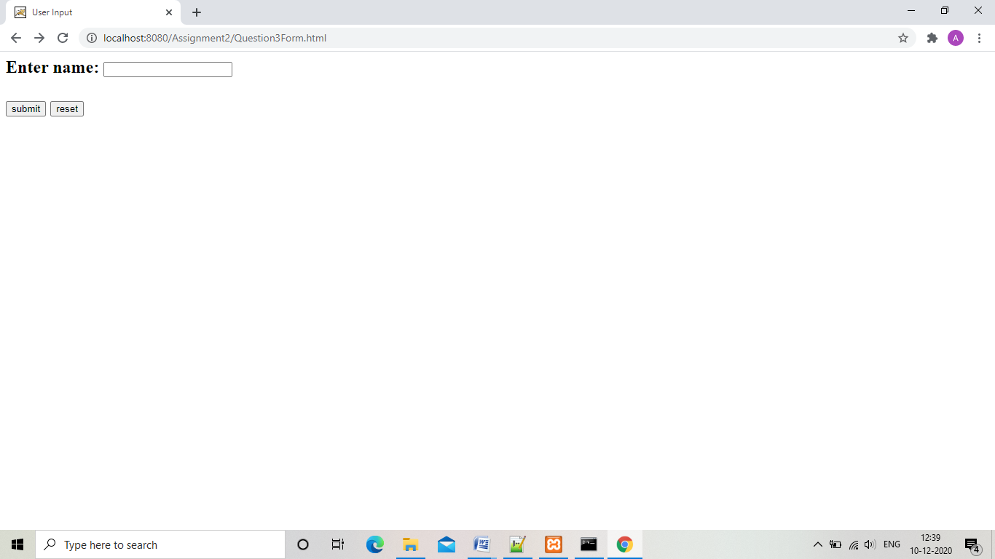

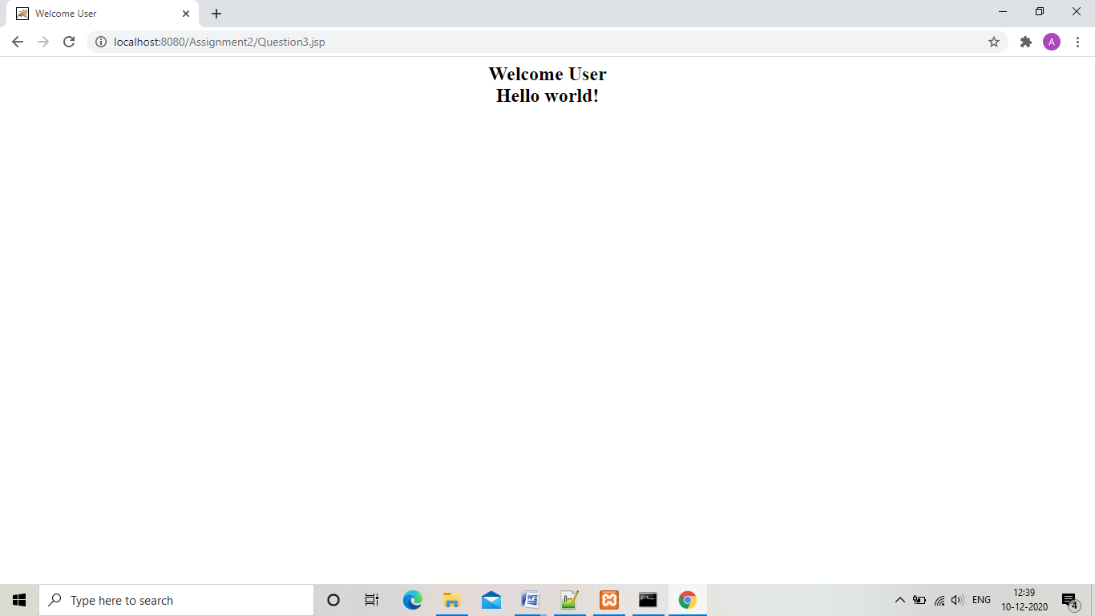

1. Create a JSP file which will take bgcolor as parameter from user and if none is passed then bgcolor will be set as RED

“Question4Form.html”

<html>

<head>

<title>

User Input

</title>

</head>

<body>

<h2><p align="center">

<form action="Question4.jsp" method="post">

<label>Enter color:</label>

<input type="text" name="color" ><br /><br />

<input type="submit" value="submit">

<input type="reset" value="reset">

</form>

</body>

<html>

“Question4.jsp”

<html>

<head>

<title>

Change Background color

</title>

</head>

<%

String color = request.getParameter("color");

if(color.equals(""))

color="red";

%>

<body bgcolor="<%= color %>">

<p>Background color =<% out.print(color);%>

</body>

<html>

“Output”

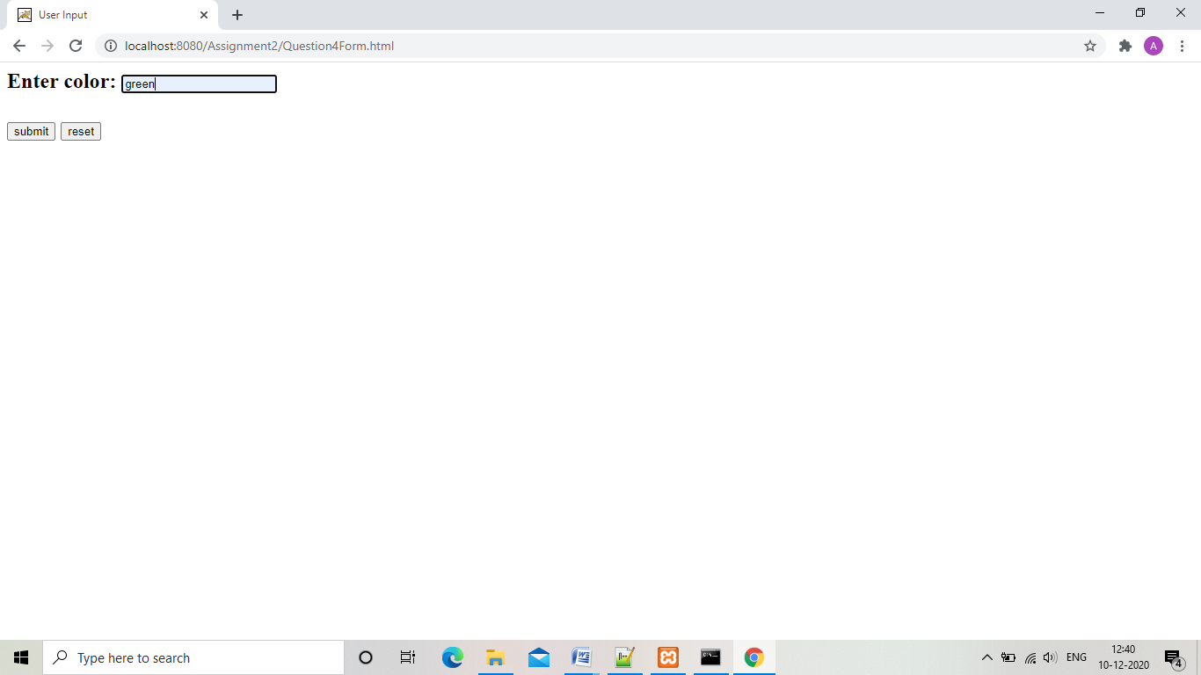

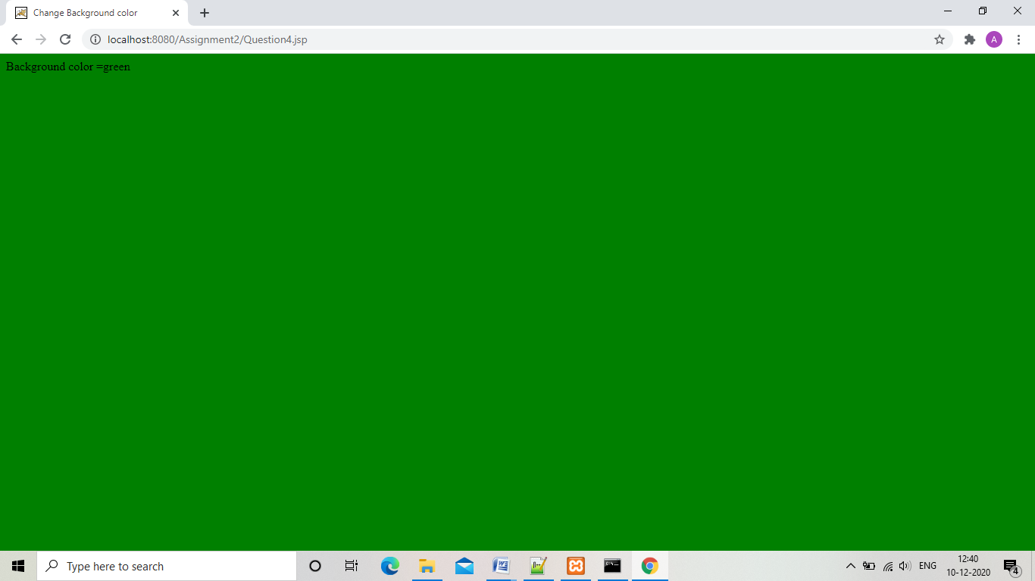

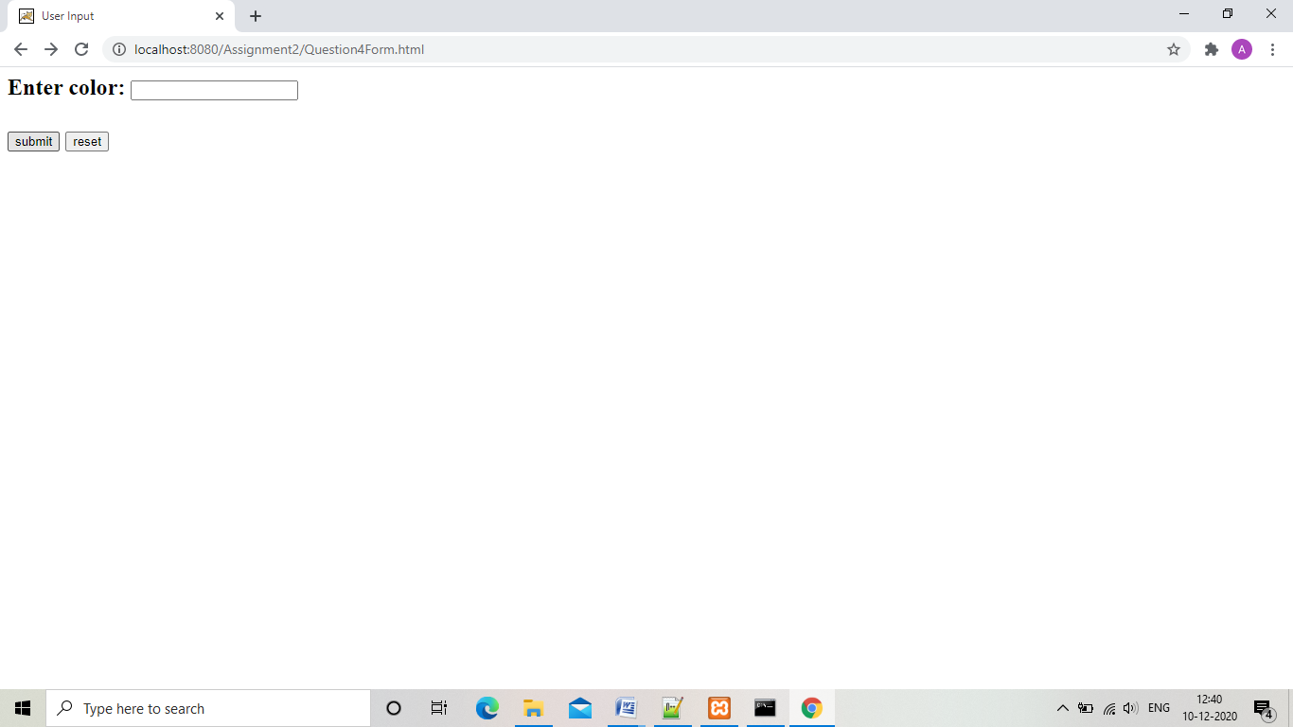

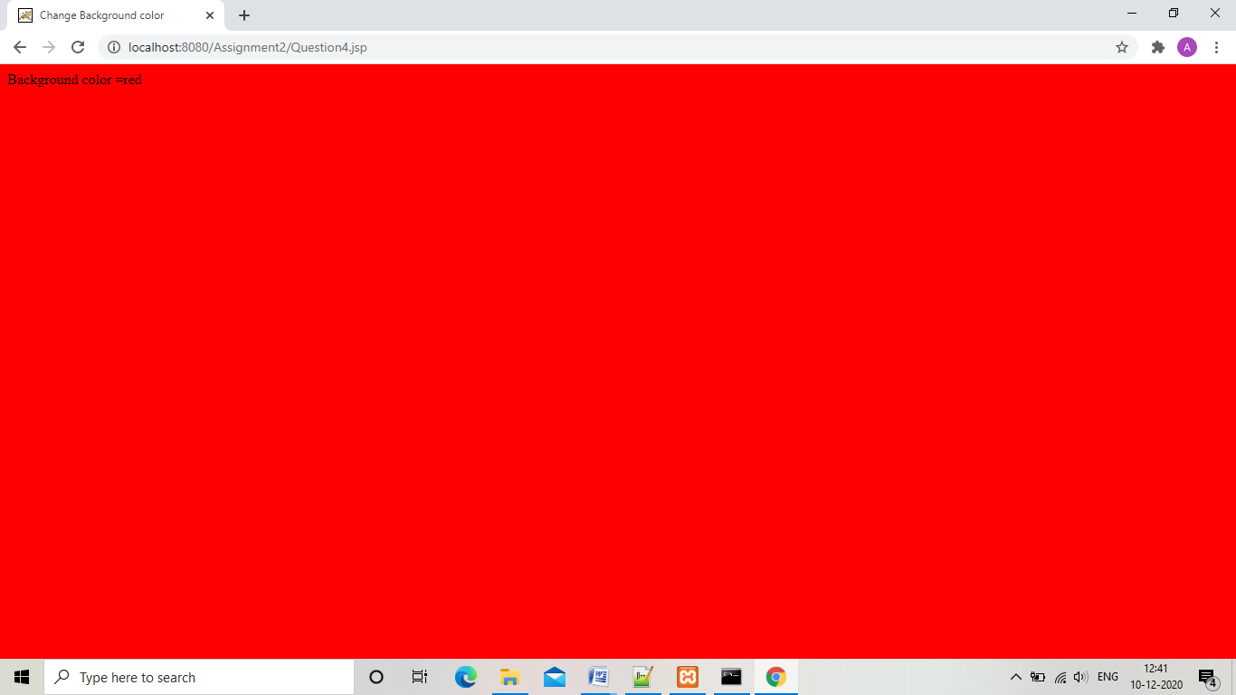

1. Write a jsp page which will print the numbe =r of times a current page has been accessed.

“Question5.jsp”

<html>

<head>

<title>

Hit count

</title>

</head>

<body>

<%

Integer hit_counter = (Integer)application.getAttribute("hitCount");

if(hit_counter==null || hit_counter==0){

out.println("First time visit.Welcome!");

hit_counter=1;

}

else

{

hit_counter+=1;

}

application.setAttribute("hitCount",hit_counter);

%>

<h2 align="center">Total number of visits:<% out.print(hit_counter);%>

</body>

</html>

“Output”

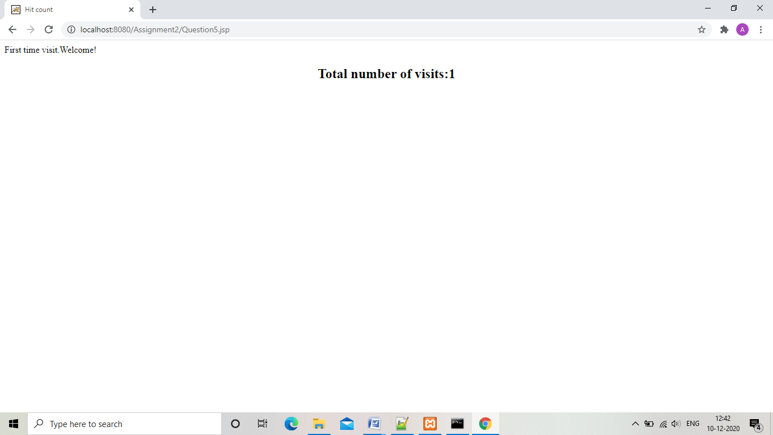

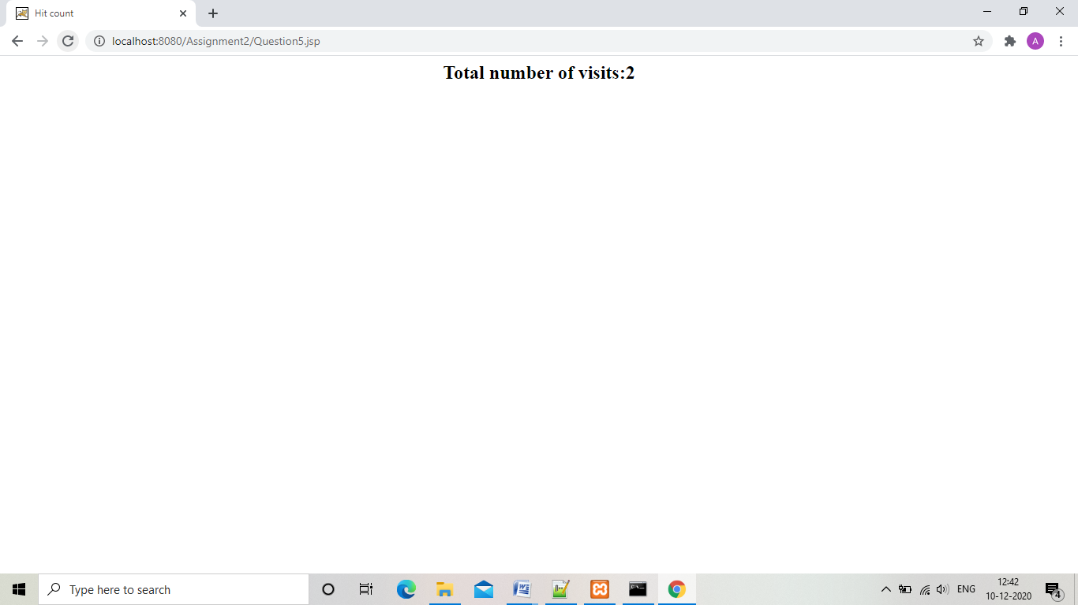

6.Create a method that will print the addition of two numbers .

“Question6.jsp”

<html>

<head>

<title>

User paramters

</title>

</head>

<body>

<h2><p align="center">Sum of 34 and 56 is:<br />

<%!

int sum(int number1,int number2)

{

return number1+number2;

}

%>

<%

out.println(sum(34,56));

%><br />

</p>

</body>

<html>

“Output”

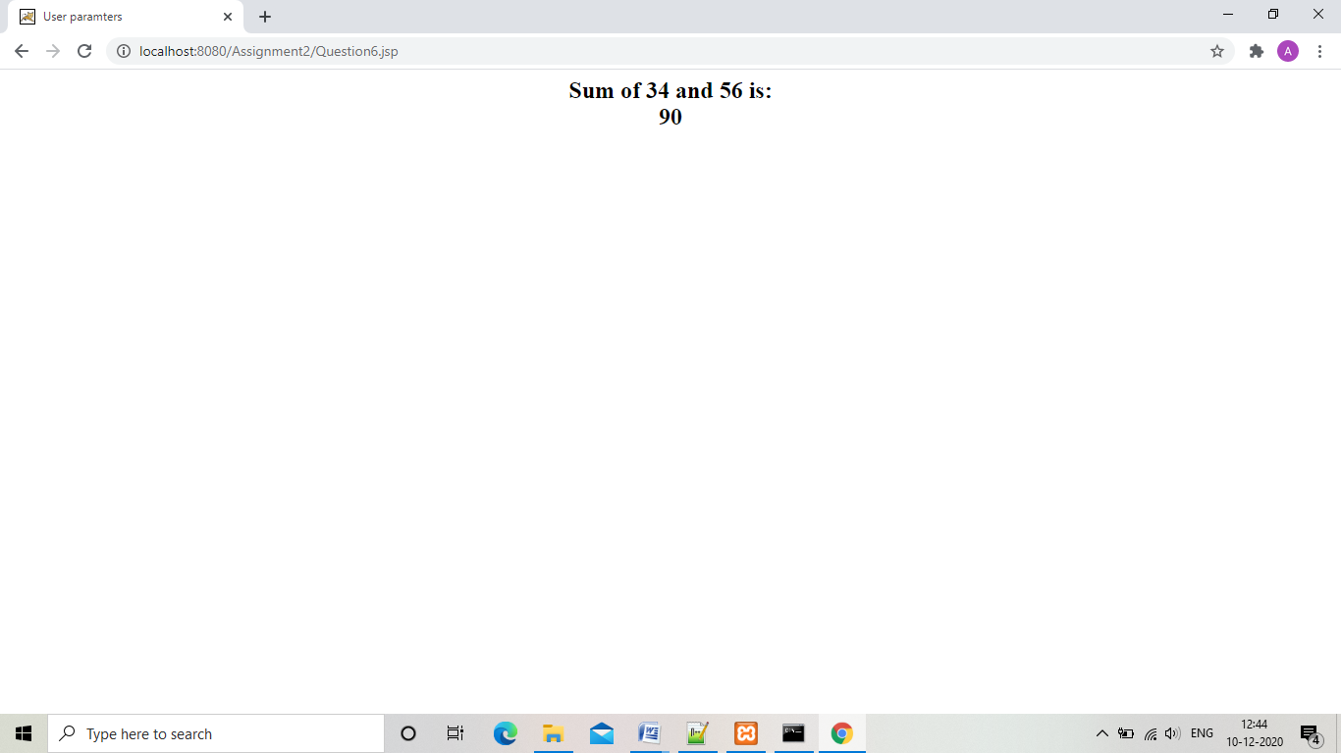

7. Allow the user to enter the name in the textbox and when he click on submit button, print the user name and send the data using GET method. If user click on submit without UserName then ask the user to enter it

“Question7Form.html”

<html>

<head>

<title>

User Input

</title>

</head>

<body>

<h2><p align="center">

<form action="Question7.jsp" method="get">

<label>Enter name:</label>

<input type="text" name="name" ><br /><br />

<input type="submit" value="submit">

<input type="reset" value="reset">

</form>

</body>

<html>

“Question7.jsp”

<html>

<head>

<title>

Welcome User

</title>

</head>

<body>

<h2><p align="center">Welcome User<br />

<%

String name = request.getParameter("name");

if(name.equals(""))

{

out.println("You need to enter your name in textbox:");

%>

<%@ include file="Question7Form.html" %>

<%

}

else

out.println("Hello "+name);

%>

</p>

</body>

<html>

“Output”

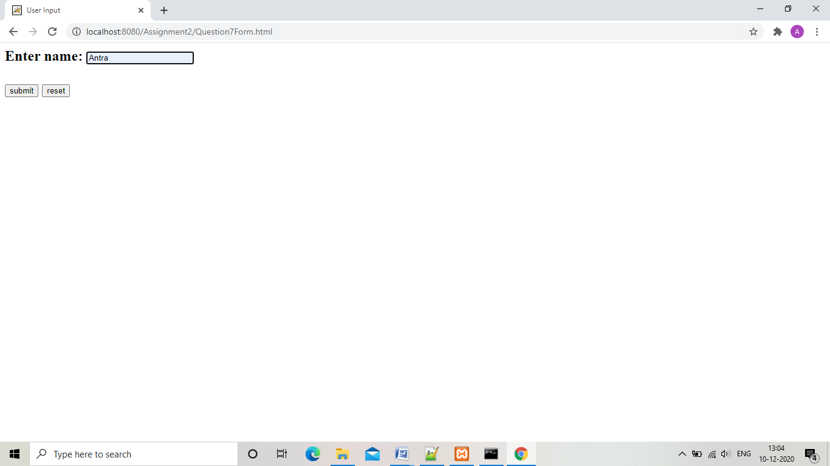

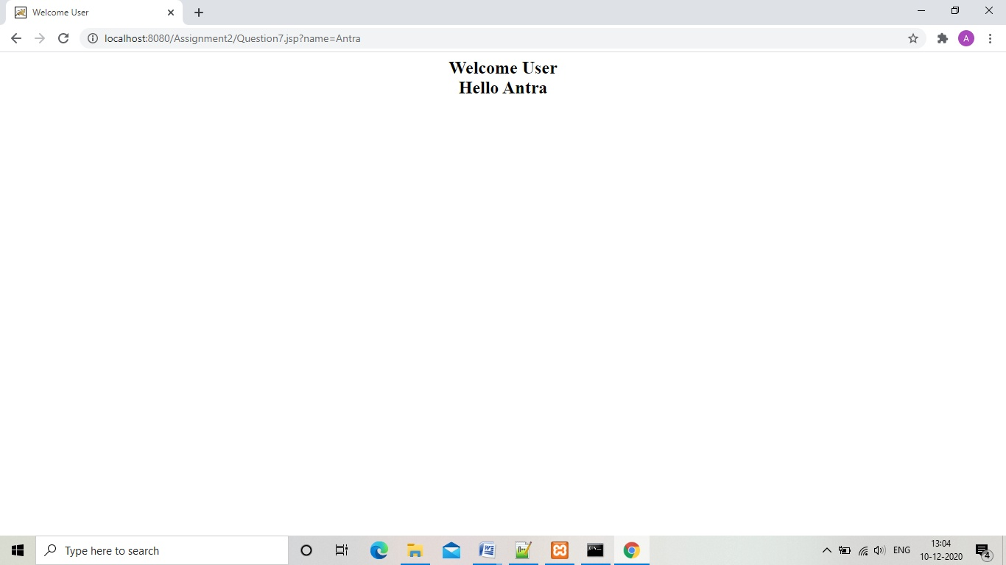

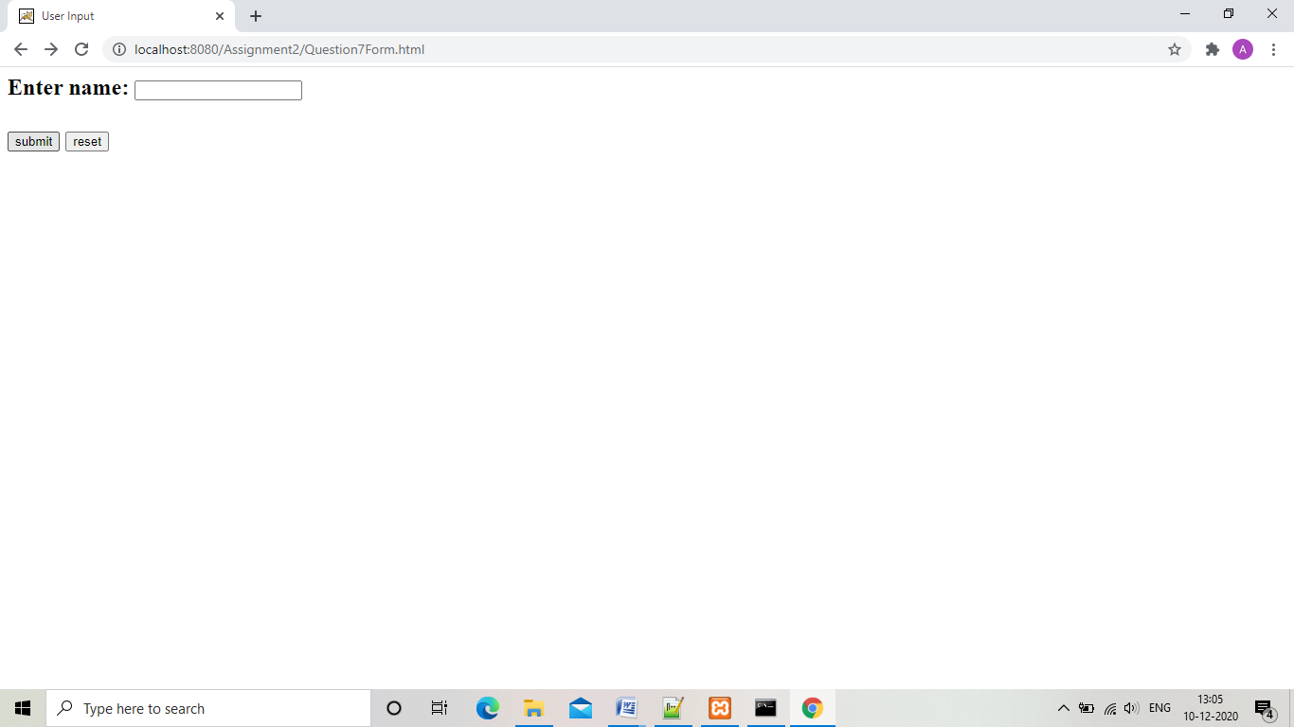

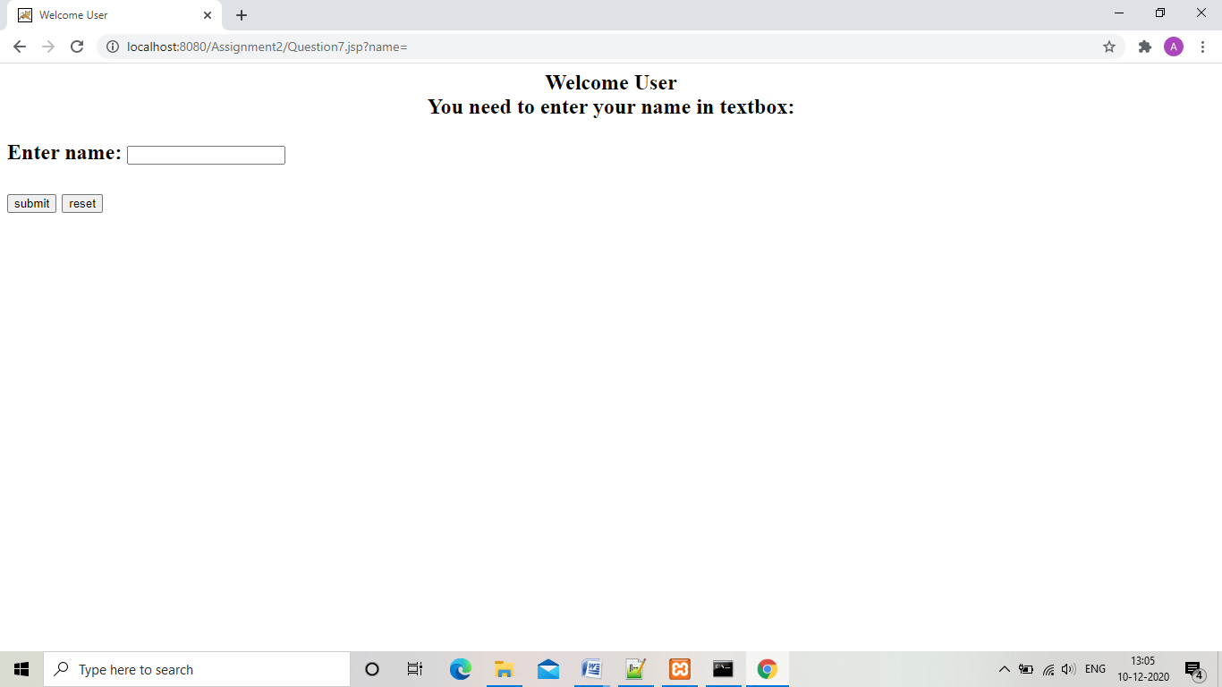

8.Execute the above program with “post”

“Question8Form.html”

<html>

<head>

<title>

User Input

</title>

</head>

<body>

<h2><p align="center">

<form action="Question8.jsp" method="post">

<label>Enter name:</label>

<input type="text" name="name" ><br /><br />

<input type="submit" value="submit">

<input type="reset" value="reset">

</form>

</body>

<html>

“Question8.jsp”

<html>

<head>

<title>

Welcome User

</title>

</head>

<body>

<h2><p align="center">Welcome User<br />

<%

String name = request.getParameter("name");

if(name.equals(""))

{

out.println("You need to enter your name in textbox:");

%>

<%@ include file="Question8Form.html" %>

<%

}

else

out.println("Hello "+name);

%>

</p>

</body>

<html>

“Output”

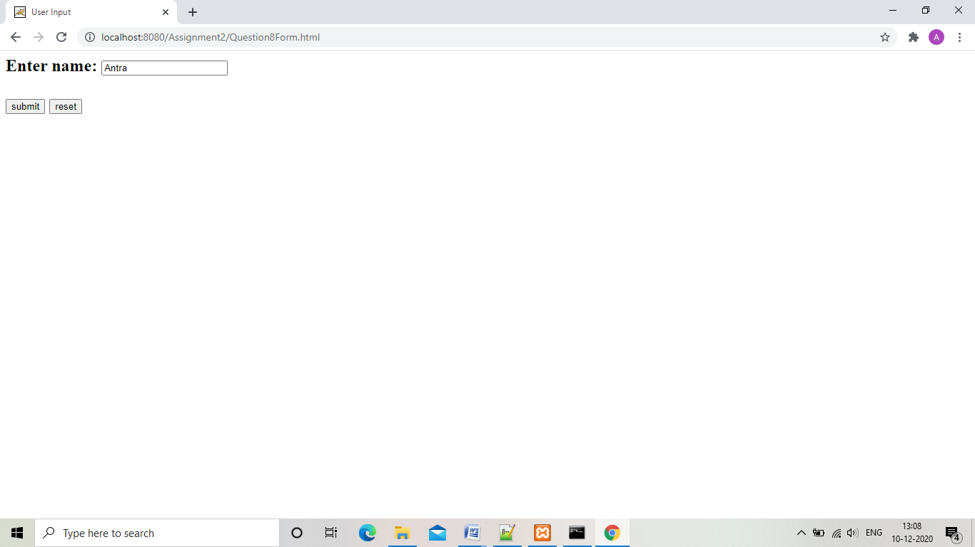

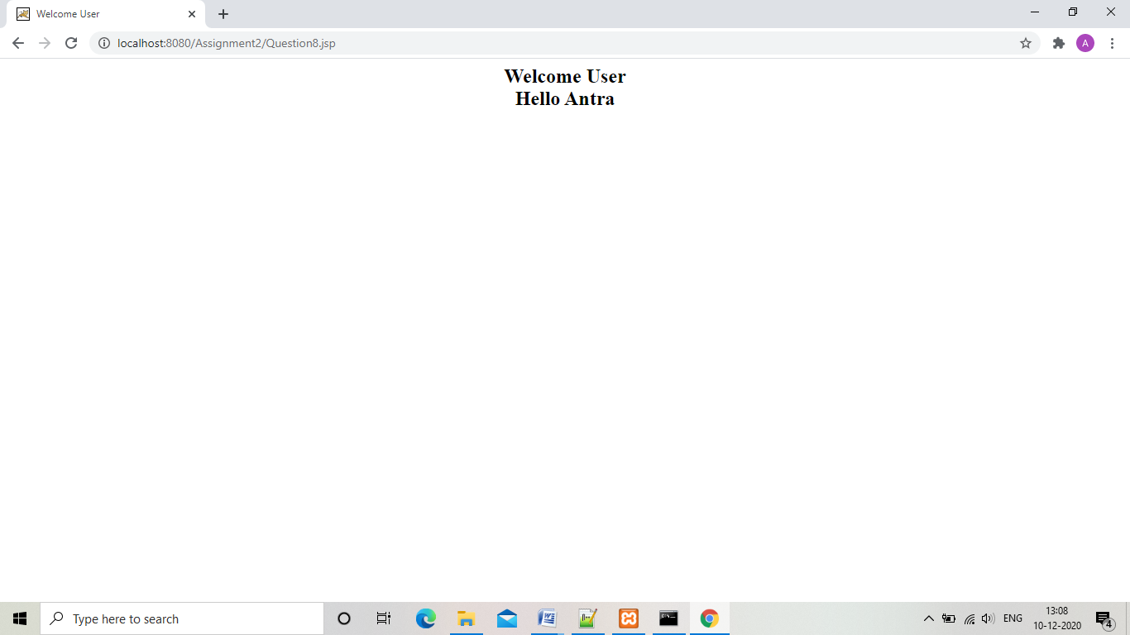

9. Make a JSP page that lets the user supply a request parameter indicating the back-ground color. If no parameter is supplied, a background color should be selected at random.

“Question9Form.html”

<html>

<head>

<title>

User Input

</title>

</head>

<body>

<h2><p align="center">

<form action="Question9.jsp" method="post">

<label>Enter color:</label>

<input type="text" name="color" ><br /><br />

<input type="submit" value="submit">

<input type="reset" value="reset">

</form>

</body>

<html>

“Question9.jsp”

<%@ page import="java.util.Random" %>

<html>

<head>

<title>

Change Background color

</title>

</head>

<%

String color = request.getParameter("color");

if(color.equals(""))

{

Random random = new Random();

String[] colors={"AliceBlue","light salmon","AntiqueWhite","Beige"};

int i = random.nextInt(4);

color=colors[i];

}

%>

<body bgcolor="<%= color %>">

<p>Background color =<% out.print(color);%>

</body>

<html>

“Output”

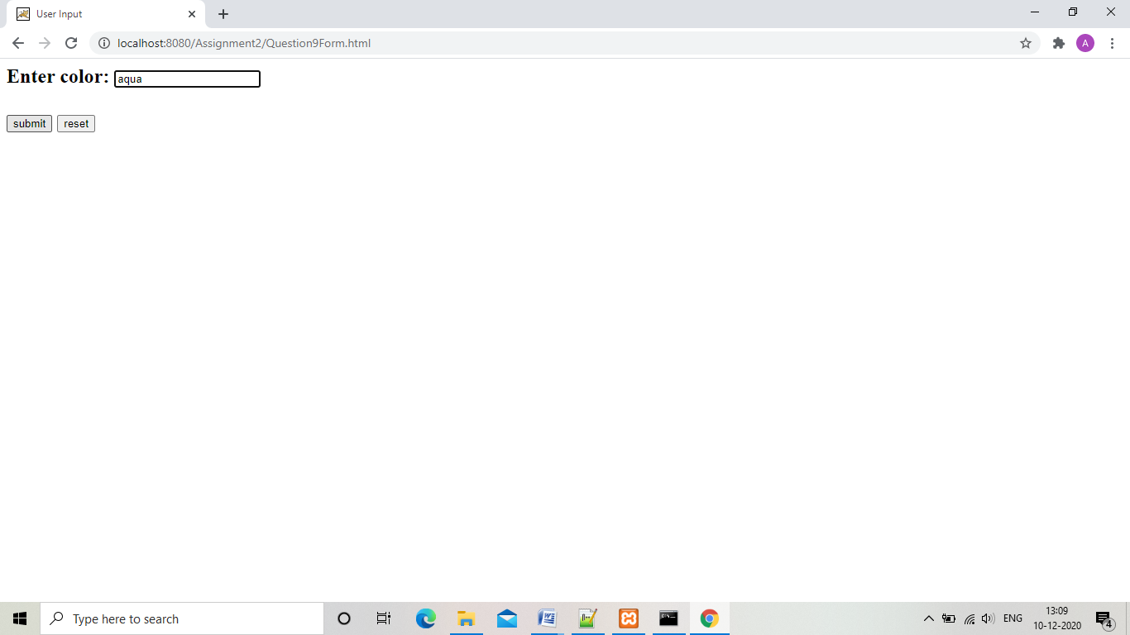

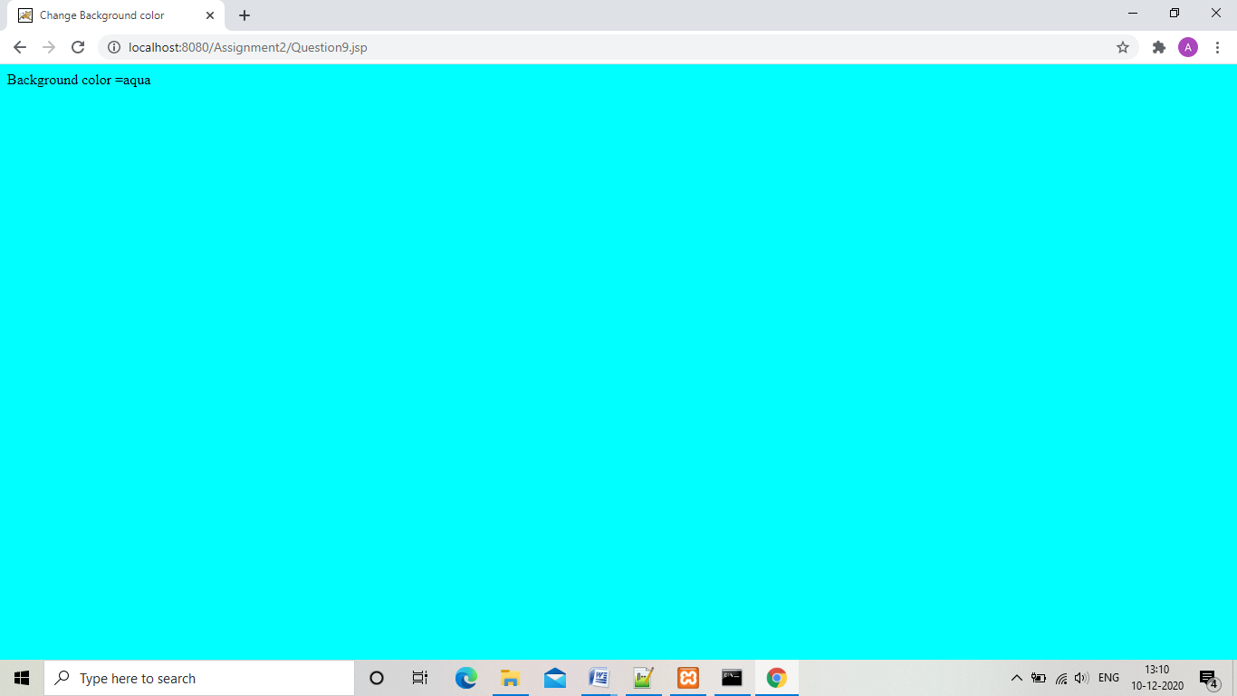

1. Wrtite a jsp page to greet user randomly.

“Question10.jsp”

<%@ page import="java.util.Date" %>

<html>

<head>

<title>

Welcome User

</title>

</head>

<body>

<h2><p align="center">

<%

Date today = new Date();

int hour = today.getHours();

if(hour<=12){

out.print("Good morning!");

}

else if(hour>12 && hour<=17){

out.print("Good afternoon!");

}

else if(hour>17 && hour<=23){

out.print("Good evening!");

}

%>

</p>

</body>

<html>

“Output”

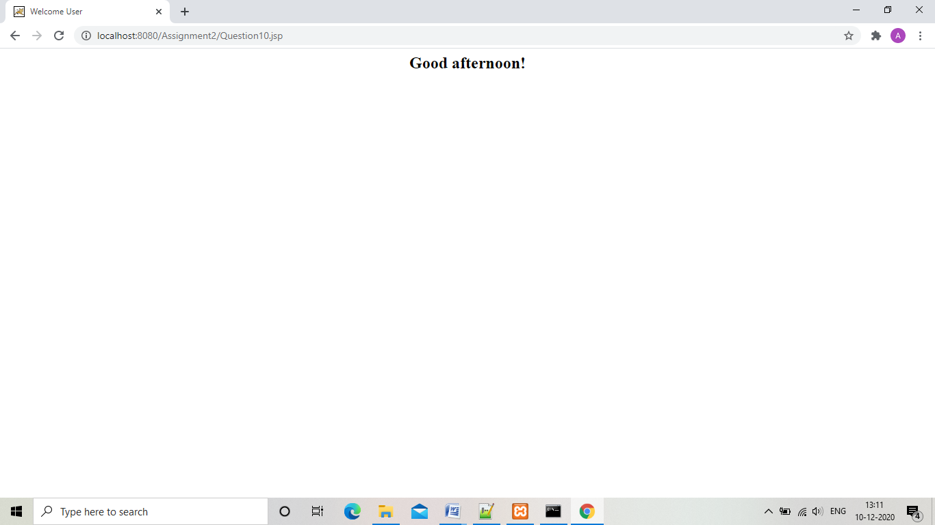

1. Create an application which will show any random number between 1 and 10 (Make proper use of import tag)

“Question11.jsp”

<%@ page import="java.util.Random" %>

<html>

<head>

<title>

Change Background color

</title>

</head>

<body>

<%

Random random = new Random();

int i = random.nextInt(500);

%>

<p>Random number generated is : =<% out.print(i);%>

</body>

<html>

“Output”

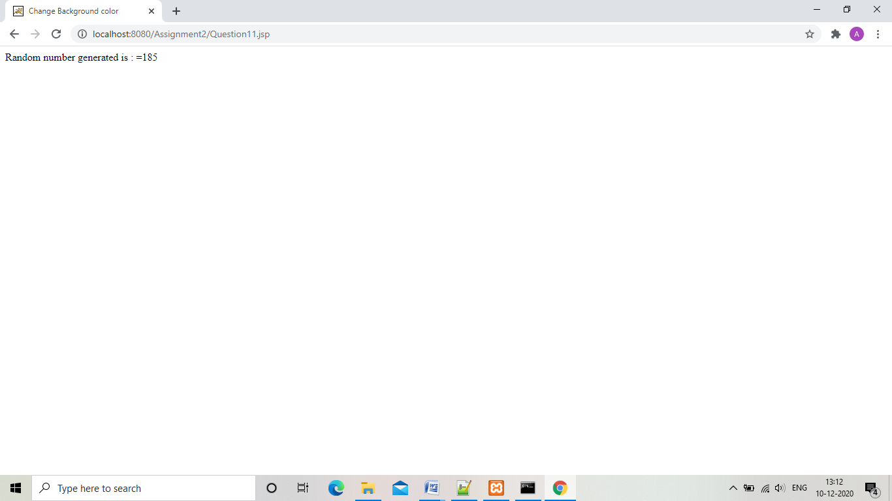

1. Create a JSP file which will take number from the user in textbox and divide the number by 5 .If any error occurs display a proper error page.

“Question12Form.html”

<html>

<head>

<title>

User Input

</title>

</head>

<body>

<h2><p align="center">

<form action="Question12.jsp" method="post">

<label>Enter Number:</label>

<input type="text" name="number" ><br /><br />

<input type="submit" value="submit">

<input type="reset" value="reset">

</form>

</body>

<html>

“Question12.jsp”

<%@ page errorPage="ErrorPage12.jsp" %>

<html>

<head>

<title>

Divide by 5

</title>

</head>

<body>

<%

int number=Integer.parseInt((String)request.getParameter("number"));

out.println(number/5);

%>

<p>

</body>

<html>

“ErrorPage12.jsp”

<%@ page isErrorPage="true" %>

<html>

<head>

<title>

Divide by 5

</title>

</head>

<body>

<h2>Sorry there was an error!

<p>

</body>

<html>

“Output”

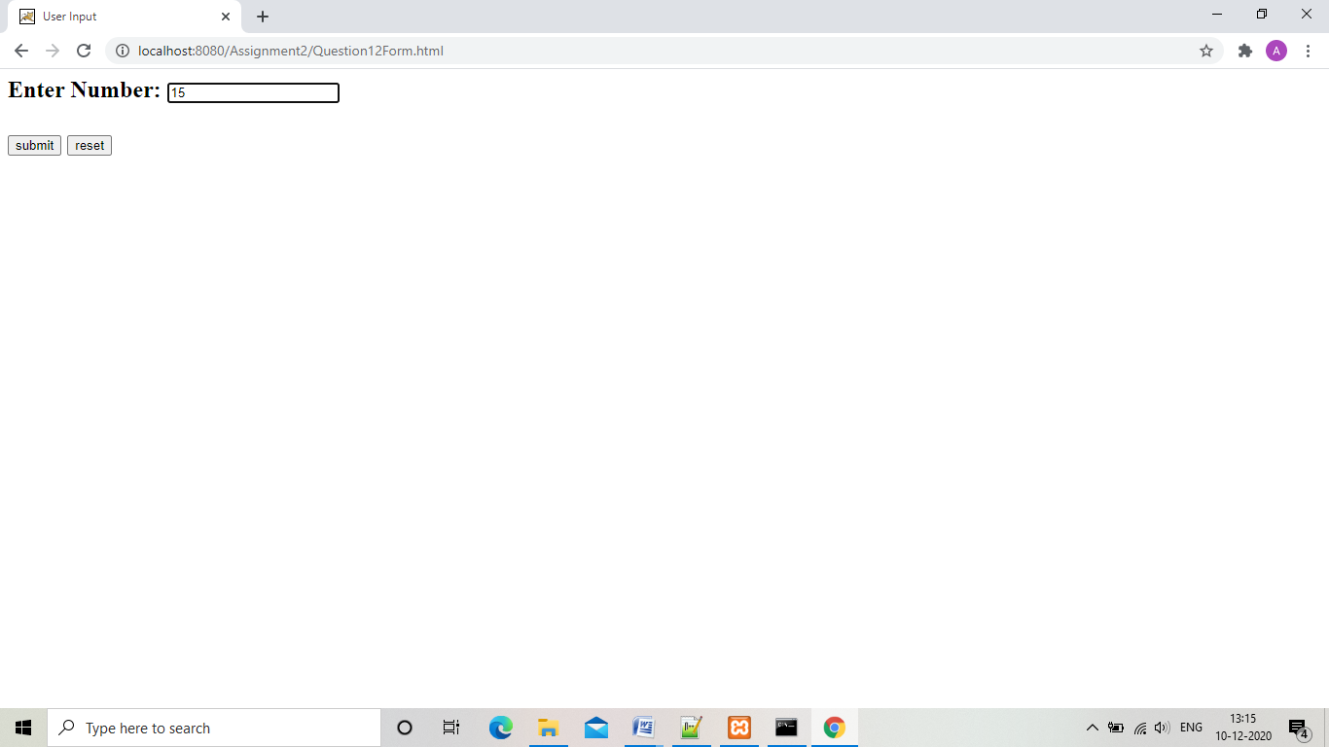

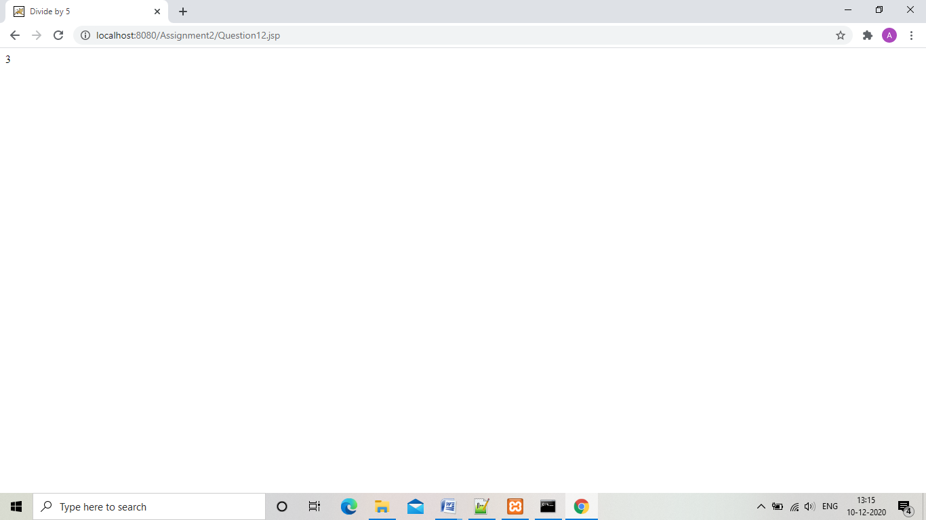

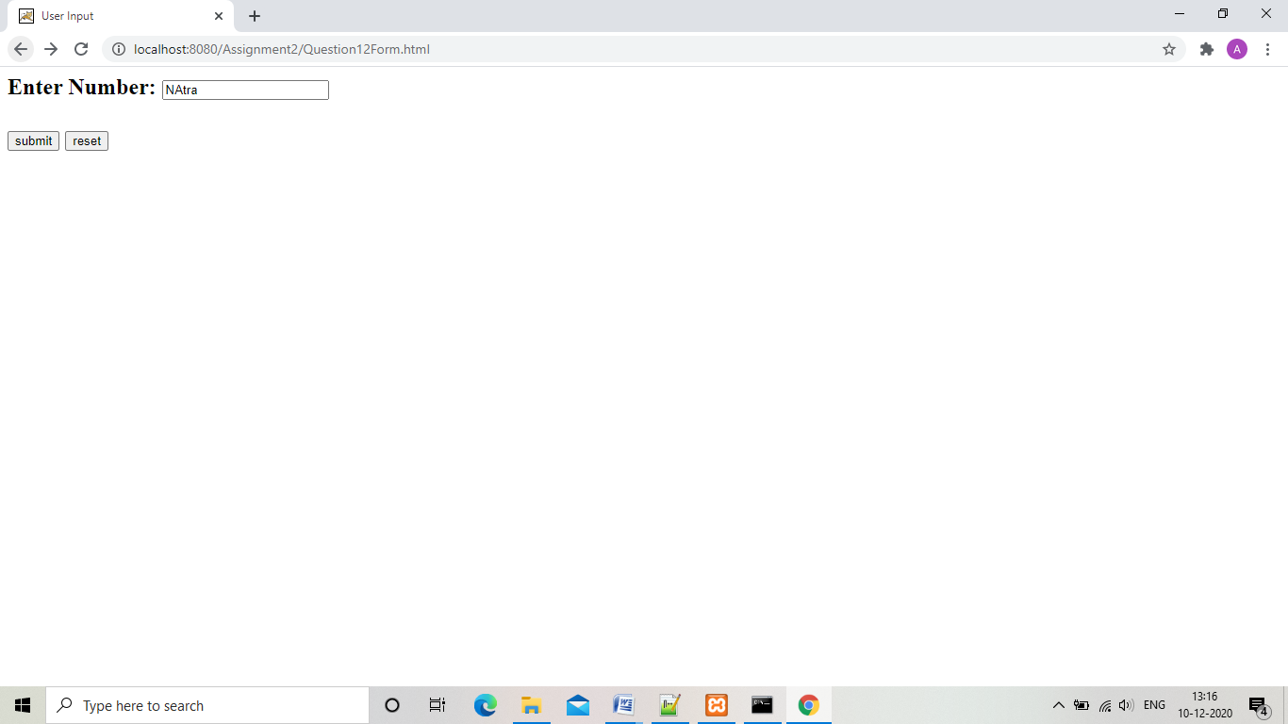

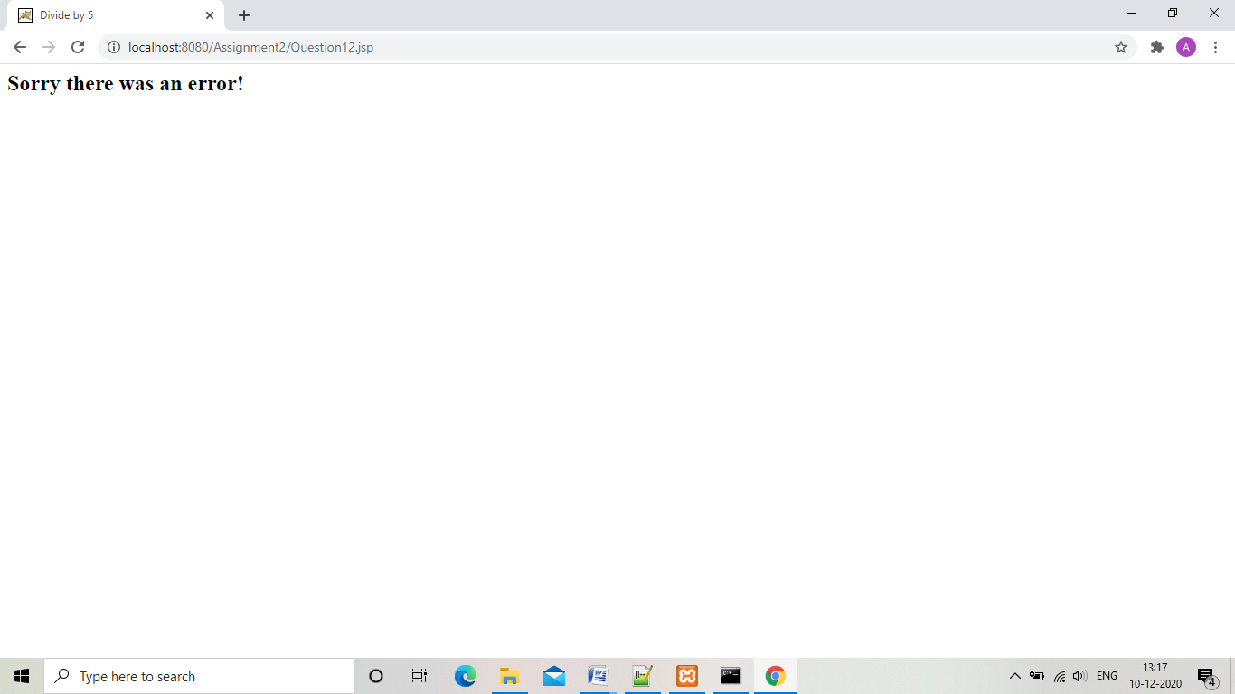

1. Generate 10 random number in the range of 1-10 and print it in the first column of table.If the number generated is even the second column should display-Even Number else Odd number.

“Question13.jsp”

<%@ page contentType="application/vnd.ms-excel" import="java.util.Random" %>

<%!

Random random = new Random();

boolean check(int number){

if(number % 2 == 0)

return true;

else

return false;

}

%>

<%

for(int i =0;i<10;i++){

int number = random.nextInt(10);

if(check(number)){

out.println(number+"\t"+"Even Number");

}

else{

out.println(number+"\t"+"Odd Number");

}

}

%>

“Output”

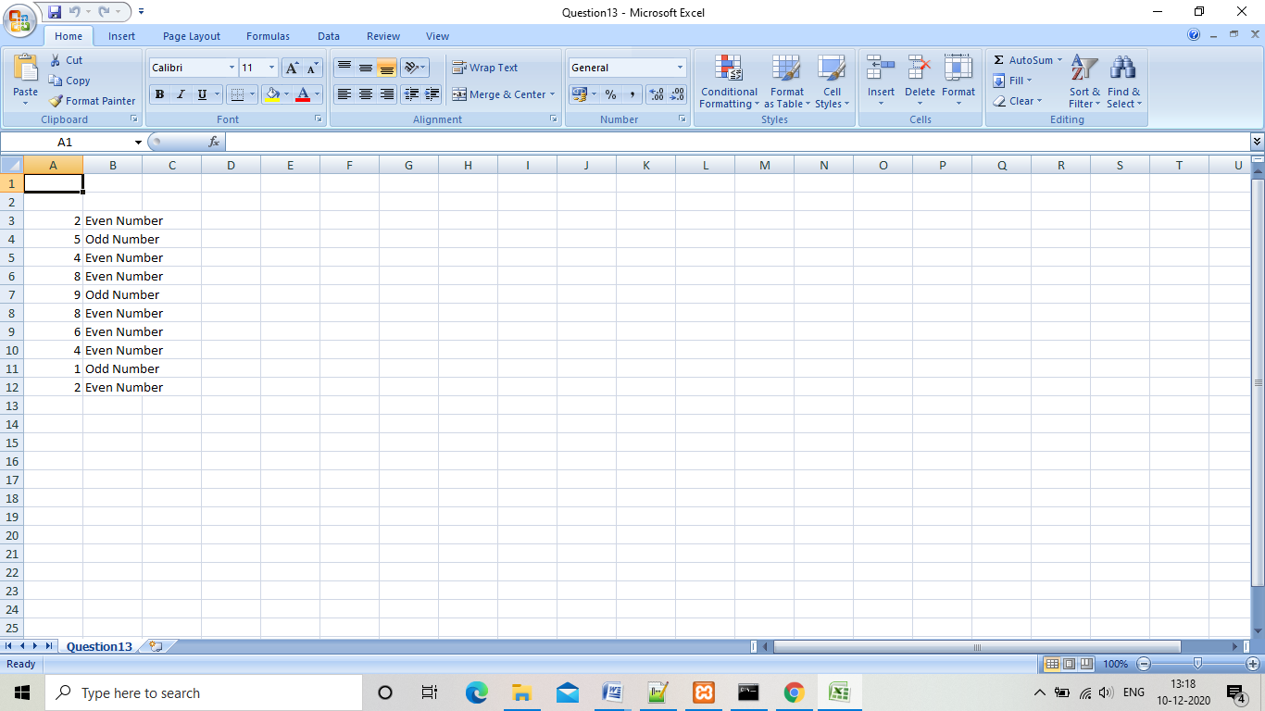

1. Create an application that displays the count of number of times any of the page has been accessed by the user. Make atleast 4 different JSP pages.If the user enter the URL of any jsp page for the first time It shows the message-“Welcome You have visited this page for the first time” and next time when user enter the same URL it show the message showing no.of times this JSP page has been visited.

“Question14HomePage.jsp”

<html>

<head>

<title>

Home Page

</title>

</head>

<body>

<%

Integer hit_counter = (Integer)application.getAttribute("HomePage");

if(hit_counter==null || hit_counter==0){

out.println("First time visit.Welcome!");

hit_counter=1;

}

else

{

hit_counter+=1;

}

application.setAttribute("HomePage",hit_counter);

%>

<center><h2>Number of visits:<% out.println(hit_counter); %>

<a href="Question14Page2.jsp">Go to Page2</a>

</body>

</html>

“Question14Page2.jsp”

<html>

<head>

<title>

Home Page

</title>

</head>

<body>

<%

Integer hit_counter = (Integer)application.getAttribute("Page2");

if(hit_counter==null || hit_counter==0){

out.println("First time visit.Welcome!");

hit_counter=1;

}

else

{

hit_counter+=1;

}

application.setAttribute("Page2",hit_counter);

%>

<center><h2>Number of visits:<% out.println(hit_counter); %>

<a href="Question14Page3.jsp">Go to Page3</a>

</body>

</html>

“Question14Page3.jsp”

<html>

<head>

<title>

Home Page

</title>

</head>

<body>

<%

Integer hit_counter = (Integer)application.getAttribute("Page3");

if(hit_counter==null || hit_counter==0){

out.println("First time visit.Welcome!");

hit_counter=1;

}

else

{

hit_counter+=1;

}

application.setAttribute("Page3",hit_counter);

%>

<center><h2>Number of visits:<% out.println(hit_counter); %>

<a href="Question14Page4.jsp">Go to Page4</a>

</body>

</html>

“Question14Page4.jsp”

<html>

<head>

<title>

Home Page

</title>

</head>

<body>

<%

Integer hit_counter = (Integer)application.getAttribute("Page4");

if(hit_counter==null || hit_counter==0){

out.println("First time visit.Welcome!");

hit_counter=1;

}

else

{

hit_counter+=1;

}

application.setAttribute("Page4",hit_counter);

%>

<center><h2>Number of visits:<% out.println(hit_counter); %>

</body>

</html>

“Output”

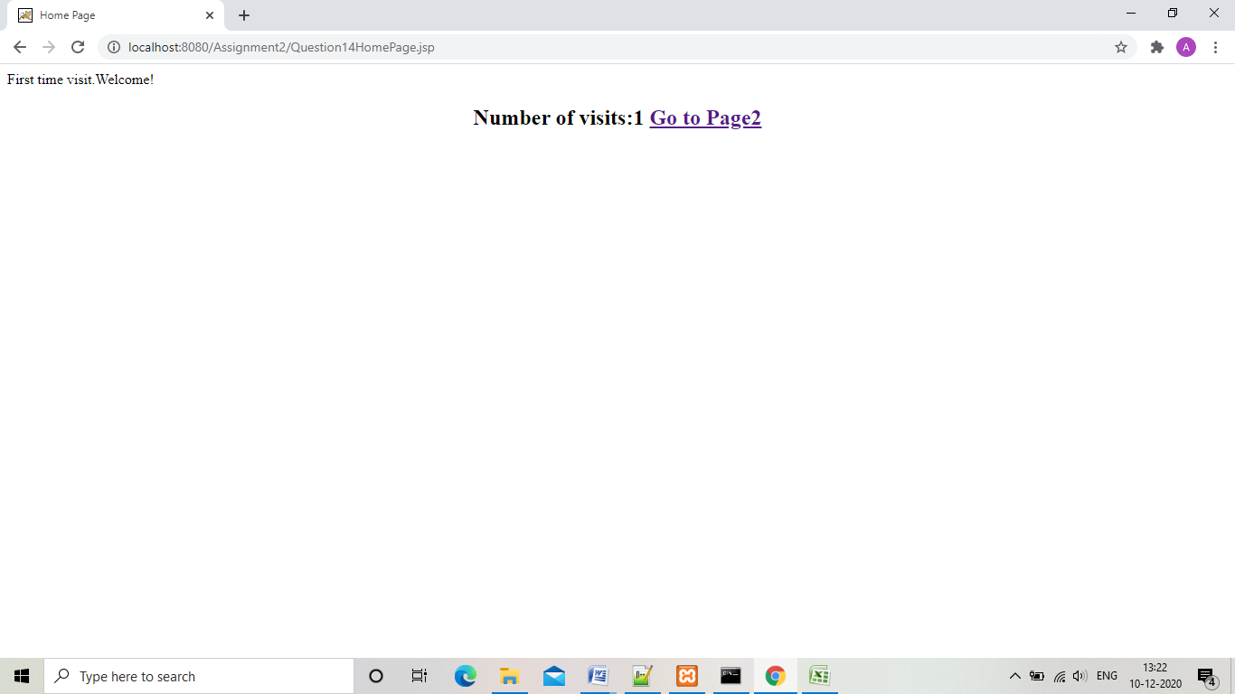

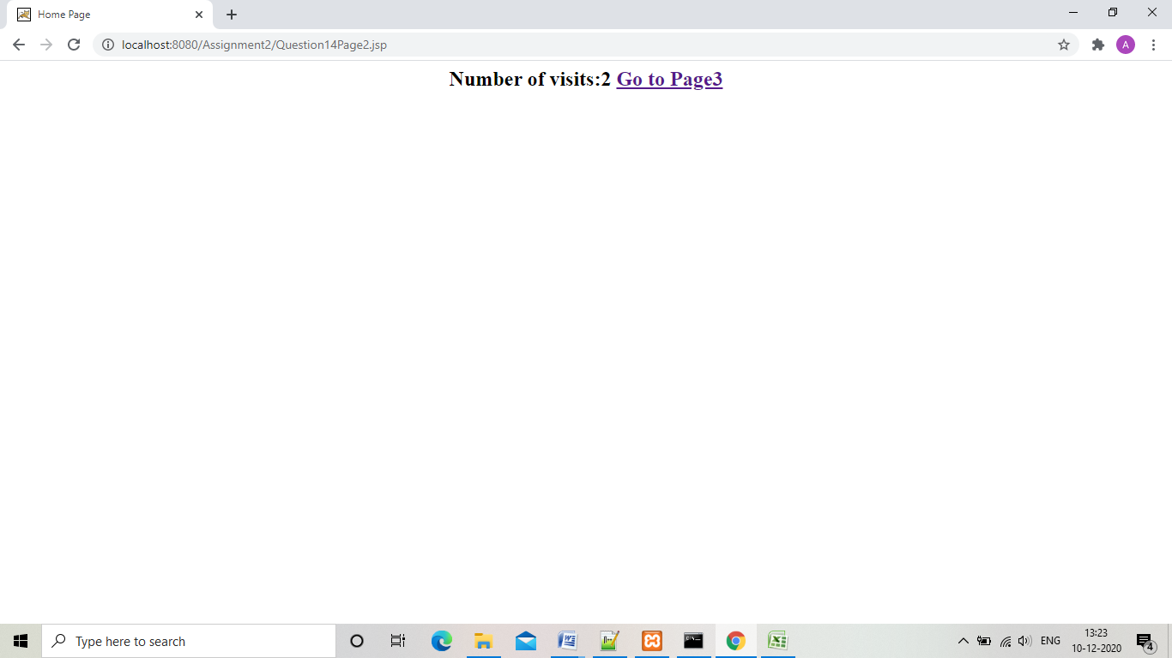

1. Design an application that accepts distance  and the time taken to cover the distance of city A to B ,B to C and C to D from user and finds the speed. If the error occurs, a page Error.jspshould be displayed, otherwise it should call a page showing the full description of journey- Time speed and distance . the output should be in excel format.

“Question15Forn.html”

<html>

<head>

<title>

User Input

</title>

</head>

<body>

<form action="Question15.jsp" method="post">

<label>Enter distance from city A to B:</label>

<input type="text" name="distance_a_b"><br /><br />

<label>Enter time to travel A to B:</label>

<input type="text" name="time_a_b"><br /><br />

<br /><br /><br />

<label>Enter distance from city B to C:</label>

<input type="text" name="distance_b_c"><br /><br />

<label>Enter time to travel B to C:</label>

<input type="text" name="time_b_c"><br /><br />

<br /><br /><br />

<label>Enter distance from city C to D:</label>

<input type="text" name="distance_c_d"><br /><br />

<label>Enter time to travel C to D:</label>

<input type="text" name="time_c_d"><br /><br />

<br /><br /><br />

<input type="submit" value="submit">

<input type="reset" value="reset">

</form>

</body>

</html>

“Question15.jsp”

<%@ page errorPage="ErrorPage15.jsp" contentType="application/vnd.ms-excel" %>

<html>

<head>

<title>

Journey

</title>

</head>

<body>

<table>

<tr>

<th><%out.println("Distance");%></th>

<th><%out.println("Time");%></th>

<th><%out.println("Speed");%></th>

</tr>

<%

int distance=Integer.parseInt((String)request.getParameter("distance_a_b"));

int time=Integer.parseInt((String)request.getParameter("time_a_b"));

int speed=distance/time;

%>

<tr>

<td><%out.print(distance);%></td>

<td><%out.print(time);%></td>

<td><%out.print(speed);%></td>

</tr>

<%

distance=Integer.parseInt((String)request.getParameter("distance_b_c"));

time=Integer.parseInt((String)request.getParameter("time_b_c"));

speed=distance/time;

%>

<tr>

<td><%out.print(distance);%></td>

<td><%out.print(time);%></td>

<td><%out.print(speed);%></td>

</tr>

<%

distance=Integer.parseInt((String)request.getParameter("distance_c_d"));

time=Integer.parseInt((String)request.getParameter("time_c_d"));

speed=distance/time;

%>

<tr>

<td><%out.print(distance);%></td>

<td><%out.print(time);%></td>

<td><%out.print(speed);%></td>

</tr>

</table>

</body>

<html>

“ErrorPage15.jsp”

<%@ page isErrorPage="true" %>

<html>

<head>

<title>

Journey

</title>

</head>

<body>

<h2>Sorry there was an error!

<p>

</body>

<html>

“Output”

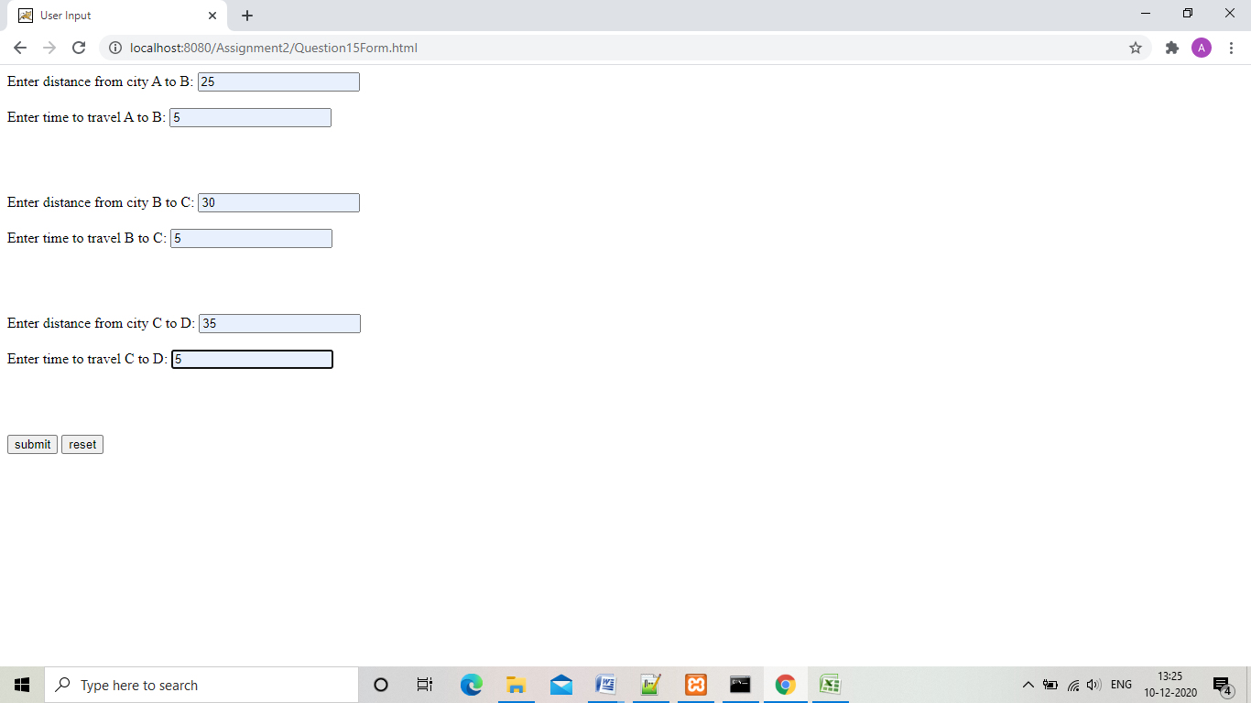

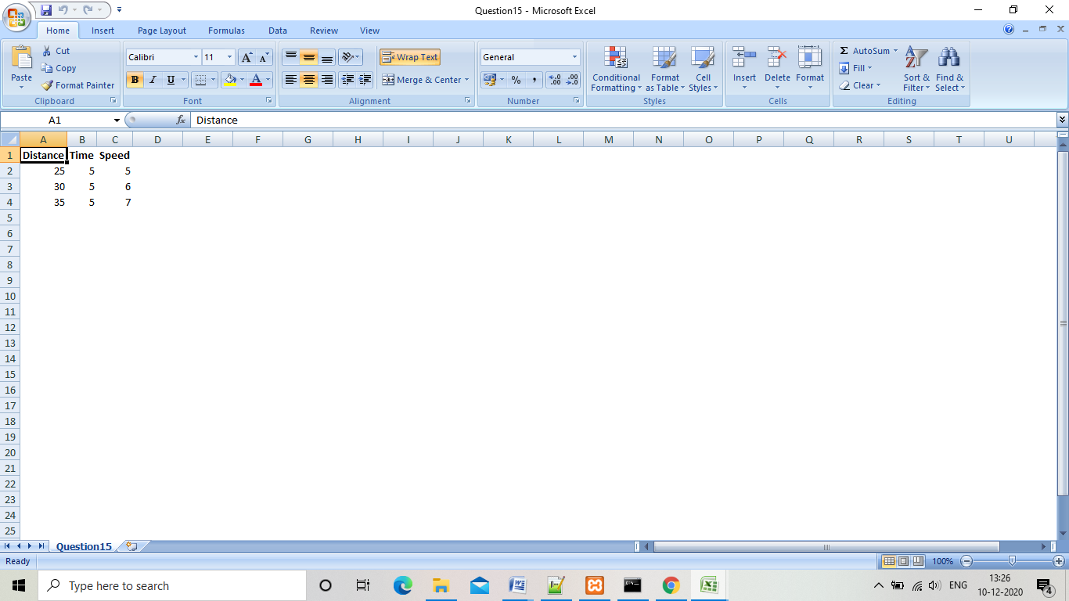

“Assignment-3”

1. 1. Create a Jsp page which provides student detail ,store the detail in student bean and show a Jsp page which display all the details.

“StudentData.java”

package student;

public class StudentData{

private String fname,lname,address;

int age;

public void setFname(String fname){

this.fname=fname;

}

public String getFname(){

return this.fname;

}

public void setLname(String lname){

this.lname=lname;

}

public String getLname(){

return this.lname;

}

public void setAddress(String address){

this.address=address;

}

public String getAddress(){

return this.address;

}

public void setAge(int age){

this.age=age;

}

public int getAge(){

return this.age;

}

}

“StudentForm.html”

<html>

<head>

<title>

User Input

</title>

</head>

<body>

<form action="Question1.jsp" method="post">

<label>Enter first name:</label>

<input type="text" name="fname"><br /><br />

<label>Enter last name:</label>

<input type="text" name="lname"><br /><br />

<label>Enter address</label>

<input type="text" name="address"><br /><br />

<label>Enter age:</label>

<input type="text" name="age"><br /><br />

<input type="submit" value="submit">

<input type="reset" value="reset">

</form>

</body>

</html>

“Question1.jsp”

<html>

<head>

<title>

Student details

</title>

</head>

<body>

<center><h2>

<jsp:useBean id="student" class="student.StudentData" />

<jsp:setProperty name="student" property="*" />

<b><u>Student details:</u></b><br /><br />

First name:<jsp:getProperty name="student" property="fname" /><br />

Last name:<jsp:getProperty name="student" property="lname" /><br />

Address:<jsp:getProperty name="student" property="address" /><br />

Age:<jsp:getProperty name="student" property="age" /><br />

</center>

</body>

</html>

“Output”

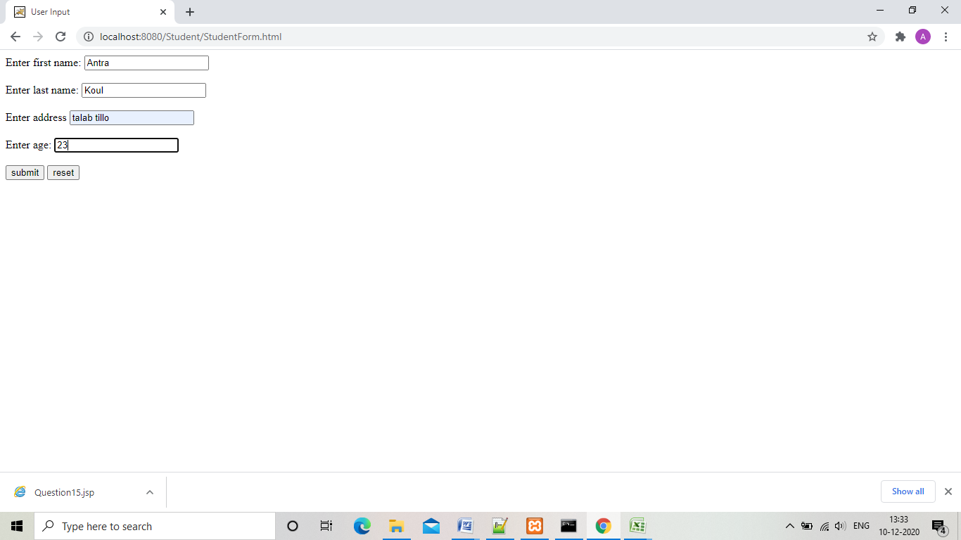

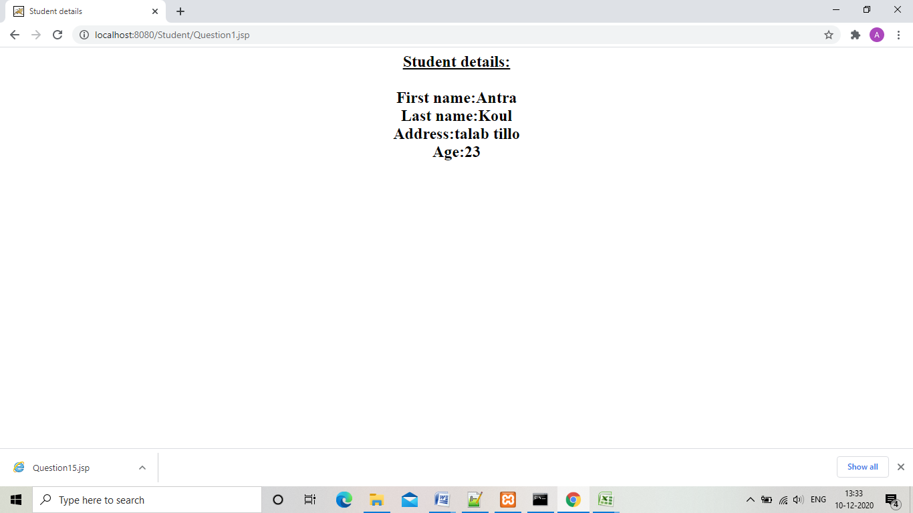

1. Create a color bean which has attributes userName background and foreground color. Create a Jsp page which ask the user –name and color choices and display the page with user specified colors with a message- Welcome <username>.

“UserForm.html”

<html>

<head>

<title>

User Input

</title>

</head>

<body>

<h2><p align="center">

<form action="UserPage.jsp" method="post">

<label>Enter username:</label>

<input type="text" name="username" required><br /><br />

<label>Enter background color:</label>

<input type="text" name="backgroundcolor" required><br /><br />

<label>Enter foreground color:</label>

<input type="text" name="foregroundcolor" required><br /><br />

<input type="submit" value="submit">

<input type="reset" value="reset">

</form>

</body>

<html>

“UserPage.jsp”

<html>

<head>

<title>

User welcome

</title>

</head>

<body>

<jsp:useBean id="user1" class="user.UserBean" />

<jsp:setProperty property="*" name="user1" />

<body bgcolor="<jsp:getProperty name='user1' property='backgroundcolor' />" text="forecolor:<jsp:getProperty name='user1' property='foregroundcolor' />">

Welcome!<jsp:getProperty name='user1' property='username' />

</body>

<html>

“UserBean.java”

package user;

public class UserBean{

private String backgroundcolor,foregroundcolor,username;

public void setUsername(String username){

this.username=username;

}

public String getUsername(){

return this.username;

}

public void setBackgroundcolor(String backgroundcolor){

this.backgroundcolor=backgroundcolor;

}

public String getBackgroundcolor(){

return this.backgroundcolor;

}

public void setForegroundcolor(String foregroundcolor){

this.foregroundcolor=foregroundcolor;

}

public String getForegroundcolor(){

return this.foregroundcolor;

}

}

“Output”

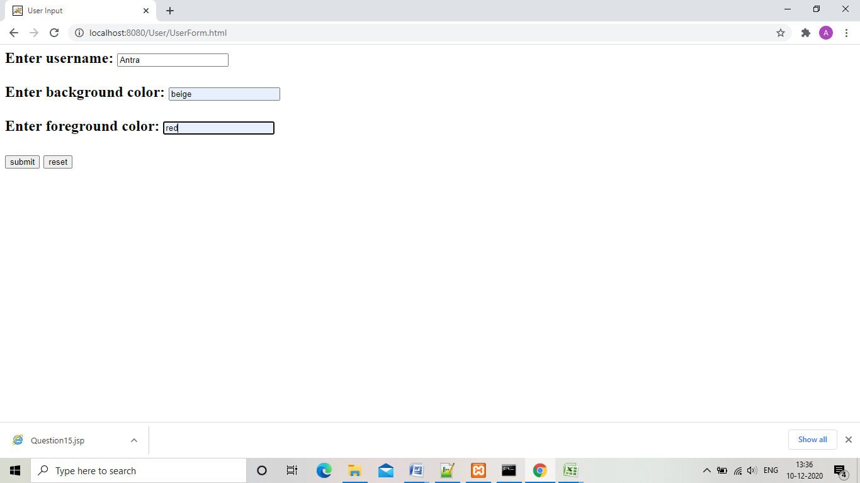

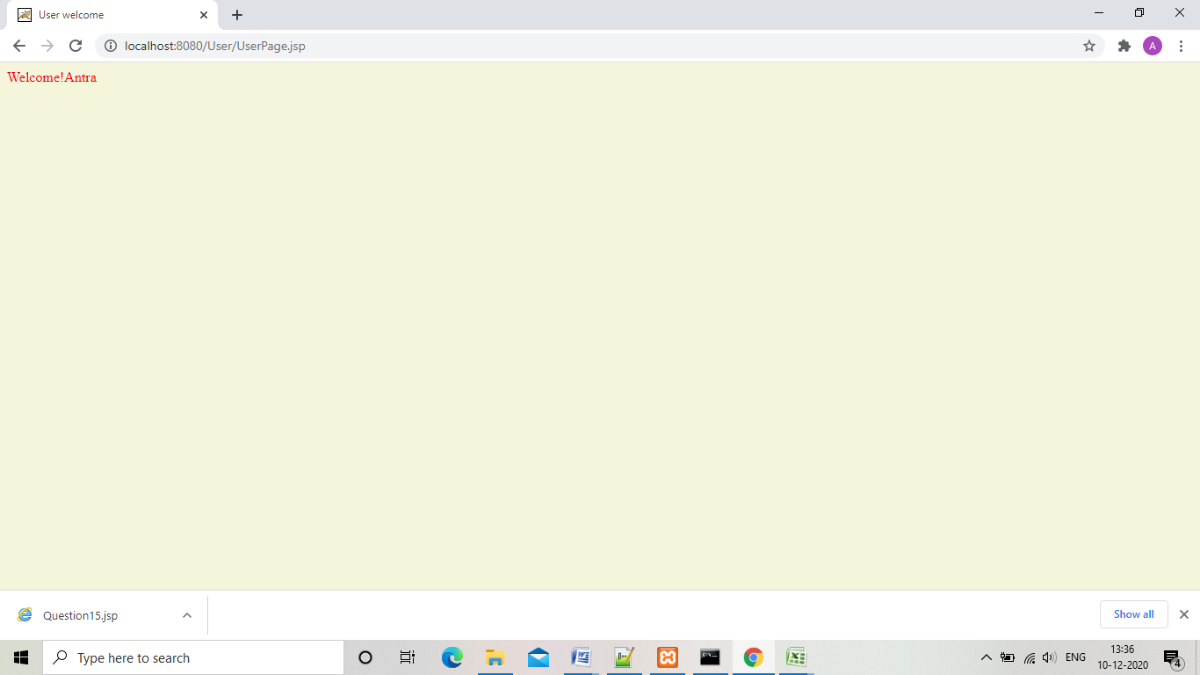

1. Create a Jsp page ask user to select Product from drop down menu , enter quantity and show a page bill.jsp which shows the bill in table format. If the bill amount is less than 200 the page should have background color white else green.

“HomePage.html”

<html>

<head>

<title>

Home page

</title>

</head>

<body>

<center><h2><i><u>Welcome ! </u></i><br /><br />

<form method="post" action="Bill.jsp">

<label>Select item:</label>

<select name="product" id="product">

<option value="notebook">Notebook</option>

<option value="pen">Pen</option>

<option value="colorpencils">Color pencils</option>

</select>

<label>Enter quantity:</label>

<input type="text" name="quantity"><br /><br />

<center>

<input type="submit" value="submit">

<input type="reset" value="reset">

<form>

</body>

<html>

“Bill.jsp”

<html>

<head>

<title>

Bill page

</title>

</head>

<%

String product = (String)request.getParameter("product");

Integer quantity = Integer.parseInt(request.getParameter("quantity"));

Integer price=0;

if(product.equals("notebook")){

price = quantity * 50;

}

else if(product.equals("pen")){

price = quantity * 30;

}

else if(product.equals("colorpencils")){

price = quantity * 150;

}

String color;

if(price<=200)

{

color="white";

}

else{

color="green";

}

%>

<body bgcolor="<%= color%>"><h2>

<center><i><u>Your bill:</u></i><br />

<table width="50%" height="50%">

<tr>

<th>Product name</th>

<th>Quantity:</th>

<th>Total</th>

</tr>

<tr>

<th><%out.print(product);%></th>

<th><%out.print(quantity);%></th>

<th><%out.print(price);%></th>

</tr>

</table>

</body>

<html>

“Shop.css”

table {

border-collapse: collapse;

}

td {

text-align: center;

}

body{

font-family:Comic Sans MS;

}

input[type=button], input[type=submit], input[type=reset] {

background-color: #4CAF50;

border: none;

color: white;

padding: 16px 32px;

text-decoration: none;

margin: 4px 2px;

cursor: pointer;

}

“Output”

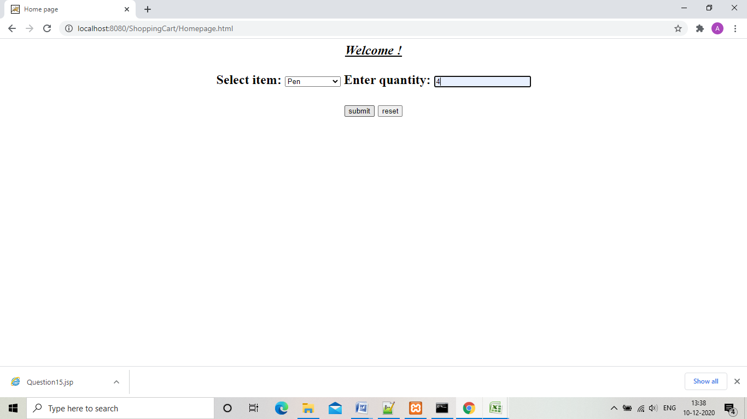

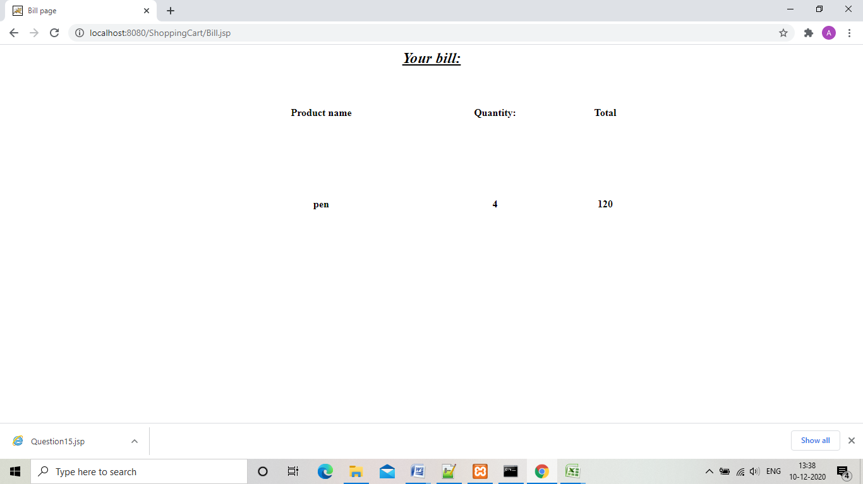

“Assignment 4”

1. (a) Create an application for bank using JSTL. Customer enters his accounteid , server validate the customer and display his account balance – Welcome customer name> your account balance is <balance> If the balance is below min balance then display appropriate message and change the background color.

“Question1.jsp”

<%@ page import="java.util.*,java.io.*,java.sql.*" %>

<%@ page import="javax.http.servlet.*,javax.servlet.*" %>

<%@ taglib uri="http://java.sun.com/jsp/jstl/sql" prefix="sql"%>

<%@ taglib uri="http://java.sun.com/jsp/jstl/core" prefix="c"%>

<html>

<head>

<title>Customer Information</title>

</head>

<body>

<%

int id=(Integer.parseInt(request.getParameter("customer_id")));

%>

<center>

<h3><i>

<c:set var="id" value="<%= id%>" />

<sql:setDataSource var="db" driver="com.mysql.jdbc.Driver" url="jdbc:mysql://localhost/jstl" user="root" password="" />

<sql:query dataSource="${db}" var="rs">

Select * from Accounts where ID=?;

<sql:param value="${id}" />

</sql:query>

<c:forEach var="table" items="${rs.rows}">

<c:set var="Name" value="${table.Name}" />

<c:if test="${Name != null}">

<c:set var="flag" value="1" />

<h2 >Customer Information </h2>

Welcome <c:out value="${Name}" /> !<br />

Your balance is <c:out value="${table.Balance}" /> <br />

<c:set var="balance" value="${table.Balance}" />

<c:if test="${balance < 2000}">

Your balance is less than minimum balance required .Kindly deposit money otherwise your account will get deactivated!

<script>

document.body.style.backgroundColor="red";

</script>

</c:if>

</c:if>

</c:forEach>

<c:if test="${flag != '1'}">

<c:out value="Sorry! wrong id" /></i>

<c:import url="Question1Form.html" />

</c:if>

</h3>

</center>

</body>

</html>

“Question1Form.html”

<html>

<head>

<title>Customer Form</title>

</head>

<body>

<center>

<h2><u>Customer Form</u><br /><br />

<form method="post" action="Question1.jsp">

<label>Enter customer id:</label>

<input type="text" name="customer_id"><br /><br />

<input type="submit" value="submit">

<input type="reset" value="reset">

</form>

</center>

</body>

</html>

“Output”

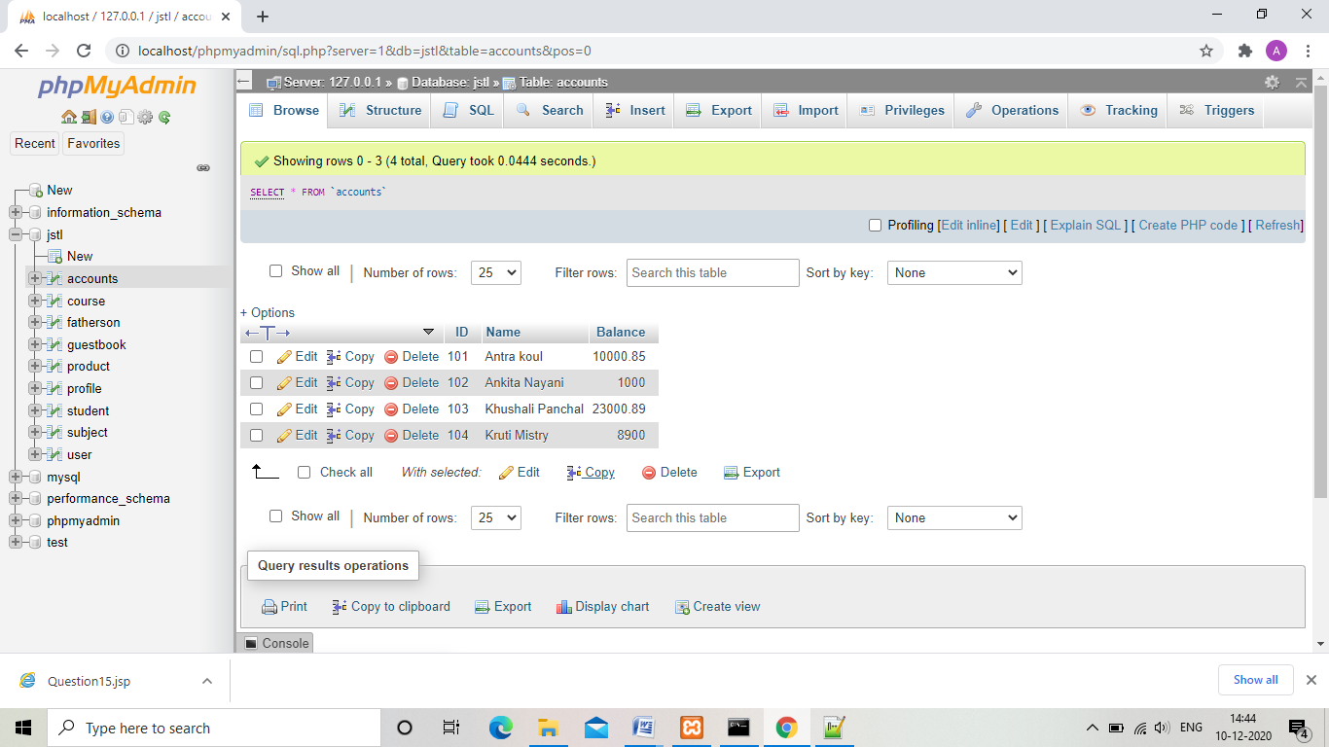

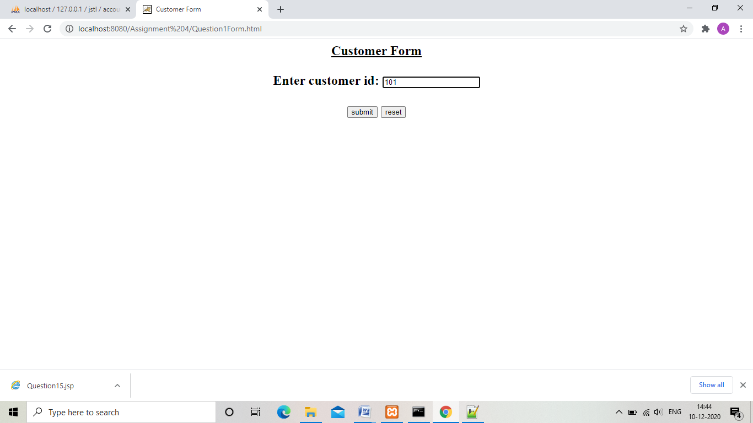

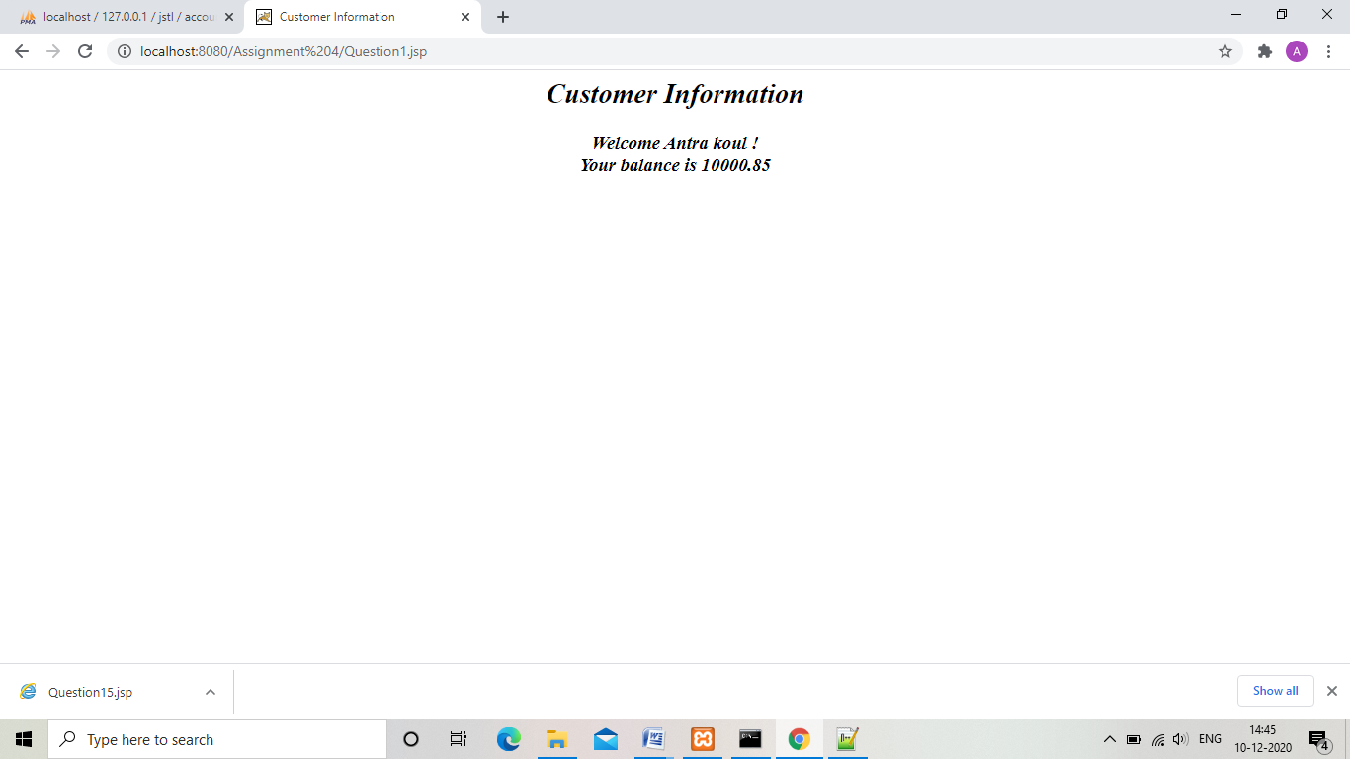

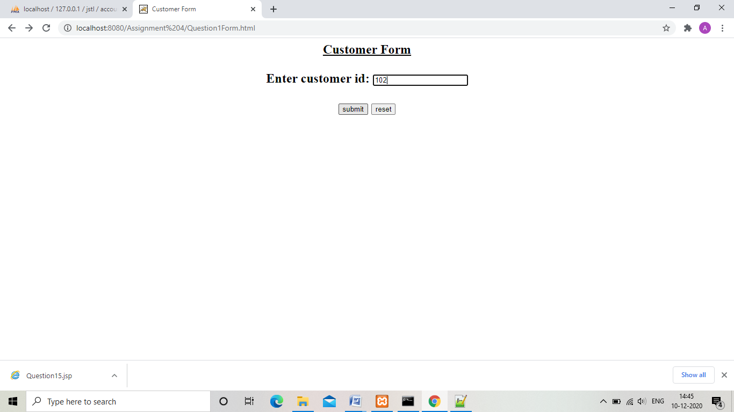

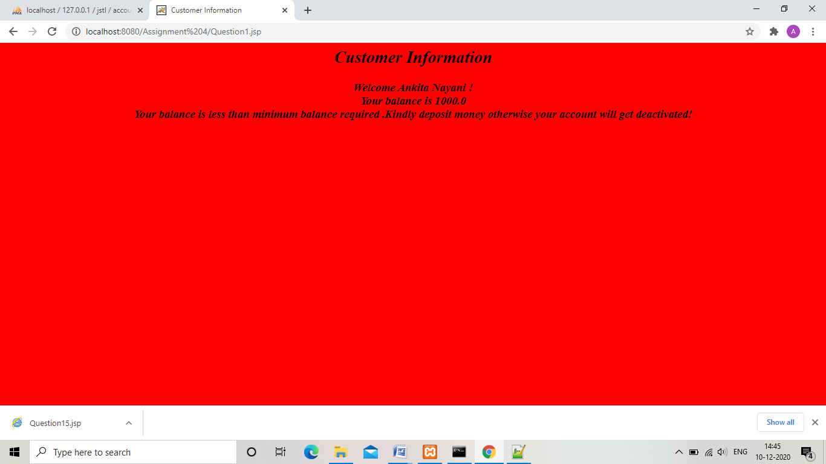

(b) Make an HTML page with a push button. When user clicks this button then shows him the content from a file. Update this after every 3 seconds.

“Question1bForm.html”

<html>

<head>

<title>user input</title>

</head>

<body>

<center>

<form method="post" action="Question1b.jsp">

<h2><i>Click the push button to see file content!</i><br /><br />

<input type="submit" value="push">

</form>

</center>

</body>

</html>

“Question1b.jsp”

<%@ taglib uri="http://java.sun.com/jsp/jstl/core" prefix="c"%>

<%@ page import="java.io.*" %>

<html>

<head>

<title>user input</title>

</head>

<body>

<center>

<%

InputStream ins = application.getResourceAsStream("/WEB-INF/File1.txt");

BufferedReader br = new BufferedReader(new InputStreamReader(ins));

String line;

while((line=br.readLine()) != null){

Thread.sleep(3000);

%>

<c:set var="content" value="<%= line%>" /><br />

<c:out value="${content}" />

<%

out.flush();

}

%>

</body>

</html>

“Output”

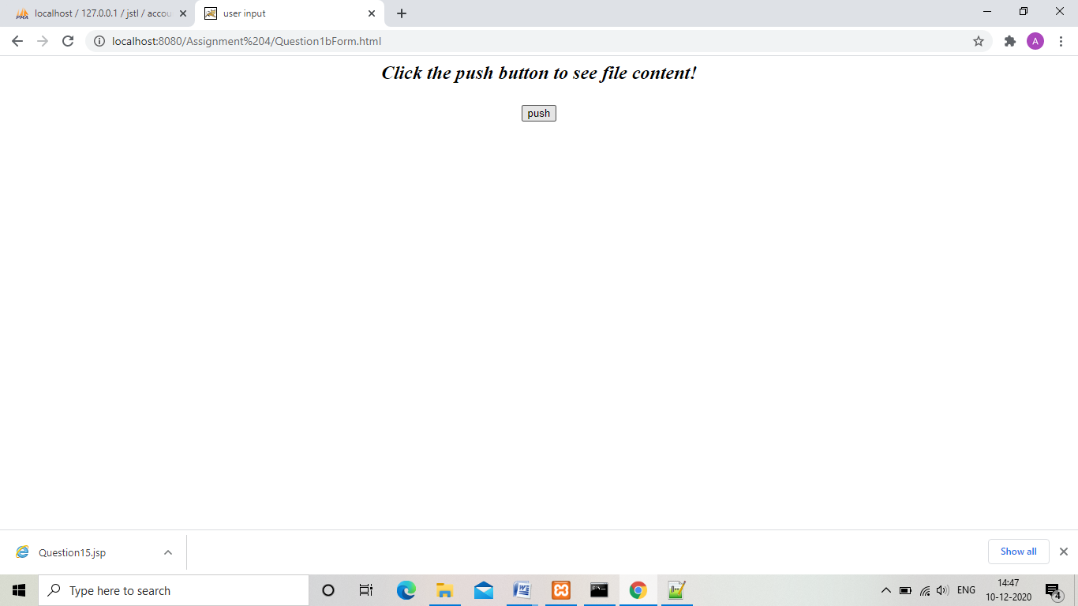

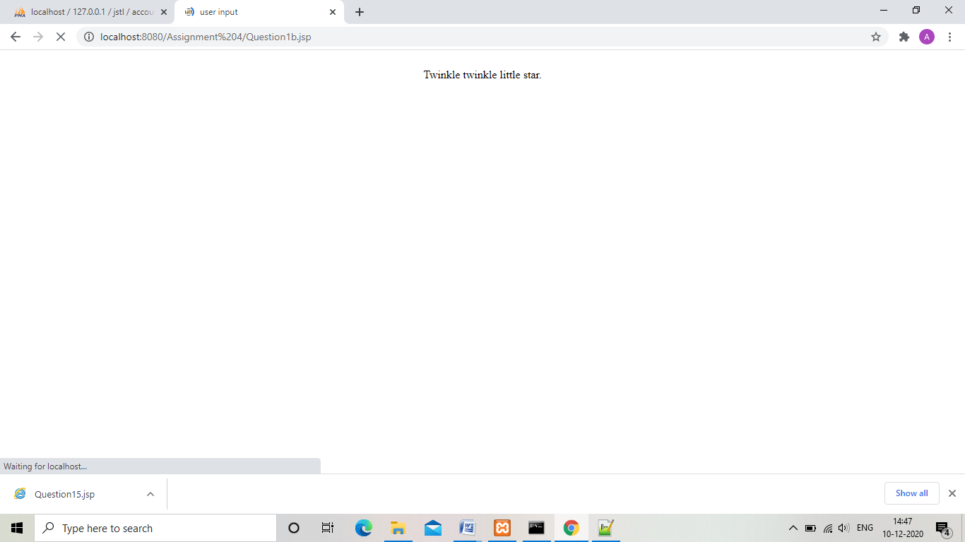

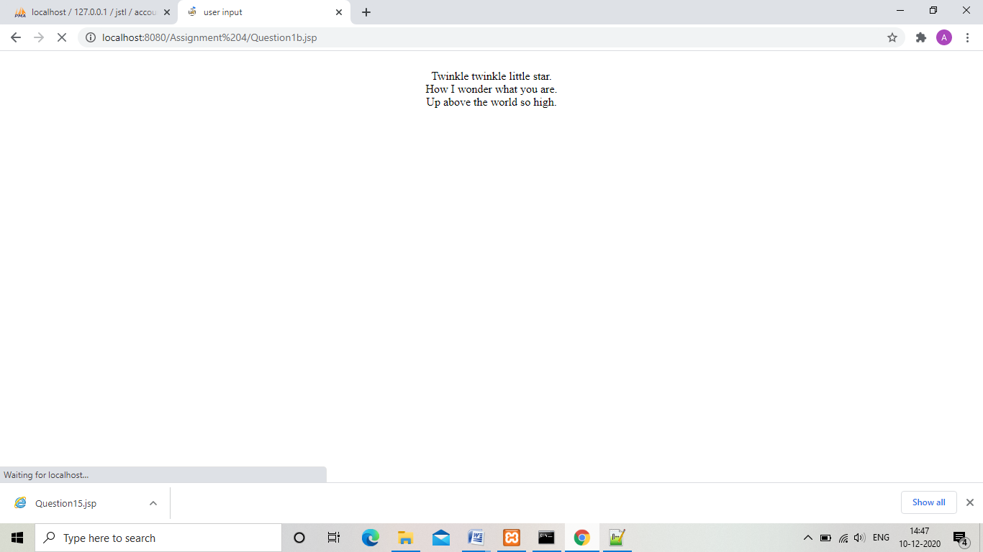

“Ajax”

1. 1. Make an HTML page with a pushbutton that invokes a alert box, which displays the

either “Good Morning” , “Good Afternoon” or “Good Evening” based on server time using Ajax-Prototype framework.

“Question2Form.html”

<html>

<head>

<title>Greeting message</title>

</head>

<script>

var request;

function showGreeting(){

if(window.XMLHttpRequest){

request = new XMLHttpRequest();

}

else if(window.ActiveXObject){

request = new ActiveXObject("Microsoft.XMLHTTP");

}

try{

request.onreadystatechange=getGreeting;

request.open("GET","Question2.jsp",true);

request.send();

}

catch(e){

alert("Unable to connect to the server!");

}

}

function getGreeting(){

if(request.readyState==4){

var val = request.responseText;

alert(val);

}

}

</script>

<body>

<center>

<form>

<label>Press the button for greeting message:</label>

<input type="button" value="Push button" onclick="showGreeting()">

</form>

</center>

</body>

</html>

“Question2.jsp”

<%@ page import = "java.util.Date" %>

<%

Date today = new Date();

int hours = today.getHours();

if(hours <= 12 && hours >= 0)

out.print("Good morning!");

else if(hours <= 19 && hours >=13)

out.print("Good afternoon!");

else

out.print("Good evening!");

%>

“Output”

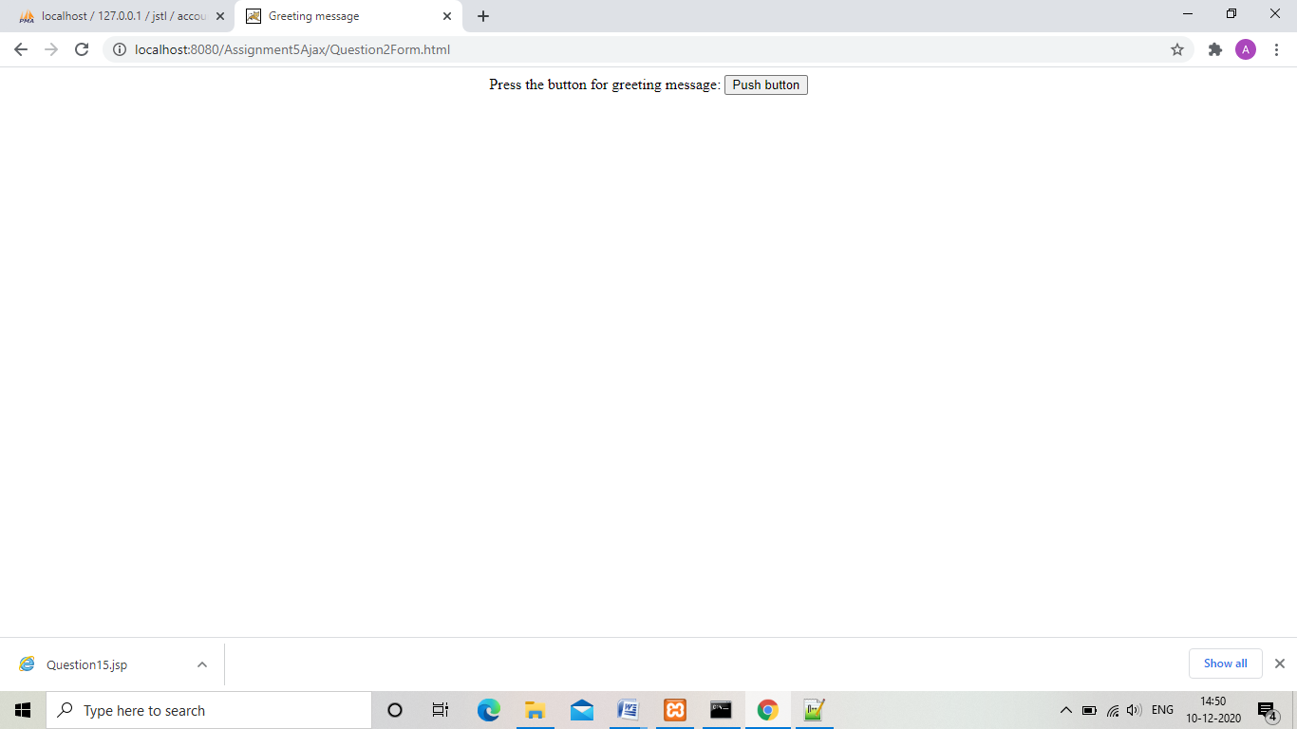

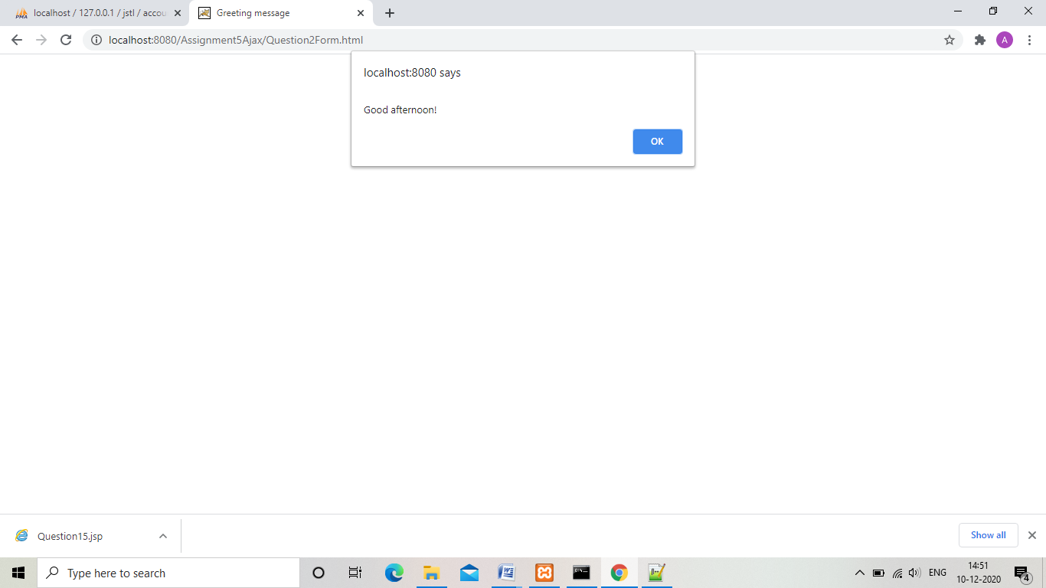

“Assignment 5”

1. 1 Develop the following application:

A. Design an html page that accepts the father’s name and age along with the son’s name and age. The user should be redirected to “myError.jsp” if any of the age is invalid and also if father’s age is less than son’s age.

B. If the age is valid, the user should be redirected to “Welcome.jsp”, where father’s age at the time of son’s birth is shown.

C. The valid details should be stored in the database using Statement or PreparedStatement

“Form.html”

<html>

<head>

<title>

User Form

</title>

</head>

<body>

<center><h3><u>User Form</u></h3><br><br>

<table>

<form action="UserServlet" method="post">

<tr>

<td>

<label>Enter father name:</label>

</td>

<td>

<input type="text" name="fathername" /><br></br>

</td>

</tr>

<tr>

<td>

<label>Enter father age:</label>

</td>

<td>

<input type="text" name="fatherage" /><br></br>

</td>

</tr>

<tr>

<td>

<label>Enter son name:</label>

</td>

<td>

<input type="text" name="sonname" /><br></br>

</td>

</tr>

<tr>

<td>

<label>Enter son age:</label>

</td>

<td>

<input type="text" name="sonage" /><br></br>

</td>

</tr>

<tr>

<td>

<input type="submit" value="submit">

</td>

<td>

<input type="reset" value="reset">

</td>

</tr>

</form>

</table>

</center>

</body>

</html>

“myerror.jsp”

<p>

<h4><i>Sorry an error occured!

</p>

“welcome.jsp”

<p>

<h4><i>Father age at the tiime of son birth is :<%

out.print(request.getAttribute("age"));

%>

</p>

“web.xml”

<?xml version="1.0" encoding="UTF-8"?>

<!--

Licensed to the Apache Software Foundation (ASF) under one or more

contributor license agreements. See the NOTICE file distributed with

this work for additional information regarding copyright ownership.

The ASF licenses this file to You under the Apache License, Version 2.0

(the "License"); you may not use this file except in compliance with

the License. You may obtain a copy of the License at

http://www.apache.org/licenses/LICENSE-2.0

Unless required by applicable law or agreed to in writing, software

distributed under the License is distributed on an "AS IS" BASIS,

WITHOUT WARRANTIES OR CONDITIONS OF ANY KIND, either express or implied.

See the License for the specific language governing permissions and

limitations under the License.

-->

<web-app xmlns="http://java.sun.com/xml/ns/javaee"

xmlns:xsi="http://www.w3.org/2001/XMLSchema-instance"

xsi:schemaLocation="http://java.sun.com/xml/ns/javaee

http://java.sun.com/xml/ns/javaee/web-app_3_0.xsd"

version="3.0"

metadata-complete="true">

<display-name>Welcome to Tomcat</display-name>

<description>

Welcome to Tomcat

</description>

<servlet>

<servlet-name>UserServlet</servlet-name>

<servlet-class>fatherson.UserServlet</servlet-class>

</servlet>

<servlet-mapping>

<servlet-name>UserServlet</servlet-name>

<url-pattern>/UserServlet</url-pattern>

</servlet-mapping>

</web-app>

”FatherSondetails.java”

package fatherson;

public class FatherSonDetails{

private String fathername,sonname;

private int fatherage,sonage;

public void setFathername(String fathername){

this.fathername=fathername;

}

public String getFathername(){

return fathername;

}

public void setSonname(String sonname){

this.sonname=sonname;

}

public String getSonname(){

return this.sonname;

}

public void setSonage(int sonage){

this.sonage=sonage;

}

public int getSonage(){

return this.sonage;

}

public void setFatherage(int fatherage){

this.fatherage=fatherage;

}

public int getFatherage(){

return this.fatherage;

}

}

“userServlet.java”

package fatherson;

import java.sql.*;

import java.io.IOException;

import java.io.PrintWriter;

import javax.servlet.RequestDispatcher;

import javax.servlet.ServletException;

import javax.servlet.http.HttpServlet;

import javax.servlet.http.HttpServletRequest;

import javax.servlet.http.HttpServletResponse;

public class UserServlet extends HttpServlet{

protected void doPost(HttpServletRequest request, HttpServletResponse response) throws ServletException, IOException {

response.setContentType("text/html");

PrintWriter out = response.getWriter();

int fatherage=Integer.parseInt(request.getParameter("fatherage"));

int sonage=Integer.parseInt(request.getParameter("sonage"));

if( fatherage< 0 || sonage< 0 || fatherage < sonage)

{

RequestDispatcher request_dispatcher = request.getRequestDispatcher("myError.jsp");

request_dispatcher.forward(request,response);

}

else{

try{

Class.forName("com.mysql.jdbc.Driver");

Connection connection = DriverManager.getConnection("jdbc:mysql://localhost/jstl","root","");

PreparedStatement stmt = connection.prepareStatement("Insert into FatherSon values(?,?,?,?)");

stmt.setString(1,request.getParameter("fathername"));

stmt.setInt(2,fatherage);

stmt.setString(3,request.getParameter("sonname"));

stmt.setInt(4,sonage);

int i =stmt.executeUpdate();

System.out.print("Record:"+i);

connection.close();

}

catch(Exception e){

e.printStackTrace();

}

int age=fatherage-sonage;

request.setAttribute("age",age+"");

RequestDispatcher request_dispatcher = request.getRequestDispatcher("welcome.jsp");

request_dispatcher.forward(request,response);

}

}

protected void doGet(HttpServletRequest request,HttpServletResponse response) throws ServletException, IOException {

doPost(request, response);

}

}

“Output”

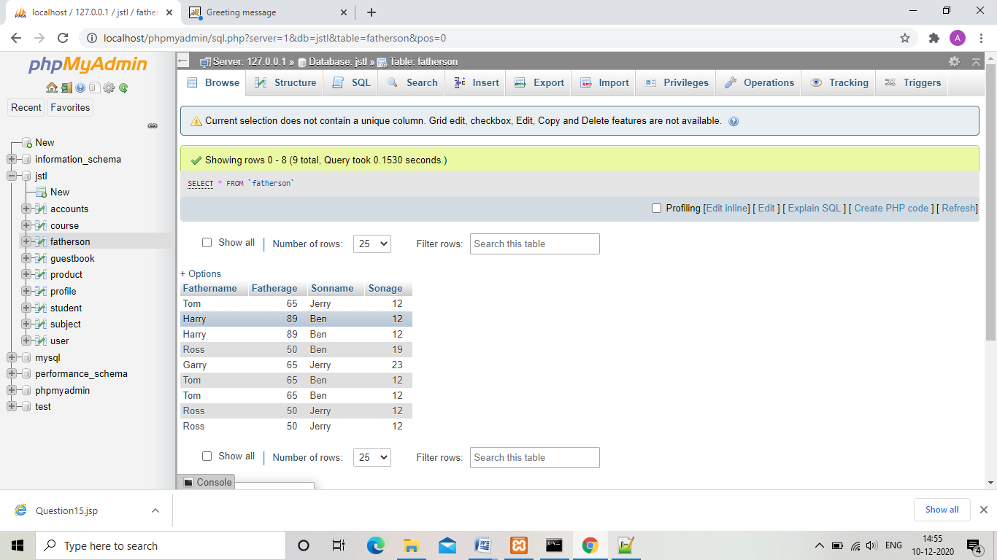

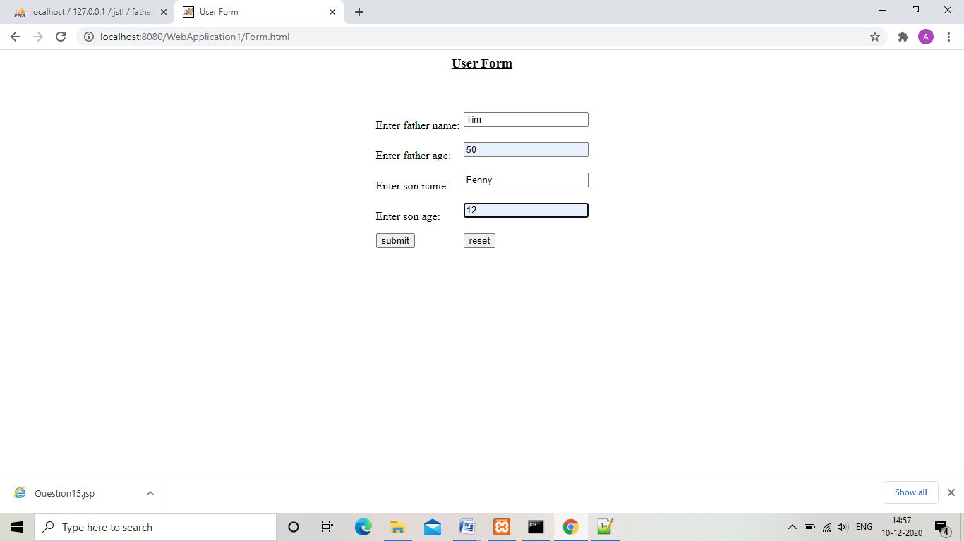

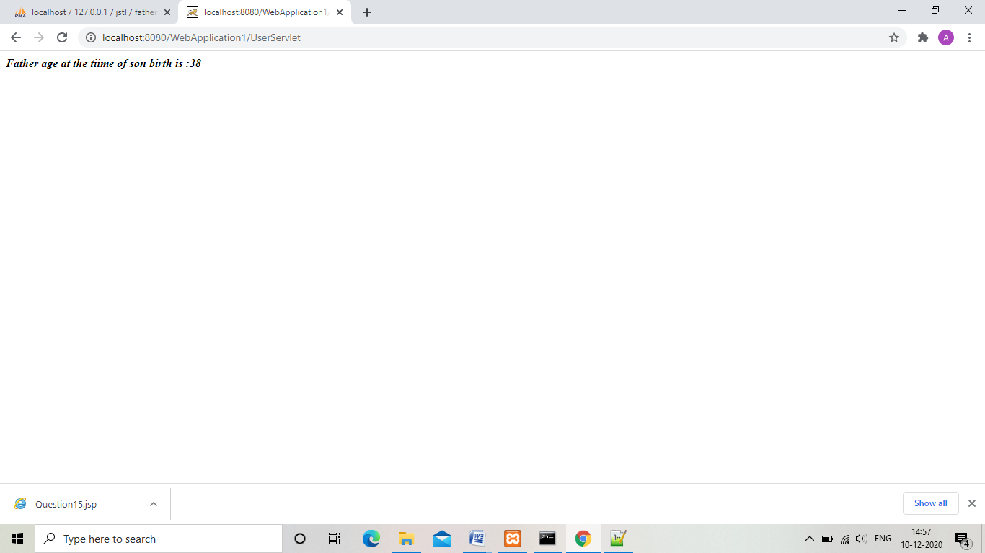

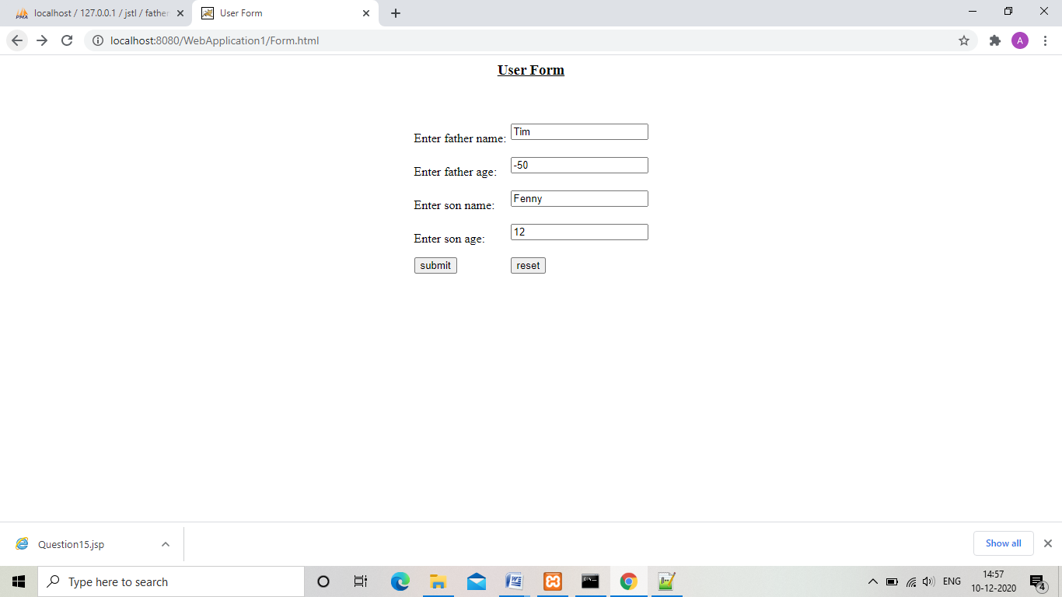

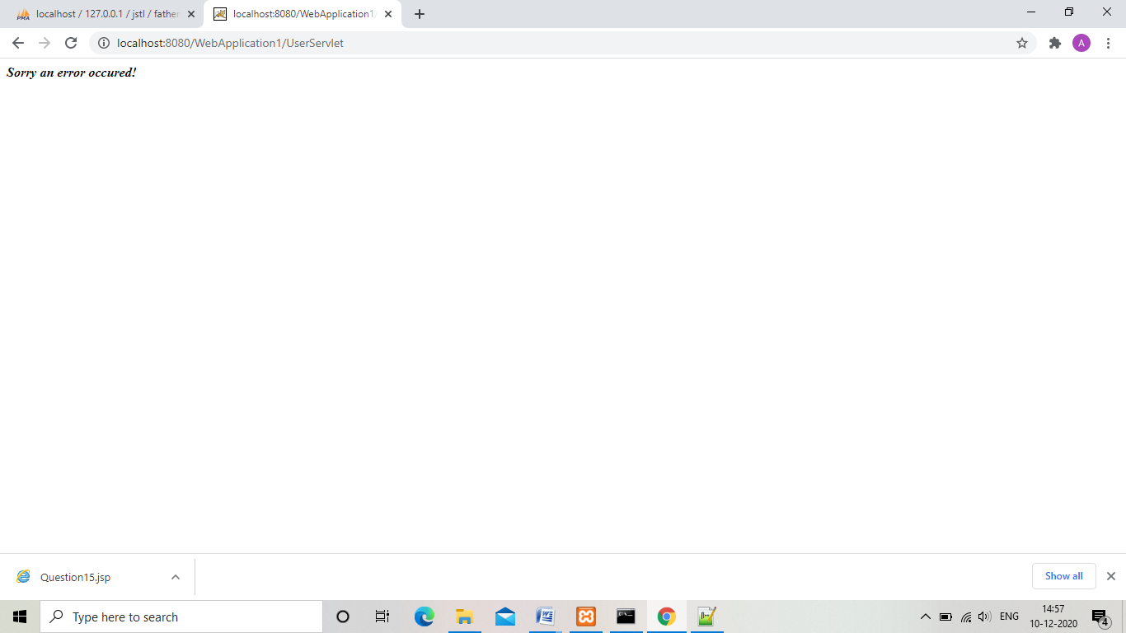

2. 3. Develop the following application:

1. Design an MVC application where-in user enter his user-id in an html form “index.jsp”.
2. Based on user-id, the user’s data should be fetched from the database.
3. If the user-type is of “student”, he should be redirected to “subjects.jsp” and if the user-type is “faculty”, he should be redirected to “profile.jsp”.
4. Maintain a count for how many time the “index.jsp” has been accessed from the server reboot

“index.jsp”

<html>

<head>

<title>

User Form

</title>

</head>

<body>

<%

String count=(String)application.getAttribute("visitor_number");

if(count==null)

{

application.setAttribute("visitor_number","1");

count=(String)application.getAttribute("visitor_number");

}

else

{

int counter=Integer.parseInt(count);

counter=counter+1;

application.setAttribute("visitor_number",counter+"");

count=(String)application.getAttribute("visitor_number");

}

out.print("Visitor number:"+count);

%>

<center><h3><u>User Form</u></h3><br><br>

<table>

<form action="IDServlet" method="post">

<tr>

<td>

<label>Enter user id :</label>

</td>

<td>

<input type="text" name="userid" /><br></br>

</td>

</tr>

<tr>

<td>

<input type="submit" value="submit">

</td>

<td>

<input type="reset" value="reset">

</td>

</tr>

</form>

</table>

</center>

</body>

</html>

“profile.jsp”

<%@ taglib uri="http://java.sun.com/jsp/jstl/sql" prefix="sql"%>

<%@ taglib uri="http://java.sun.com/jsp/jstl/core" prefix="c"%>

<html>

<head>

<title>

Subjects

</title>

</head>

<body>

<h3><i>Teacher Profile

<c:set var="id" value="${requestScope['id']}" />

<sql:setDataSource var="db" driver="com.mysql.jdbc.Driver" url="jdbc:mysql://localhost/jstl" user="root" password=""/>

<sql:query dataSource="${db}" var="rs">

Select * from profile ;

</sql:query>

<table width="50%" height="50%">

<tr>

<th>Qualification</th>

<th>Salary</th>

</tr>

<c:forEach var="table" items="${rs.rows}">

<c:set var="userid" value="${table.ID}" />

<c:if test="${userid==id}">

<tr>

<td align="center"><c:out value="${table.Qualification}" /></td>

<td align="center"><c:out value="${table.Salary}" /></td>

</tr>

</c:if>

</c:forEach>

</table>

</body>

</html>

“subjects.jsp”

<%@ taglib uri="http://java.sun.com/jsp/jstl/sql" prefix="sql"%>

<%@ taglib uri="http://java.sun.com/jsp/jstl/core" prefix="c"%>

<html>

<head>

<title>

Subjects

</title>

</head>

<body>

<h3><i>Subjects:</i>

<c:set var="id" value="${requestScope['id']}" />

<sql:setDataSource var="db" driver="com.mysql.jdbc.Driver" url="jdbc:mysql://localhost/jstl" user="root" password=""/>

<sql:query dataSource="${db}" var="rs">

Select * from subject ;

</sql:query>

<table width="50%" height="50%">

<tr>

<th>Subject</th>

</tr>

<c:forEach var="table" items="${rs.rows}">

<c:set var="userid" value="${table.ID}" />

<c:if test="${userid==id}">

<tr>

<td align="center"><c:out value="${table.subjects}" /></td>

</tr>

</c:if>

</c:forEach>

</table>

</body>

</html>

“IDServlet.java”

package userid;

import java.sql.*;

import java.io.IOException;

import java.io.PrintWriter;

import javax.servlet.RequestDispatcher;

import javax.servlet.ServletException;

import javax.servlet.http.HttpServlet;

import javax.servlet.http.HttpServletRequest;

import javax.servlet.http.HttpServletResponse;

public class IDServlet extends HttpServlet{

protected void doPost(HttpServletRequest request, HttpServletResponse response) throws ServletException, IOException {

response.setContentType("text/html");

PrintWriter out = response.getWriter();

int id=Integer.parseInt(request.getParameter("userid"));

request.setAttribute("id",id+"");

String type="";

try{

Class.forName("com.mysql.jdbc.Driver");

Connection connection = DriverManager.getConnection("jdbc:mysql://localhost/jstl","root","");

Statement stmt = connection.createStatement();

ResultSet rs=stmt.executeQuery("Select * from user");

while(rs.next()){

if(rs.getInt("ID") == id){

type=rs.getString("Type");

break;

}

}

if(type.equalsIgnoreCase("Student")){

RequestDispatcher request_dispatcher = request.getRequestDispatcher("subjects.jsp");

request_dispatcher.forward(request,response);

}

else

{

RequestDispatcher request_dispatcher = request.getRequestDispatcher("profile.jsp");

request_dispatcher.forward(request,response);

}

connection.close();

}

catch(Exception e){

e.printStackTrace();

}

}

protected void doGet(HttpServletRequest request,HttpServletResponse response) throws ServletException, IOException {

doPost(request, response);

}

}

“web.xml”

<?xml version="1.0" encoding="UTF-8"?>

<!--

Licensed to the Apache Software Foundation (ASF) under one or more

contributor license agreements. See the NOTICE file distributed with

this work for additional information regarding copyright ownership.

The ASF licenses this file to You under the Apache License, Version 2.0

(the "License"); you may not use this file except in compliance with

the License. You may obtain a copy of the License at

http://www.apache.org/licenses/LICENSE-2.0

Unless required by applicable law or agreed to in writing, software

distributed under the License is distributed on an "AS IS" BASIS,

WITHOUT WARRANTIES OR CONDITIONS OF ANY KIND, either express or implied.

See the License for the specific language governing permissions and

limitations under the License.

-->

<web-app xmlns="http://java.sun.com/xml/ns/javaee"

xmlns:xsi="http://www.w3.org/2001/XMLSchema-instance"

xsi:schemaLocation="http://java.sun.com/xml/ns/javaee

http://java.sun.com/xml/ns/javaee/web-app_3_0.xsd"

version="3.0"

metadata-complete="true">

<display-name>Welcome to Tomcat</display-name>

<description>

Welcome to Tomcat

</description>

<servlet>

<servlet-name>IDServlet</servlet-name>

<servlet-class>userid.IDServlet</servlet-class>

</servlet>

<servlet-mapping>

<servlet-name>IDServlet</servlet-name>

<url-pattern>/IDServlet</url-pattern>

</servlet-mapping>

</web-app>

“Output”

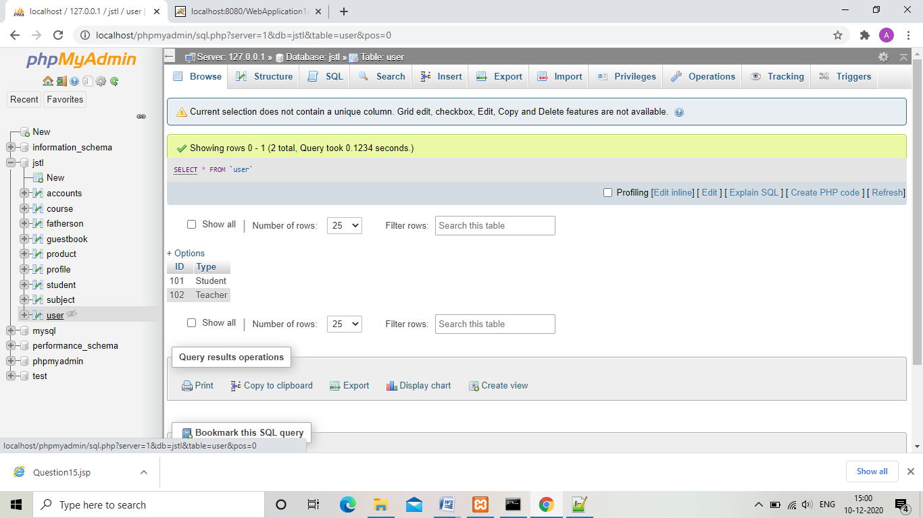

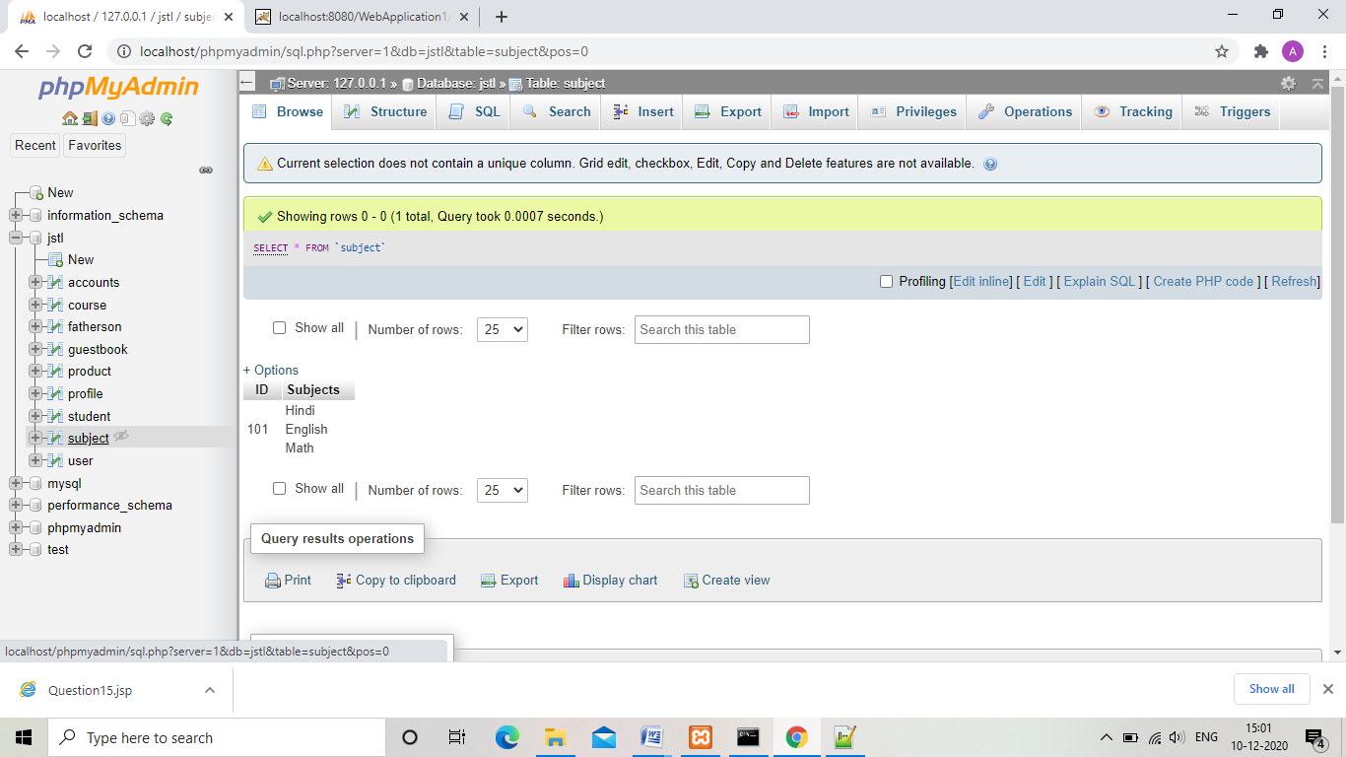

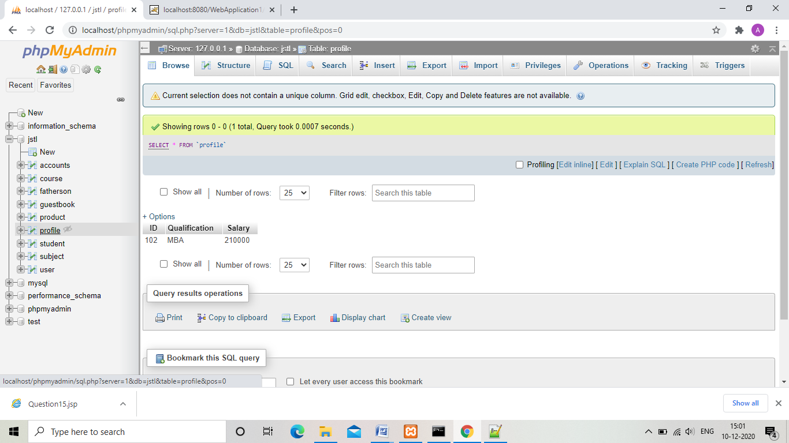

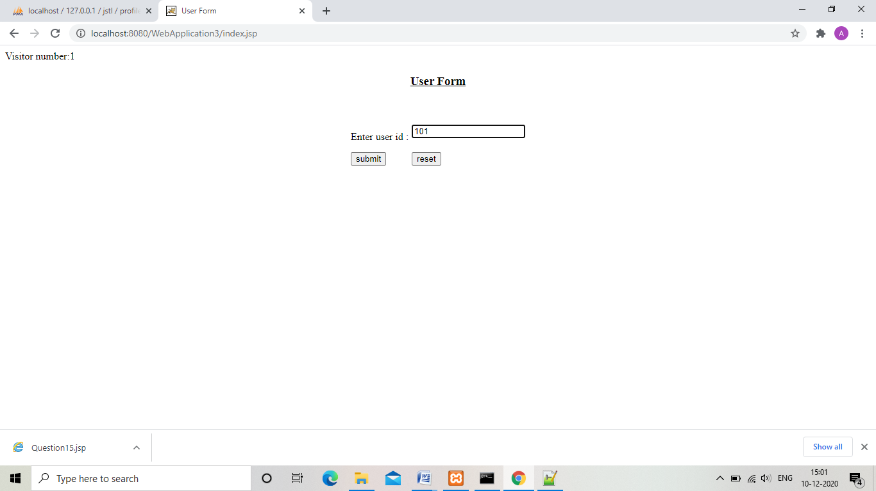

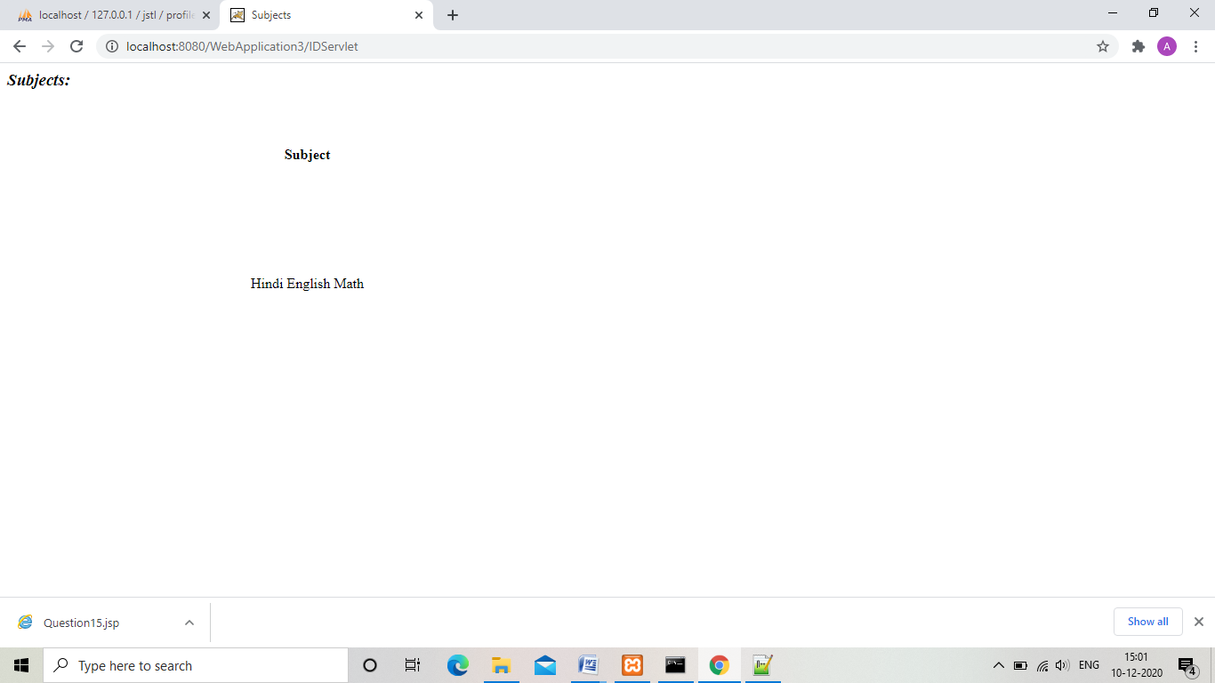

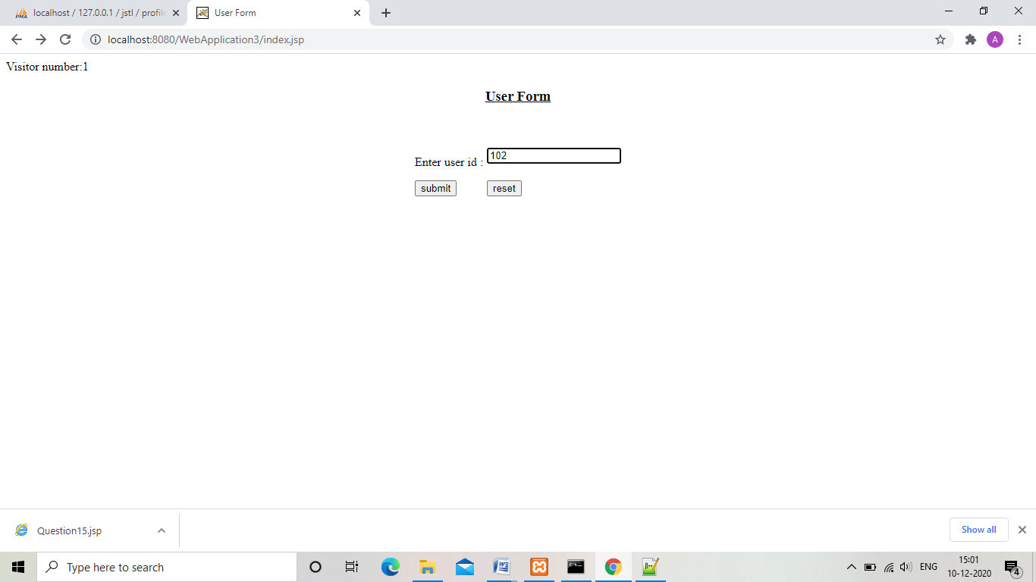

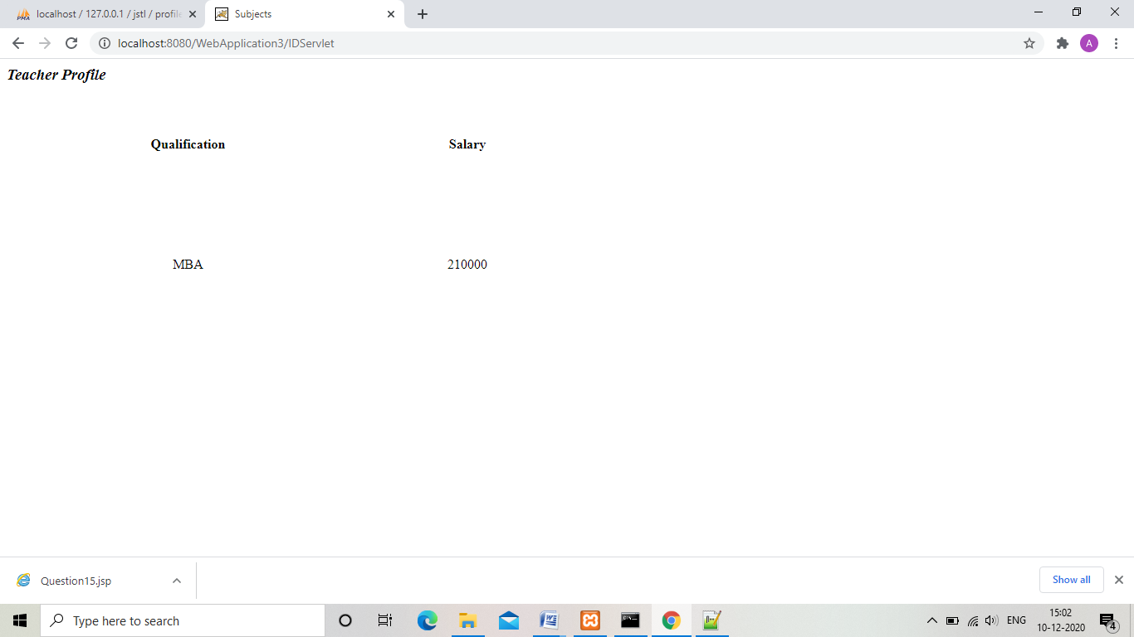

3.

4. Develop an application for a GuestBook as following:

1. Design an HTML page that takes user’s name, email and the comments of the user.

The page should have three buttons submit, clear form and view guestbook

1. On the click of submit the user’s details should be stored in the database and the user should be shown a page showing his entered details and a note of thanks.
2. On clicking the clear form button the data entered on the form should be cleared. And on clicking on view Guestbook page the whole guest book should be shown to the user.

“index.jsp”

<html>

<head>

<title>

User Form

</title>

</head>

<body>

<center><h3><u>Guest Form</u></h3><br><br>

<table>

<form action="GuestServlet" method="post">

<tr>

<td>

<label>Enter user name:</label>

</td>

<td>

<input type="text" name="username" /><br></br>

</td>

</tr>

<tr>

<td>

<label>Enter email:</label>

</td>

<td>

<input type="text" name="email" /><br></br>

</td>

</tr>

<tr>

<td>

<label>Enter comments:</label>

</td>

<td>

<textarea rows="5" cols="20" name="comments"></textarea><br></br>

</td>

</tr>

<tr>

<td>

<input type="submit" value="submit">

</td>

<td>

<input type="reset" value="reset">

</td>

</tr>

</form>

</table>

<form action="display.jsp">

<input type="submit" value="View Guest book">

</form>

</center>

</body>

</html>

“ShowDetail.jsp”

<html>

<head>

<title>

User Form

</title>

</head>

<body>

<center><h3><u>Thanks for your feedback and entry!</u></h3><br><br>

Entered Details:<%= request.getAttribute("Detail")%>

</center>

</body>

</html>

“display.jsp”

<%@ page import="java.io.*,java.util.*,java.sql.*"%>

<%@ page import="javax.servlet.http.*,javax.servlet.*" %>

<%@ taglib uri="http://java.sun.com/jsp/jstl/sql" prefix="sql"%>

<%@ taglib uri="http://java.sun.com/jsp/jstl/core" prefix="c" %>

<html>

<head>

<title>

Student Information

</title>

</head>

<body><h3>GuestBook

<sql:setDataSource var="db" driver="com.mysql.jdbc.Driver" url="jdbc:mysql://localhost/jstl" user="root" password=""/>

<sql:query dataSource="${db}" var="rs">

Select * from Guestbook

</sql:query>

<table >

<tr>

<th>Username</th>

<th>Email</th>

<th>Comments</th>

</tr>

<c:forEach var="table" items="${rs.rows}">

<tr>

<td align="center"><c:out value="${table.Username}" /></td>

<td align="center"><c:out value="${table.Email}" /></td>

<td align="center"><c:out value="${table.Comments}" /></td>

</tr>

</c:forEach>

</table>

</body>

</html>

“GuestServlet.java”

package guest;

import java.sql.*;

import java.io.IOException;

import java.io.PrintWriter;

import javax.servlet.RequestDispatcher;

import javax.servlet.ServletException;

import javax.servlet.http.HttpServlet;

import javax.servlet.http.HttpServletRequest;

import javax.servlet.http.HttpServletResponse;

public class GuestServlet extends HttpServlet{

protected void doPost(HttpServletRequest request, HttpServletResponse response) throws ServletException, IOException {

response.setContentType("text/html");

PrintWriter out = response.getWriter();

try{

Class.forName("com.mysql.jdbc.Driver");

Connection connection = DriverManager.getConnection("jdbc:mysql://localhost/jstl","root","");

PreparedStatement stmt = connection.prepareStatement("Insert into Guestbook values(?,?,?)");

stmt.setString(1,request.getParameter("username"));

stmt.setString(2,request.getParameter("email"));

stmt.setString(3,request.getParameter("comments"));

String detail="Username:"+request.getParameter("username")+"\nEmail"+request.getParameter("email")+"\nComments"+request.getParameter("comments");

request.setAttribute("Detail",detail);

int i =stmt.executeUpdate();

System.out.print("Record:"+i);

connection.close();

}

catch(Exception e){

e.printStackTrace();

}

RequestDispatcher request_dispatcher = request.getRequestDispatcher("ShowDetail.jsp");

request_dispatcher.forward(request,response);

}

protected void doGet(HttpServletRequest request,HttpServletResponse response) throws ServletException, IOException {

doPost(request, response);

}

}

“web.xml”

<?xml version="1.0" encoding="UTF-8"?>

<!--

Licensed to the Apache Software Foundation (ASF) under one or more

contributor license agreements. See the NOTICE file distributed with

this work for additional information regarding copyright ownership.

The ASF licenses this file to You under the Apache License, Version 2.0

(the "License"); you may not use this file except in compliance with

the License. You may obtain a copy of the License at

http://www.apache.org/licenses/LICENSE-2.0

Unless required by applicable law or agreed to in writing, software

distributed under the License is distributed on an "AS IS" BASIS,

WITHOUT WARRANTIES OR CONDITIONS OF ANY KIND, either express or implied.

See the License for the specific language governing permissions and

limitations under the License.

-->

<web-app xmlns="http://java.sun.com/xml/ns/javaee"

xmlns:xsi="http://www.w3.org/2001/XMLSchema-instance"

xsi:schemaLocation="http://java.sun.com/xml/ns/javaee

http://java.sun.com/xml/ns/javaee/web-app_3_0.xsd"

version="3.0"

metadata-complete="true">

<display-name>Welcome to Tomcat</display-name>

<description>

Welcome to Tomcat

</description>

<servlet>

<servlet-name>GuestServlet</servlet-name>

<servlet-class>guest.GuestServlet</servlet-class>

</servlet>

<servlet-mapping>

<servlet-name>GuestServlet</servlet-name>

<url-pattern>/GuestServlet</url-pattern>

</servlet-mapping>

</web-app>

“Output”

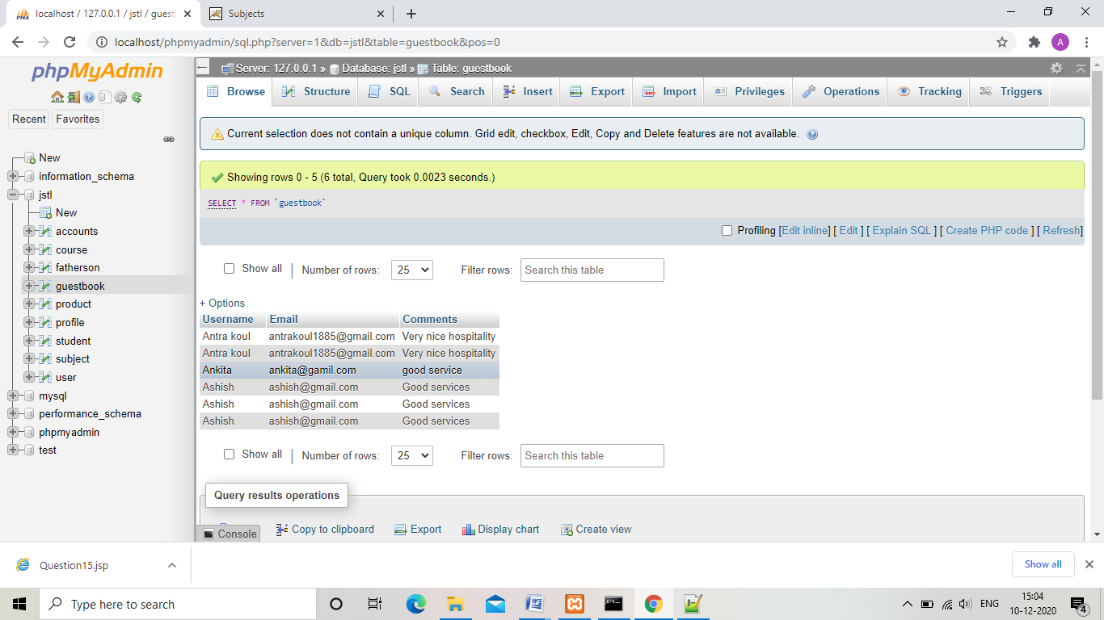

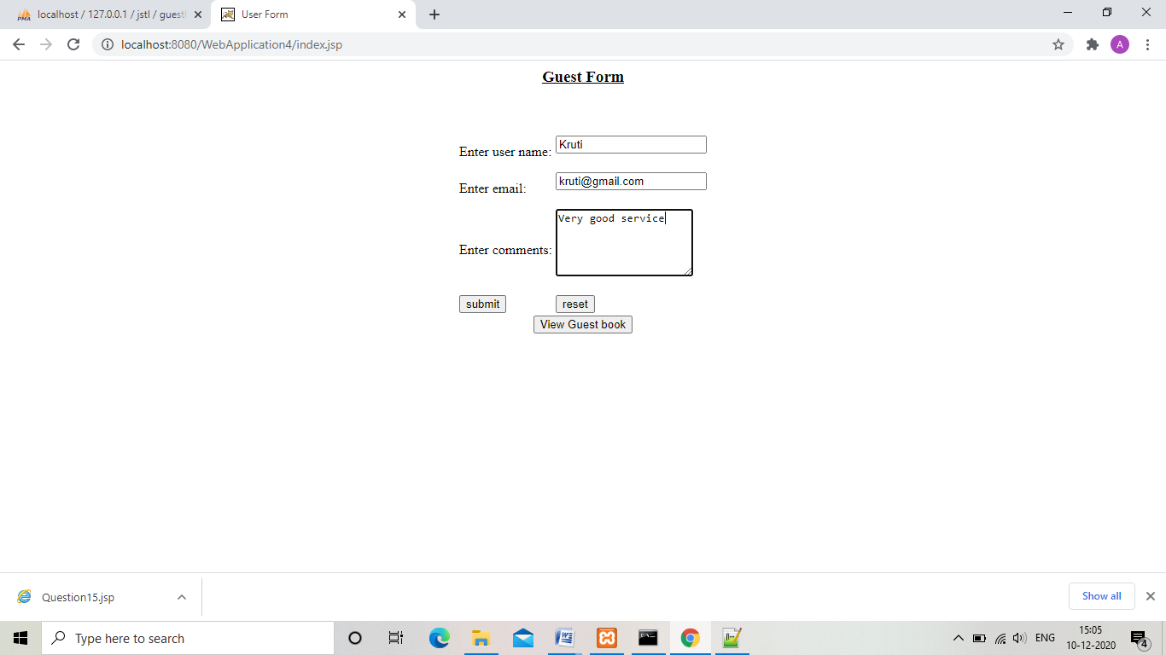

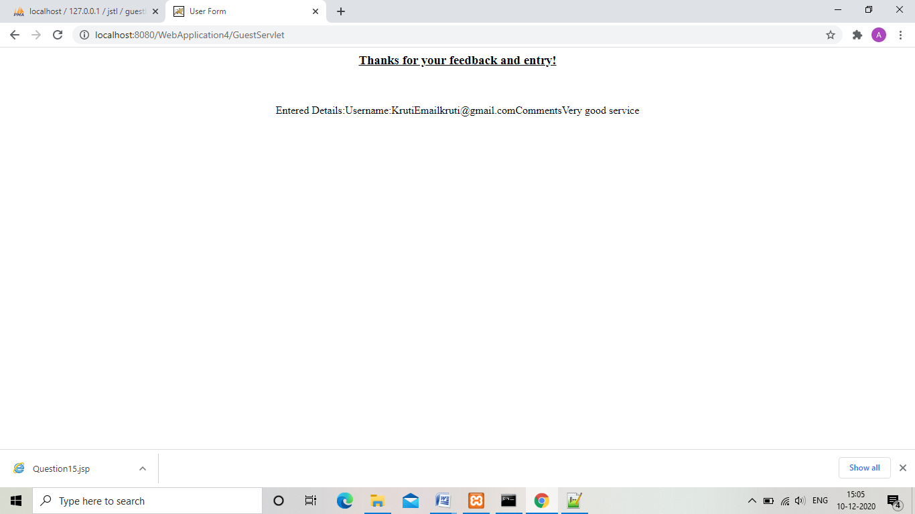

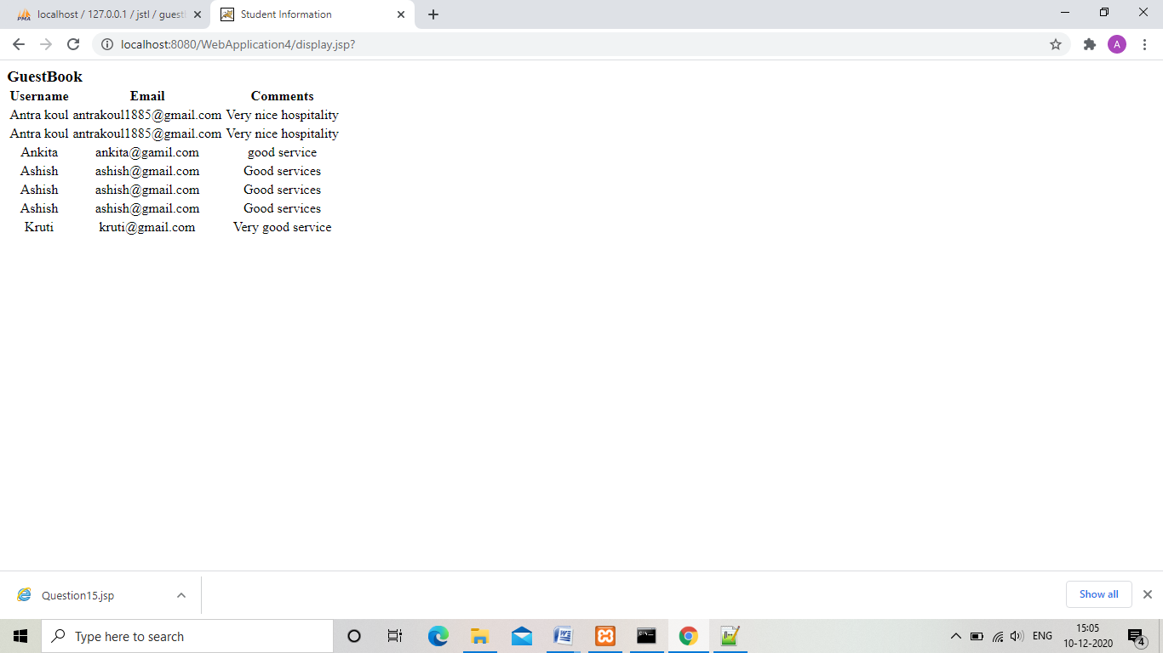

4.

6. Develop an application for a Inventory for Products as following:

1. Design an HTML page that takes the product details like:

Product-id

Product-name

Desctiption

Price from the user

1. On submitting the page a bean should be populated with the given values for Product in a servlet
2. The bean created then should be inserted in the database.
3. On the same page, all the available products in the database should be shown to the user.

“Form.html”

<html>

<head>

<title>Product Form</title>

</head>

<body>

<center>

<h2><u>Product form Form</u><br /><br />

<form method="post" action="Question3">

<label>Enter product id:</label>

<input type="text" name="productid"><br /><br />

<label>Enter product name:</label>

<input type="text" name="productname"><br /><br />

<label>Enter description:</label>

<input type="text" name="description"><br /><br />

<label>Enter price:</label>

<input type="text" name="price"><br /><br />

<input type="submit" value="Add product">

<input type="reset" value="reset">

</form>

</center>

</body>

</html>

“Product.jsp”

<%@ taglib uri="http://java.sun.com/jsp/jstl/sql" prefix="sql"%>

<%@ taglib uri="http://java.sun.com/jsp/jstl/core" prefix="c"%>

<html>

<head>

<title>Product details</title>

</head>

<body>

<sql:setDataSource var="db" driver="com.mysql.jdbc.Driver" url="jdbc:mysql://localhost/jstl" user="root" password="" />

<sql:query var="rs" dataSource="${db}">

Select * from Product;

</sql:query>

<center><h3><i>Product data</i>

<table>

<tr>

<th>Product ID</th>

<th>Product name</th>

<th>Product Description</th>

<th>Product price</th>

</tr>

<c:forEach var="table" items="${rs.rows}">

<tr>

<td align="center"><c:out value="${table.ID}" /></td>

<td align="center"><c:out value="${table.Name}" /></td>

<td align="center"><c:out value="${table.Description}" /></td>

<td align="center"><c:out value="${table.Price}" /></td>

</tr>

</c:forEach>

</table>

</center>

</body>

</html>

“ProductDetails.java”

package product;

public class ProductDetails{

private String productid,productname,description,price;

public void setProductid(String productid){

this.productid=productid;

}

public String getProductid(){

return productid;

}

public void setProductname(String productname){

this.productname=productname;

}

public String getProductname(){

return this.productname;

}

public void setDescription(String description){

this.description=description;

}

public String getDescription(){

return description;

}

public String getPrice(){

return this.price;

}

public void setPrice(String price){

this.price=price;

}

}

“Question3.java”

package product;

import java.sql.*;

import java.io.IOException;

import java.io.PrintWriter;

import javax.servlet.RequestDispatcher;

import javax.servlet.ServletException;

import javax.servlet.http.HttpServlet;

import javax.servlet.http.HttpServletRequest;

import javax.servlet.http.HttpServletResponse;

public class Question3 extends HttpServlet{

protected void doPost(HttpServletRequest request, HttpServletResponse response) throws ServletException, IOException {

response.setContentType("text/html");

PrintWriter out = response.getWriter();

ProductDetails p1 = new ProductDetails();

p1.setProductid(request.getParameter("productid"));

p1.setProductname(request.getParameter("productname"));

p1.setDescription(request.getParameter("description"));

p1.setPrice(request.getParameter("price"));

try{

Class.forName("com.mysql.jdbc.Driver");

Connection connection = DriverManager.getConnection("jdbc:mysql://localhost/jstl","root","");

PreparedStatement stmt = connection.prepareStatement("Insert into Product values(?,?,?,?)");

stmt.setString(1,request.getParameter("productid"));

stmt.setString(2,request.getParameter("productname"));

stmt.setString(3,request.getParameter("description"));

stmt.setString(4,request.getParameter("price"));

int i =stmt.executeUpdate();

System.out.print("Record:"+i);

connection.close();

}

catch(Exception e){

e.printStackTrace();

}

RequestDispatcher request_dispatcher = request.getRequestDispatcher("Products.jsp");

request_dispatcher.forward(request,response);

}

protected void doGet(HttpServletRequest request,HttpServletResponse response) throws ServletException, IOException {

doPost(request, response);

}

}

“web.xml”

<?xml version="1.0" encoding="UTF-8"?>

<!--

Licensed to the Apache Software Foundation (ASF) under one or more

contributor license agreements. See the NOTICE file distributed with

this work for additional information regarding copyright ownership.

The ASF licenses this file to You under the Apache License, Version 2.0

(the "License"); you may not use this file except in compliance with

the License. You may obtain a copy of the License at

http://www.apache.org/licenses/LICENSE-2.0

Unless required by applicable law or agreed to in writing, software

distributed under the License is distributed on an "AS IS" BASIS,

WITHOUT WARRANTIES OR CONDITIONS OF ANY KIND, either express or implied.

See the License for the specific language governing permissions and

limitations under the License.

-->

<web-app xmlns="http://java.sun.com/xml/ns/javaee"

xmlns:xsi="http://www.w3.org/2001/XMLSchema-instance"

xsi:schemaLocation="http://java.sun.com/xml/ns/javaee

http://java.sun.com/xml/ns/javaee/web-app_3_0.xsd"

version="3.0"

metadata-complete="true">

<display-name>Welcome to Tomcat</display-name>

<description>

Welcome to Tomcat

</description>

<servlet>

<servlet-name>Question3</servlet-name>

<servlet-class>product.Question3</servlet-class>

</servlet>

<servlet-mapping>

<servlet-name>Question3</servlet-name>

<url-pattern>/Question3</url-pattern>

</servlet-mapping>

</web-app>

“Output”

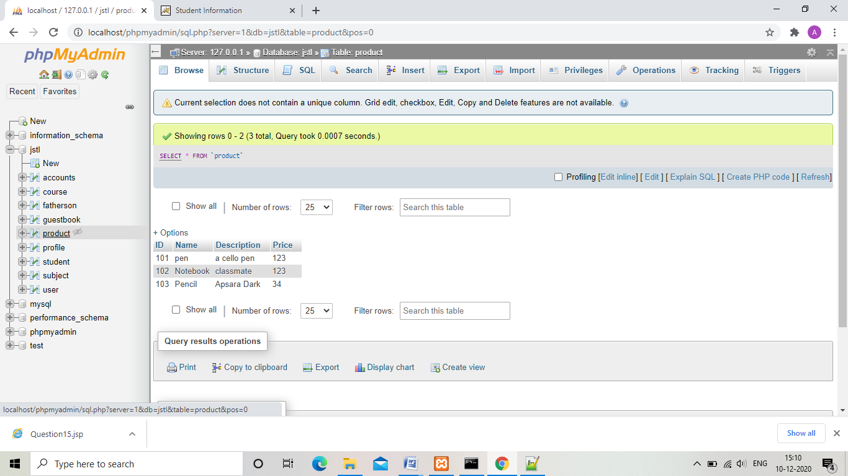

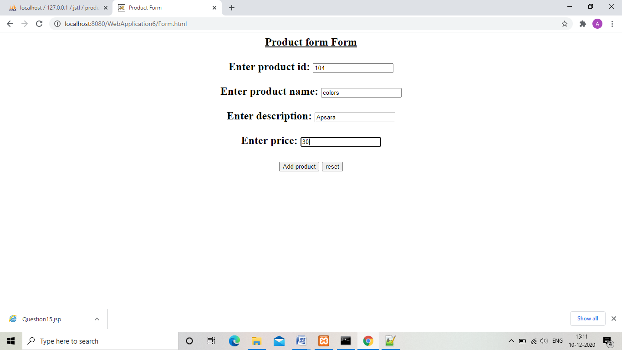

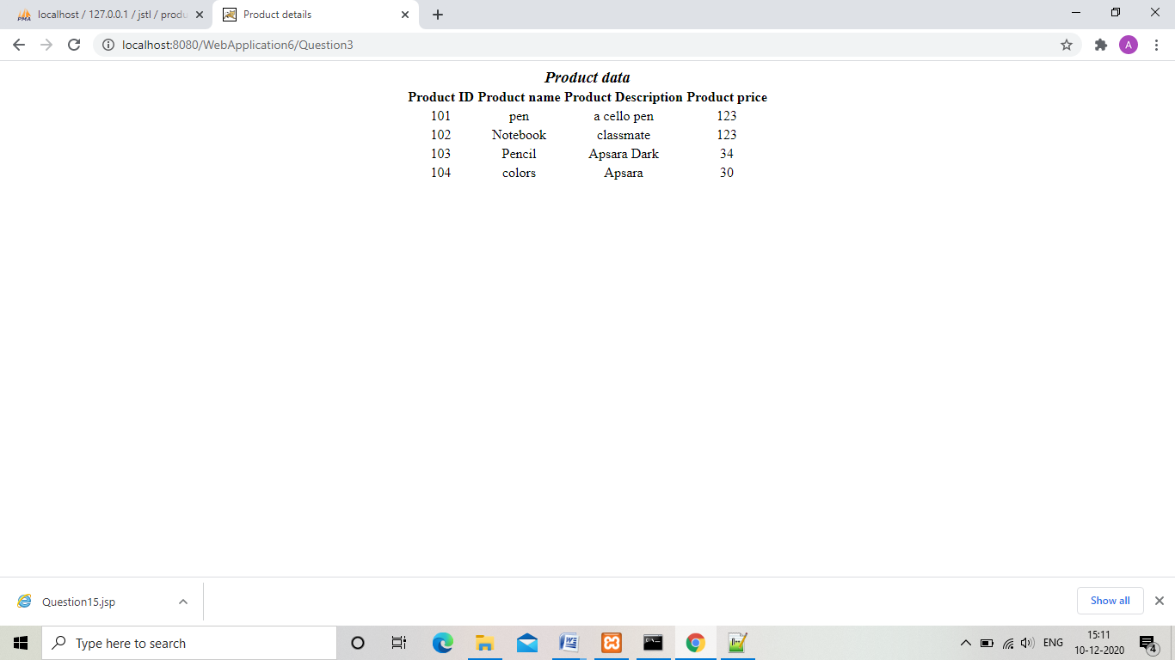

5. Develop an application as following:

1. Design an HTML form that takes the input as user-id from the user.
2. Based on the id, fetch the data from the database. Check his type and accordingly populate the bean of MCAStudent or MBAStudent.
3. If the user is an MCAStudent, he should be given a page that displays the subject names for MCA and if the user is an MBAStudent, the subject should be shown

accordingly from the database.

“index.jsp”

<html>

<head>

<title>

User Form

</title>

</head>

<body>

<center><h3><u>User Form</u></h3><br><br>

<table>

<form action="StudentServlet" method="post">

<tr>

<td>

<label>Enter user id :</label>

</td>

<td>

<input type="text" name="userid" /><br></br>

</td>

</tr>

<tr>

<td>

<input type="submit" value="submit">

</td>

<td>

<input type="reset" value="reset">

</td>

</tr>

</form>

</table>

</center>

</body>

</html>

“mba.jsp”

<%@ taglib uri="http://java.sun.com/jsp/jstl/sql" prefix="sql"%>

<%@ taglib uri="http://java.sun.com/jsp/jstl/core" prefix="c"%>

<%@ page import="userid.MBA"%>

<html>

<head>

<title>

MBA Subjects

</title>

</head>

<body>

<%

MBA m=(MBA)request.getAttribute("MBA");

%>

<center><i>

Subject1:<%= m.getSubject1()%><br /><br />

Subject2:<%= m.getSubject2()%><br /><br />

Subject3:<%= m.getSubject3()%></i></center>

</body>

</html>

“mca.jsp”

<%@ taglib uri="http://java.sun.com/jsp/jstl/sql" prefix="sql"%>

<%@ taglib uri="http://java.sun.com/jsp/jstl/core" prefix="c"%>

<%@ page import="userid.MCA"%>

<html>

<head>

<title>

MCA Subjects

</title>

</head>

<body>

<%

MCA m=(MCA)request.getAttribute("MCA");

%>

<center><i>

Subject1:<%= m.getSubject1()%><br /><br />

Subject2:<%= m.getSubject2()%><br /><br />

Subject3:<%= m.getSubject3()%></i></center>

</body>

</html>

“web.xml”

<?xml version="1.0" encoding="UTF-8"?>

<!--

Licensed to the Apache Software Foundation (ASF) under one or more

contributor license agreements. See the NOTICE file distributed with

this work for additional information regarding copyright ownership.

The ASF licenses this file to You under the Apache License, Version 2.0

(the "License"); you may not use this file except in compliance with

the License. You may obtain a copy of the License at

http://www.apache.org/licenses/LICENSE-2.0

Unless required by applicable law or agreed to in writing, software

distributed under the License is distributed on an "AS IS" BASIS,

WITHOUT WARRANTIES OR CONDITIONS OF ANY KIND, either express or implied.

See the License for the specific language governing permissions and

limitations under the License.

-->

<web-app xmlns="http://java.sun.com/xml/ns/javaee"

xmlns:xsi="http://www.w3.org/2001/XMLSchema-instance"

xsi:schemaLocation="http://java.sun.com/xml/ns/javaee

http://java.sun.com/xml/ns/javaee/web-app_3_0.xsd"

version="3.0"

metadata-complete="true">

<display-name>Welcome to Tomcat</display-name>

<description>

Welcome to Tomcat

</description>

<servlet>

<servlet-name>StudentServlet</servlet-name>

<servlet-class>userid.StudentServlet</servlet-class>

</servlet>

<servlet-mapping>

<servlet-name>StudentServlet</servlet-name>

<url-pattern>/StudentServlet</url-pattern>

</servlet-mapping>

</web-app>

“MBA.java”

package userid;

public class MBA{

String subject1,subject2,subject3;

public void setSubject1(String subject1){

this.subject1=subject1;

}

public String getSubject1(){

return this.subject1;

}

public void setSubject2(String subject2){

this.subject2=subject2;

}

public String getSubject2(){

return this.subject2;

}

public void setSubject3(String subject3){

this.subject3=subject3;

}

public String getSubject3(){

return this.subject3;

}

}

“MCA.java”

package userid;

public class MCA{

String subject1,subject2,subject3;

public void setSubject1(String subject1){

this.subject1=subject1;

}

public String getSubject1(){

return this.subject1;

}

public void setSubject2(String subject2){

this.subject2=subject2;

}

public String getSubject2(){

return this.subject2;

}

public void setSubject3(String subject3){

this.subject3=subject3;

}

public String getSubject3(){

return this.subject3;

}

}

“StudentServlet.java”

package userid;

import java.sql.*;

import java.io.IOException;

import java.io.PrintWriter;

import javax.servlet.RequestDispatcher;

import javax.servlet.ServletException;

import javax.servlet.http.HttpServlet;

import javax.servlet.http.HttpServletRequest;

import javax.servlet.http.HttpServletResponse;

public class StudentServlet extends HttpServlet{

protected void doPost(HttpServletRequest request, HttpServletResponse response) throws ServletException, IOException {

response.setContentType("text/html");

PrintWriter out = response.getWriter();

int id=Integer.parseInt(request.getParameter("userid"));

String type="";

try{

Class.forName("com.mysql.jdbc.Driver");

Connection connection = DriverManager.getConnection("jdbc:mysql://localhost/jstl","root","");

Statement stmt = connection.createStatement();

ResultSet rs=stmt.executeQuery("Select * from course");

while(rs.next()){

if(rs.getInt("ID") == id){

type=rs.getString("CourseType");

break;

}

}

if(type.equalsIgnoreCase("MBA")){

MBA m = new MBA();

m.setSubject1("Finance");

m.setSubject2("Operations");

m.setSubject3("Marketing");

request.setAttribute("MBA",m);

RequestDispatcher request_dispatcher = request.getRequestDispatcher("mba.jsp");

request_dispatcher.forward(request,response);

}

else

{

MCA m = new MCA();

m.setSubject1("C");

m.setSubject2("Java");

m.setSubject3("Software Engineering");

request.setAttribute("MCA",m);

RequestDispatcher request_dispatcher = request.getRequestDispatcher("mca.jsp");

request_dispatcher.forward(request,response);

}

connection.close();

}

catch(Exception e){

e.printStackTrace();

}

}

protected void doGet(HttpServletRequest request,HttpServletResponse response) throws ServletException, IOException {

doPost(request, response);

}

}

“Output”

